**REFERENCES**

Ahmad, I. S., et al. (2013). The potential sources of foreign language reading anxiety in a jordanian EFL context: A Theorical Framework. *Canadian Center of Science and Education, English Language Teaching. Vol. 6, No. 11.* ISSN 1916-4742 E-ISSN 1916-4750.Institute of Educationn International Islamic University Malaysia. DOI: 10.5539/elt.v6n11p89.

Anggraini, M.S,. Juniarso, T., Susiloningsih, W. (2021). Efektivitas Pembelajaran Daring Era Pandemi Covid-19 Terhadap Pemahaman Siswa Kelas V Di SD Hang Tuah 10 Juanda Surabaya. *Adi Buana Repository.* Retrieved from <https://repository.unipasby.ac.id/id/eprint/556/>

Arivuchelvan, K.M., & Lakahmi, K. (2017). Reading Comprehension System – A Review. *Computer science. Indian J.Sci.Res. vol. 14, Issue.1. Pp. 83-90, P-ISSN: 0976-2876, E-ISSN: 2250-0138.*

Arya, S. (2023). Questonnaire method of data collection. *Research methodology*. Retrieved from [https://microbenotes.com/questionnaire-method-of-data-collection/.](https://microbenotes.com/questionnaire-method-of-data-collection/.%20%20%20e)

Dewanto, A. C. T. (2019). Maximizing students’ effective participation using jigsaw technique in reading factual report text (A classroom action research at XI Akuntansi 1 SMK negeri 1 Surakarta in second semester 2018/2019). *Universitas sebelas Maret, Surakarta.*

Dianti, V. (2023). Improving students’ reading comprehension through round robin technique (A classroom action research to the tenth grade students of SMAN 1 Pemangkat in the academic year of 2022/2023). *Diploma thesis, IKIP PGRI PONTIANAK*.

Erdiansyah, E., & Fitriawati, F. (2023). The correlation between reading anxiety and students’ critical reading ability at English Study Program of UNP. *Journal of English language teaching, 12. (1): PP. 270-279.* DOI:10.24036/jelt.v12i1.121547.

Fajar Pendidikan. (2024). Pengertian Expository text, Ciri, Struktur dan Tujuan. *Fajar Pendidikan*. Retrieved from <http://fajarpendidikan.co.id/pengertian-expository-text-ciri-struktur-dan-tujuan/>

Farihah. (2017). The correlation between reading anxiety and reading comprehension achievement of the eleventh grade students of SMA negeri 3 Palembang. *UIN Raden Fatah Palembang*.

Ghonsooly, B., & Elahi, M. (2010*).* Learners' Self-efficacy in Reading and its relation to Foreign Language Reading Anxiety and Reading Achievement. *Journal of English Language Teaching and Learning, 2(217), 45-68.*

Guimba, Dr. W. D., & Alico, J. C. (2015). Reading anxiety and comprehension of grade 8 Filipino learners*. International journal of humanities and social sciences. Spec. Vol, PP. 44-59. P-ISSN: 169-2620, E-ISSN: 1694-2639.* Retrieved from <https://iajhss.org/index.php/ijhss>.

Jafar, T. N. (2012). Improving students’ reading comprehension using small group interaction (A classroom action research at second grade of SMP N 1 Salem, Brebes academic year 2011/2012). *Bachelor thesis, universitas Muhammadiyah Purwokerto.* Retrieved from <https://repository.ump.ac.id:80/id/eprint/3423>.

Koay, Dr. J. (2021). What is reading Anxiety. *Edumaxi learning solutions.* Retrieved from <https://www.edumaxi.com/blog/what-is-reading-anxiety>.

Kurniawan, Y.I. (2015). Chapter II Review of Related Literature: Definition of Reading, Types of Reading, Definition of Reading Comprehension. *Universitas Muhammadiyah Gresik (UMG) Repository.* Retrieved from <http://eprints.umg.ac.id/2809/3/CHAPTER%20II.pdf>

Lutfiana, L. (2019). The implementation of collaborative strategic reading (car) in teaching reading comprehension. *(Doctoral dissertation, IKIP PGRI BOJONEGORO)*.

Mawaddah, P. R. (2022). Foreign Language Reading Anxiety Level and its Potential Factors among Indonesian EFL Junior High School in MTs Negeri 5 JEMBER. Retrieved from <http://digilib.uinkhas.ac.id/9431/1/FIX_REVISI_SKRIPSI_AYA_beda123.pdf>

Mekonnen, W. (2020). Review on correlation research. *International journal of English literature and culture*. Vol.8(4), pp 99-106. ISSN: 2360-7831. DOI: 10.1466z/IJELC.2020.085.

Mentary. (2024). Tingkat pemahaman pelatih pada peran statistik pertandingan dalam kompetensi DBL Yogyakarta series 2023. *Universitas negeri Yogyakarta.*

Muhlis, A. (2017). Foreign language reading anxiety among Indonesian EFL senior high school students. *English franca academic journal of English language and education. Vol.1, No.1. P-ISSN: 2580-3670, E-ISSN: 2580-3689.* Retrieved from <https://journal.iaincurup.ac.id/index.php/English/article/view/160/94>.

Munir, S., Suzanne, N., & Fitri, H. (2023). The correlation between students’ reading anxiety and their reading ability. *Ahmad Dahlan Journal of English Studies. Vol.10, No.2, P. 89-99.* Retrieved from <https://doi.org/10-26555/adjes.v1012.354>.

Nasifah,L.Z. (2024). Pengertian Teks Eksposisi, Struktur, Jenis-jenis, dan Contohnya. *detikEdu*. retreived from <https://www.detik.com/edu/detikpedia/d-7383993/pengertian-teks-eksposisi-struktur-jenis-jenis-dan-contohnya>

Nasir, N., & Sukmawati, S. (2023). Analysis of research data quantitative and qualitative. Edumaspul. *Jurnal pendidikan*, 7(1). 368-373. Retrieved from <https://ummaspul.e-journal.id/maspulir/article/view/5488>.

Nasya, N. K. S., et al. (2024). Pentingnya Bahasa Inggris Pada era Globalisasi. *Karimah Tauhid*. *Vol. 3, No. 3, pp. 3685-3692.* DOI:10.3099/karimuntauhid.v3i3.12571.

Nisa, E. (2022). Improving English Text Reading Skills for Class XII Students at SMA Negeri 2 Ponorogo Through the Three-Stage Way*. Scientific Journal of Visionary Education (JIPV), 3 (1), 27-31.* Retrieved from <https://ejurnalkotamadiun.org/index.php/JIPV/article/view/1209>

Perpustakaan Online Gratis. (2024). Baca Practice Test Toefl Cmedia 948 Gratis-Perpus.org. *Penerbit Cmedia*. Retreived from <https://perpus.org/fiksi/practice-test-toefl-cmedia-948>

Piccolo, L. R., et al. (2017). Reading anxiety in L1: Reviewing the concept. *Early childhood education journal, 45(4), 537-543.* Retrieved from <https://doi.org/10-1007/510643-016-0822-x>.

Pratama, R., et al. (2023). Correlation Research. Jurnal Ilmiah Ilmu Pendidikan. eISSN: 2614-8854. Vol.6, No.3, pp. 1754-1759. Universitas Islam negeri Raden Fatah Palembang, Indonesia. Retrieved from <https://jiip.stkipyapisdompu.ac.id>.

Putra, P. (2014). The correlation of playing role-playing game and students’ reading comprehension of narrative text. *Journal of English and Education*. Vol.2(2), pp.56-67. Retrieved from <https://journal.upi.edu/index.php/L-E/article/viewFile/4603/3203>.

Rosada, A. Rufinus, A. & Bunau, E. (2015). Improving students’ reading comprehension on narrative text by using story map technique. *Jurnal pendidikan dan pembelajaran*. ISSN: 2715-2723. Vol.4, No. 9. DOI: <http://DX.doi.org/10.26418/Jppk.V4i9.11386>.

Sanny, B. I., & Dewi, R. K. (2020). Pengaruh Net Interest Margin (NIM) Terhadap Return on Asset (ROA) Pada PT Bank Pembangunan Daerah Jawa Barat Dan Banten Tbk Periode 2013-2017. *Jurnal E-Bis (Ekonomi-Bisnis). Vol. 4 No. 1 (2020) pp.78-87. p-ISSN : 2580-2062. e-ISSN : 2622-3368.* Doi:https://doi.org/ 10.37339/jurnal e-bis.v4i1.239.

Selviana, L., Afgani, M.W., Siroj, R.A. (2024). Correlation Research. *INNOVATIVE: Journal of Social Science Research. Vol.4, No.1, pp. 5118-5128 E-ISSN 2807-4238 and P-ISSN 2807-4246.* Retrieved from <https://j-innovative.org/index.php/Innovative>.

Sugiyono, (2020). BAB III Merode Penelitian. *Repository Universitas Ngudi* Wiluyo. Retreived from <http://repository2.unw.ac.id/2366/5/BAB%20III%20-%20Carollyn%20Dizzy.pdf>.

Tera, S., et al. (2024). Investigating Students’ Reading Anxiety and Their Factors. *Journal of Development and Innovation in Language and Literature Education. E-ISSN: 2723-6900 P-ISSN: 2745-9578. Vol. 4 No. 2, Pp. 110-123.* Retrieved from <https://doi.org/10.52760/jadila.v4i2.776>

Turner, D., P. (2020). Sampling methods in research design. *Journal of head and face pain*. ISSN: 0017-8748. Retrieved from: <https://doi.org/10.1111/head.13707>.

Voyager Sopris Learning. (2024). Examples of Expository Text. *VSL Blog*. Retrieved from <https://www.voyagersopris.com/vsl/blog/expository-text-samples>

Wahyuni, B. A., & Syafitri, N. (2022). Students’ reading anxiety and students’ reading comprehension. *English education journal (E2J)? P-ISSN: 2460-0504, E-ISSN: 2686-3731.* DOI:,10.55340/E2J.v8i1.847.

Willie, M., M. (2024). Population and target population in research methodology. *Social science and education I research article*. *E-ISSN: 2797-5827. Vol.4, Issue.1.* DOI: 10.52970/grade.v4i1.4

**READING ANXIETY QUESTIONAIRE ADOPTED FROM**

**TERA SELIAN (2024)**

**Name :**

**Semester :**

**Information:**

Strongly Agree : Sangat Setuju

Agree : Setuju

Netral : Netral

Disagree : Tidak Setuju

Strongl Disagree : Sangat Tidak Setuju

1. When I am reading in English, I get worried whenever I encounter strange vocabulary. *(Ketika saya membaca dalam bahasa Inggris, saya* *menjadi khawatir setiap kali saya menemukan kosakata aneh)*

|  |  |
| --- | --- |
|  | Strongly Agree |
|  | Agree |
|  | Netral |
|  | Disagree |
|  | Storngly Disagree |

1. I feel anxious in reading English when I encounter series of strange words. *(Saya merasa cemas saat membaca bahasa Inggris ketika saya menghadapi serangkaian kata aneh)*

|  |  |
| --- | --- |
|  | Strongly Agree |
|  | Agree |
|  | Netral |
|  | Disagree |
|  | Storngly Disagree |

1. I feel frustrated when reading because I often come across words I don't understand. *(Saya merasa frustrasi saat membaca karena sering menemukan kata yang saya tidak pahami)*

|  |  |
| --- | --- |
|  | Strongly Agree |
|  | Agree |
|  | Netral |
|  | Disagree |
|  | Storngly Disagree |

1. I find it difficult to understand the text because my limited vocabulary makes me feel like I can't read fluently. *(Saya merasa kesulitan memahami teks karena keterbatasan kosa kata saya membuat saya merasa tidak bisa membaca dengan lancar)*

|  |  |
| --- | --- |
|  | Strongly Agree |
|  | Agree |
|  | Netral |
|  | Disagree |
|  | Storngly Disagree |

1. I often feel anxious about understanding the meaning of the text I read because I do not know the meaning of certain words. *(Saya sering merasa cemas memahmi makna dari teks yang saya baca karena saya tidak tahu artinya kata-kata tertentu)*

|  |  |
| --- | --- |
|  | Strongly Agree |
|  | Agree |
|  | Netral |
|  | Disagree |
|  | Storngly Disagree |

1. When reading about unfamiliar topics, I find it difficult to understand the text and it often makes me feel like I'm losing focus. (*Ketika membaca tentang topik yang tidak familiar, Saya merasa sulit untuk mengerti teks dan sering membuat saya merasa kehilangan focus*)

|  |  |
| --- | --- |
|  | Strongly Agree |
|  | Agree |
|  | Netral |
|  | Disagree |
|  | Storngly Disagree |

1. I do not prefer reading unfamiliar topics, particularly in the English language. *(Saya tidak suka membaca topik yang tidak dikenal, terutama dalam bahasa inggris)*

|  |  |
| --- | --- |
|  | Strongly Agree |
|  | Agree |
|  | Netral |
|  | Disagree |
|  | Storngly Disagree |

1. I feel anxious when I have to read texts on topics that are unfamiliar to me. *(Saya merasa cemas saat harus membaca teks tentang topik yang asing bagi saya)*

|  |  |
| --- | --- |
|  | Strongly Agree |
|  | Agree |
|  | Netral |
|  | Disagree |
|  | Storngly Disagree |

1. I feel anxious when I am reading a topic in the English language which I have no idea about. *(Saya merasa cemas ketika saya membaca suatu topik di Bahasa Inggris yang tidak saya ketahui)*

|  |  |
| --- | --- |
|  | Strongly Agree |
|  | Agree |
|  | Netral |
|  | Disagree |
|  | Storngly Disagree |

1. In reading English, I feel afraid because I do not understand the idea if there is more than one meaning for each word. *(Dalam membaca bahasa Inggris, saya merasa takut karena tidak mengerti gagasan jika ada lebih dari satu arti untuk setiap kata)*

|  |  |
| --- | --- |
|  | Strongly Agree |
|  | Agree |
|  | Netral |
|  | Disagree |
|  | Storngly Disagree |

1. When I read English, I often do not understand the words, because I still cannot quite understand what the writer says. *(Ketika saya membaca bahasa Inggris, saya sering tidak memahami kata-kata karena aku masih belum bisa mengerti apa yang penulisnya sampaikan)*

|  |  |
| --- | --- |
|  | Strongly Agree |
|  | Agree |
|  | Netral |
|  | Disagree |
|  | Storngly Disagree |

1. I feel anxious when asked to translate a paragraph when I read English because I not used to it. *(Saya merasa cemas ketika diminta menerjemahkan satu paragraph saat saya membaca Bahasa inggris dikarenakan saya tidak terbiasa)*

|  |  |
| --- | --- |
|  | Strongly Agree |
|  | Agree |
|  | Netral |
|  | Disagree |
|  | Storngly Disagree |

1. It is frustrating in reading English when one word is connected with another to change the meaning. *(Sungguh membuat frustasi ketika membaca bahasa Inggris ketika satu kata terhubung dengan yang lain untuk mengubah arti)*

|  |  |
| --- | --- |
|  | Strongly Agree |
|  | Agree |
|  | Netral |
|  | Disagree |
|  | Storngly Disagree |

1. I most often feel afraid because I cannot understand an English text even though I know every word’s meaning. *(Saya paling sering merasa takut karena saya tidak bisa mengerti teks Bahasa Inggris meskipun saya tahu arti setiap katanya)*

|  |  |
| --- | --- |
|  | Strongly Agree |
|  | Agree |
|  | Netral |
|  | Disagree |
|  | Storngly Disagree |

1. I feel anxious in reading aloud in fear of making errors. *(Saya merasa cemas ketika membaca dengan suara keras karena takut membuat kesalahan)*

|  |  |
| --- | --- |
|  | Strongly Agree |
|  | Agree |
|  | Netral |
|  | Disagree |
|  | Storngly Disagree |

1. I feel afraid of making mistakes when trying to understand the text, which makes me reluctant to continue reading. *(Saya takut membuat kesalahan saat mencoba memahami teks, yang membuat saya enggan untuk melanjutkan membaca)*
2. I feel pressured when reading because I am afraid of making mistakes in interpreting the contents of the text. *(Saya merasa tertekan saat membaca karena takut melakukan kesalahan dalam mengartikan isi teks)*

|  |  |
| --- | --- |
|  | Strongly Agree |
|  | Agree |
|  | Netral |
|  | Disagree |
|  | Storngly Disagree |

1. I feel afraid if I encounter a word, I do not know how it is pronounced. *(Saya merasa takut jika saya menemukan kata yang tidak saya ketahui bagaimana cara pengucapannya)*

|  |  |
| --- | --- |
|  | Strongly Agree |
|  | Agree |
|  | Netral |
|  | Disagree |
|  | Storngly Disagree |

1. I feel scared when reading aloud because I prefer silent reding. (*Saya merasa takut ketika membaca dengan suara keras karena saya lebih suka membaca dalam hati)*

|  |  |
| --- | --- |
|  | Strongly Agree |
|  | Agree |
|  | Netral |
|  | Disagree |
|  | Storngly Disagree |

1. I often doubt my understanding of the text, afraid that I will make mistakes in interpretation. *(Saya sering meragukan pemahaman saya terhadap teks, takut jika saya membuat kesalahan dalam interpretasi)*

|  |  |
| --- | --- |
|  | Strongly Agree |
|  | Agree |
|  | Netral |
|  | Disagree |
|  | Storngly Disagree |

1. In reading aloud in the class, I do not understand the text even though it is easy. *(Dalam membaca dengan suara keras di kelas, saya tidak mengerti teks meskipun itu mudah)*

|  |  |
| --- | --- |
|  | Strongly Agree |
|  | Agree |
|  | Netral |
|  | Disagree |
|  | Storngly Disagree |

1. I feel worried that reading long texts will make melose focus and miss important information. *(Saya khawatir membaca teks yang Panjang akan membuat saya kehilangan fokus dan tidak mendapatkan informasi yang penting)*

|  |  |
| --- | --- |
|  | Strongly Agree |
|  | Agree |
|  | Netral |
|  | Disagree |
|  | Storngly Disagree |

1. I often feel anxious that the effects of reading will make me unable to understand the material well. *(Saya sering merasa cemas bahwa efek dari membaca akan membuat saya tidak bisa memahami materi dengan baik)*

|  |  |
| --- | --- |
|  | Strongly Agree |
|  | Agree |
|  | Netral |
|  | Disagree |
|  | Storngly Disagree |

1. I get afraid when I am not sure whether I understand what I am reading in English or not. *(Saya menjadi cemas ketika saya tidak yakin apakah saya mengerti apa yang saya baca dalam bahasa Inggris atau tidak)*

|  |  |
| --- | --- |
|  | Strongly Agree |
|  | Agree |
|  | Netral |
|  | Disagree |
|  | Storngly Disagree |

1. When reading English, I get anxious and do not remember what I have read. *(Ketika membaca bahasa Inggris, saya merasa cemas dan tidak ingat apa yang telah saya baca)*

|  |  |
| --- | --- |
|  | Strongly Agree |
|  | Agree |
|  | Netral |
|  | Disagree |
|  | Storngly Disagree |

**READING COMPREHENSION TEST**

**FROM PERPUSTAKAAN ONLINE GRATIS (2024)**

**DIRECTIONS!**

**In this section you will read several passages. Each one is followed by several questions about it. For this section, you are to choose the one best answer, (A), (B), (C), or (D), to each question.**

**Questions 1-10**

|  |  |
| --- | --- |
| Line (1) | As Philadelphia grew from a small town into a city in the first half of the eighteenth century, it became an increasingly important marketing center for a vast and growing agricultural hinterland. Market days saw the crowded city even more crowded, as fanners from within a radius of 24 or more kilometers brought their sheep, cows, pigs, vegetables, cider, and other products for direct sale to the townspeople. The High Street Market was continuously enlarged throughout the period until 1736, when it reached from Front Street to Third. By 1745 New Market was opened on Second Street between Pine and Cedar. The next year the Callowhill Market began operation. Along with market days, the institution of twice-yearly fairs persisted in Philadelphia even after similar trading days had been discontinued in other colonial cities. The fairs provided a means of bringing handmade goods from outlying places to would-be buyers in the city. Linens and  stockings from Germantown, for example, were popular items. |
| (2) |
| (3) | Auctions were another popular form of occasional trade. Because of the competition, retail merchants opposed these as well as the fairs. Although governmental attempts to eradicate fairs and auctions were less than successful, the ordinary course of economic development was on the merchants’ side, as increasing business specialization became the order of the day. Export merchants became differentiated from their importing counterparts, and specialty shops  began to appear in addition to general stores selling a variety of goods. |
| (4) | One of the reasons Philadelphia’s merchants generally prospered was because the surrounding area was undergoing tremendous economic and demographic growth. They did their business, after all, in the capital city of the province. Not only did they cater to the governor and his circle, but citizens from all over the colony came to the capital for legislative sessions of the assembly and council and the  meetings of the courts of justice. |

1. What does the passage mainly discuss?
   1. Philadelphia’s agriculture importance
   2. Philadelphia’s development as a marketing center
   3. The sale of imported goods in Philadelphia
   4. The administration of the city of Philadelphia
2. It can be inferred from the passage that new markets opened in Philadelphia because
   1. They provided more modem facilities than older markets
   2. The high street market was forced to close
   3. Existing markets were unable to serve the growing population
   4. Farmers wanted markets that were closer to the farms.
3. The word *hinterland* in line 1 is closest in meaning to
   1. Tradition
   2. Association
   3. Produce
   4. Region
4. The word “it” in line 1 refers to
   1. The crowded city
   2. A radius
   3. The high street market
   4. The period
5. The word “persisted” in line 1 is closest in meaning to
   1. Returned
   2. Started
   3. Declined
   4. Continued
6. According to the passage, fairs in Philadelphia were held
   1. On the same day as market says
   2. As often as possible
   3. A couple of times a year
   4. Whenever the government allowed it
7. It can be inferred that the author mentions “Linens and stockings” in line 2 to show that they were items that
   1. retail merchants were not willing to sell
   2. were not available in the stores in Philadelphia
   3. were more popular in Germantown man in Philadelphia
   4. could easily be transported
8. The word *eradicate* in line 16 is closest in meaning to
   1. Eliminate
   2. Exploit
   3. Organize
   4. Operate
9. What does the author mean by stating in line 3 that “economic development was on the merchants’ side”?
   1. Merchants had a strong impact on economic expansion.
   2. Economic forces allowed merchants to prosper.
   3. Merchants had to work together to achieve economic independence
   4. Specialty shops near large markets were more likely to be economically successful.
10. The word “undergoing” in line 4 is closest in meaning to
    1. Requesting
    2. Experiencing
    3. Repeating
    4. Including

**Questions 11-22**

|  |  |
| --- | --- |
| Line  (1) | Aviculturists, people who raise birds for commercial sale, have not yet learned how to simulate the natural incubation of parrot eggs in the wild. They continue to look for better ways to increase egg production and to improve chick survival rates. When parrots incubate their eggs in the wild, the temperature and humidity of the nest are controlled naturally. Heat is transferred from the bird’s skin to the top portion of the eggshell, leaving the sides and bottom of the egg at a cooler temperature. This temperature gradient may be vital to successful hatching. Nest construction can contribute to this temperature gradient. Nests of loosely arranged sticks, rocks, or dirt are cooler in temperature at the bottom where the egg contacts the nesting material. Such nests also act as humidity regulators by allowing rain to drain into the bottom sections of the nest so that the eggs are not in direct contact with the water. As the water that collects in the bottom of the nest evaporates, the water vapor rises and is heated by the incubating bird, which adds significant humidity to the incubation environment.  In artificial incubation programs, aviculturists remove eggs from the nests of parrots and incubate them under laboratory conditions. Most commercial incubators heat the eggs fairly evenly from top to bottom, thus ignoring the bird’s method of natural incubation, and perhaps reducing the viability and survivability of the hatching chicks. When incubators are not used, aviculturists sometimes suspend wooden boxes outdoors to use as nests in which to place eggs. In areas where weather can become cold after eggs are laid, it is very important to maintain a deep foundation of nesting material to act as insulator against the cold bottom of the box. If eggs rest against the wooden bottom in extremely cold weather conditions, they can become chilled to a point where the embryo can no longer survive. Similarly, these boxes should be protected from direct sunlight to avoid high temperatures that are also fatal to the growing embryo. Nesting material should be added in sufficient amounts to avoid both extreme temperature situations mentioned above and assure that the eggs have a soft, secure place to rest. |
| (2) |
| (3) |
| (4) |

1. What is the main idea of the passage?
   1. Nesting material varies according to the parrots’ environment.
   2. Humidity is an important factor in incubating parrots’ eggs.
   3. Aviculturists have constructed the ideal nest box for parrots.
   4. Wild parrots’ nests provide information useful for artificial incubation.
2. The word *they* in line 1 refers to
   1. Aviculturists
   2. Birds
   3. Eggs
   4. Rates
3. According to paragraph 1, when the temperature of the sides and bottom of the egg are cooler than the top, then
   1. There may be a good chance for successful incubation
   2. The embryo will not develop normally
   3. The incubating parent moves the egg to a new position.
   4. The incubation process is slowed down
4. According to paragraph 2, sticks, rocks, or dirt are used to
   1. Soften the bottom of the nest for the newly hatched chick
   2. Hold the nest together
   3. Help lower the temperature at the bottom of the nest
   4. Make the nest bigger
5. According to paragraph 2, the construction of the nest allows water to
   1. Provide a beneficial source of humidity in the nest
   2. Loosen the materials at the bottom of the nest
   3. Keep the nest in a clean condition
   4. Touch the bottom of the eggs
6. All of the following are part of a parrot’s incubation method EXCEPT
   1. Heating the water vapor as it rises from the bottom of the nest
   2. Arranging nesting material at the bottom of the nest
   3. Transferring heat from the parent to the top of the eggshell
   4. Maintaining a constant temperature on the egg’s hell
7. The word *suspend* in line 4 is closest in meaning to
   1. Build
   2. Paint
   3. Hang
   4. Move
8. The word *fatal* in line 4 is closest in meaning to
   1. Close
   2. Deadly
   3. Natural
   4. Hot
9. The word *secure* in line 4 is closest in meaning to
   1. Fresh
   2. Dim
   3. Safe
   4. Warm
10. According to paragraph 2, a deep foundation of nesting material provides
    1. A constant source of humidity
    2. A strong nest box
    3. More room for newly hatched chicks
    4. Protection against cold weather
11. Which of the following is a problem with commercial incubators?
    1. They lack the natural temperature changes of the outdoors.
    2. They are unable to heat the eggs evenly
    3. They do not transfer heat to the egg in the same way the parent bird does.
    4. They are expensive to operate.
12. Which of the following terms is defined in the passage?
    1. Aviculturists (line I)
    2. Gradient (line 8)
    3. Incubation (line 15)
    4. Embryo (line 24)

**Questions 23-33**

|  |  |
| --- | --- |
| Line  (1) | The mineral particles found in soil range in size from microscopic clay particles to large boulders. The most abundant particles sand, silt, and clay are the focus of examination in studies of soil texture. Texture is the term used to describe the composite sizes of particles in a soil sample, typically several representative handrails. To measure soil texture, the sand, silt, and clay particles are sorted out by size and weight. The weights of each size are then expressed as a percentage of the sample weight. |
| (2) | In the field, soil texture can be estimated by extracting a handful of sod and squeezing the damp soil into three basic shapes; (1) cast, a lump formed by squeezing a sample in a clenched first; (2) thread, a pencil shape formed by rolling soil between the palms; and (3) ribbon, a flattish shape formed by squeezing a small sample between the thumb and index finger. The behavioral characteristics of the soil when molded into each of these shapes if they can be formed at all, provides the basis for a general textural classification. The behavior of the soil in the hand test is determined by the amount of clay in the sample. Clay particles are highly cohesive, and when dampened, behave as a plastic. Therefore the higher the clay content in a sample, the more refi ned and durable the shapes into which it can be molded. |
| (3) |
| (4) | Another method of determining soil texture involves the use of devices called sediment sieves, screens built with a specified mesh size. When the soil is filtered through a group of sieves, each with a different mesh size, the particles become grouped in corresponding size categories. Each category can be weighed to make a textural determination. Although sieves work well for silt, sand, and larger particles, they are not appropriate for clay particles. Clay is far too small to sieve accurately; therefore, in soils with a high proportion of clay, the fine particles are measured on the basis of their settling velocity when suspended in water. Since clays settle so slowly, they are easily segregated from sand and silt. The water can be drawn off and evaporated, leaving a residue of clay, which can be weighed. |

1. What does the passage mainly discuss?
   1. Characteristics of high-quality soil
   2. Particles typically found in most soils
   3. How a high clay content affects the texture of soil
   4. Ways to determine the texture of soil
2. The author mentions *several representative handrails* in line 1 in order to show
   1. The range of soil samples
   2. The process by which soil is weighed
   3. The requirements for an adequate soil sample
   4. How small soil particles are
3. The phrase *sorted out* in line 1 is closest in meaning to
   1. Mixed
   2. Replaced
   3. Carried
   4. Separated
4. It can be inferred that the names of the three basic shapes mentioned in paragraph 2 reflect
   1. The way the soil is extracted
   2. The results of squeezing the soil
   3. The need to check more than one handful
   4. The difficulty of forming different shapes
5. The word *dampened* in line 3 is closest in meaning to
   1. Damaged
   2. Stretched
   3. Moistened
   4. Examined
6. Which of the following can be inferred from the passage about a soil sample with little or no clay in it?
   1. It is not very heavy.
   2. It may not hold its shape when molded.
   3. Its shape is durable
   4. Its texture cannot be classified
7. The word *they* in line 4 refers to
   1. Categories
   2. Sieves
   3. Larger particles
   4. Clay particles
8. It can be inferred from the passage that the sediment sieve has an advantage over the hand test in determining soil texture because
   1. Using the sieve takes less time
   2. The sieve can measure clay
   3. Less training is required to use the sieve
   4. The sieve allows for a more exact measure
9. During the procedure described in paragraph 3, when clay particles are placed into water, they
   1. Stick to the sides of the water container
   2. Take some time to sink to the bottom
   3. Separate into different sizes
   4. Dissolve quickly
10. The word *fine* in line 4 is closest in meaning to
    1. Tiny
    2. Many
    3. Excellent
    4. Various
11. All of the following words are defined in the passage EXCEPT
    1. Texture (line 1)
    2. Ribbon (line 2)
    3. Sediment sieves (line 4)
    4. Evaporated (line 4)

**Questions 34-43**

|  |  |
| --- | --- |
| Line  (1) | A number of factors related to the voice reveal the personality of the speaker. The first is the broad area of communication, which includes imparting information by use of language, communicating with a group or an individual, and specialized communication through performance. A person conveys thoughts and ideas through choice of words, by a tone of voice that is pleasant or unpleasant, gentle or harsh, by the rhythm that is inherent within the language itself, and by speech rhythms that are flowing and regular or uneven and hesitant, and finally, by the pitch and melody of the utterance. When speaking before a group, a person’s tone may indicate unsureness or fright, confidence or calm. At interpersonal levels, the tone may reflect ideas and feelings over and above the words chosen, or may belie them. Here the conversant’s tone can consciously or unconsciously reflect intuitive sympathy or antipathy, lack of concern or interest, fatigue, anxiety, enthusiasm or excitement, all of which are usually discernible by the acute listener. Public performance is a manner of communication that is highly specialized with its own techniques for obtaining effects by voice and / or gesture. The motivation derived from the text, and in the case of singing, the music, in combination with the performer’s skills, personality, and ability to create empathy will determine the success of artistic, political, or pedagogic communication.  Second, the voice gives psychological clues to a person’s self- image, perception of others, and emotional health. Self-image can be indicated by a tone of voice that is confident, pretentious, shy, aggressive, outgoing, or exuberant, to name only a few personality traits. Also the sound may give a clue to the facade or mask of that person, for example, a shy person hiding behind an overconfident front. How a speaker perceives the listener’s receptiveness, interest, or sympathy in any given conversation can drastically alter the tone of presentation, by encouraging or discouraging the speaker. Emotional health is evidenced in the voice by free and melodic sounds of the happy, by constricted and harsh sound of the angry, and by dull and lethargic qualities of the depressed. |
| (2) |
| (3) |
| (4) |

3

1. What does the passage mainly discuss?
   1. The function of the voice in performance
   2. The connection between voice and personality
   3. Communication styles
   4. The production of speech
2. What does the author mean by stating that “At interpersonal levels, tone may reflect ideas and feelings over and above the words chosen” (lines 2)?
   1. Feelings are expressed with different words than ideas are.
   2. The tone of voice can carry information beyond the meaning of words.
   3. A high tone of voice reflects an emotional communication.
   4. Feelings are more difficult to express than ideas.
3. The word *here* in line 2 refers to
   1. Interpersonal interactions
   2. The tone
   3. Ideas and feelings
   4. Words chosen
4. The word *derived* in line 3 is closest in meaning to
5. Discussed
6. Prepared
7. Registered
8. Obtained
9. Why does the author mention *artistic, political, or pedagogic communication* in line 3?
   1. As examples of public performance
   2. As examples of basic styles of communication
   3. To contrast them to singing
   4. To introduce the idea of self- image
10. According to the passage, an exuberant tone of voice, may be an indication of a person’s
    1. General physical health
    2. Personality
    3. Ability to communicate
    4. Vocal quality
11. According to the passage, an overconfident front may hide
    1. Hostility
    2. Shyness
    3. Friendliness
    4. Strength
12. The word *drastically* in line 4 is closest in meaning to
13. Frequently
14. Exactly
15. Severely
16. Easily
17. The word *evidenced* in line 4 is closest in meaning to
18. Questioned
19. Repeated
20. Indicated
21. Exaggerated
22. According to the passage, what does a constricted and harsh voice indicate?
23. Lethargy
24. Depression
25. Boredom
26. Anger

**Questions 44-50**

|  |  |
| --- | --- |
| Line  (1) | As the twentieth century began, the importance of formal education in the United States increased the frontier had mostly disappeared and by 1910 most Americans lived in towns and cities. Industrialization and the bureaucratization of economic life combined with a new emphasis upon credentials and expertise to make schooling increasingly important for economic and social mobility. Increasingly, too, schools were viewed as the most important means of integrating immigrants into American society. |
| (2) | The arrival of a great wave of southern and eastern European immigrants at the turn of the century coincided with and contributed to an enormous expansion of formal schooling. By 1920 schooling to age fourteen or beyond was compulsory in most states, and the school year was greatly lengthened. Kindergartens, vacation schools, extracurricular activities, and vocational education and counselling extended the influence of public schools over the lives of students, many of whom in the larger industrial cities were the children of immigrants. Classes for adult immigrants were sponsored by public schools, corporations, unions, churches, settlement houses, and other agencies. |
| (3) |
| (4) | Reformers early in the twentieth century suggested that education programs should suit the needs of specific populations. Immigrant women were one such population. Schools tried to educate young women so they could occupy productive places in the urban industrial economy, and one place many educators considered appropriate for women was the home. |
| (5) | Although looking after the house and family was familiar to immigrant women, American education gave homemaking a new definition. In preindustrial economies, homemaking had meant the production as well as the consumption of goods, and it commonly included income-producing activities both inside and outside the home, in the highly industrialized early-twentieth-century United States, however, overproduction rather than scarcity was becoming a problem. Thus, the ideal American homemaker was viewed as a consumer rather than a producer. Schools trained women to be consumer homemakers cooking, shopping, decorating, and caring for children “efficiently” in their own homes, or if economic necessity demanded, as employees in the homes of others. Subsequent reforms have made these notions seem quite out-of-date. |

1. It can be inferred from paragraph 1 that one important factor in the increasing importance of education in the United States was
2. The growing number of schools in frontier communities
3. An increase in the number of trained teachers
4. The expanding economic problems of schools
5. The increased urbanization of the entire country
6. The word *means* in line 1 is closest in meaning to
7. Advantages
8. Probability
9. Method
10. Qualifications
11. The phrase *coincided with* in line 2 is closest in meaning to
12. Was influenced by
13. Happened at the same time as
14. Began to grow rapidly
15. Ensured the success of
16. According to the passage, one important change in United States education by the 1920’s was that
17. Most places required children to attend school
18. The amount of time spent on formal education was limited
19. New regulations were imposed on non-traditional education
20. Adults and children studied in the same classes
21. Vacation schools and extracurricular activities are mentioned in lines 2-3 to illustrate
22. Alternatives to formal education provided by public schools
23. The importance of educational changes
24. Activities that competed to attract new immigrants to their programs
25. The increased impact of public schools on students
26. According to the passage, early- twentieth century education reformers believed that
27. different groups needed different kinds of education
28. special programs should be set up in frontier communities to modernize them
29. corporations and other organizations damaged educational progress
30. more women should be involved in education and industry
31. The word *it* in line 5 refers to
32. Consumption
33. Production
34. Homemaking
35. Education

**TABLE OF CORRELATION COEFFICIENT VALUES ​**

**"r" PRODUCT MOMENT SIGNIFICANCE LEVEL 5% AND 1%**

|  |  |  |  |  |  |  |  |  |
| --- | --- | --- | --- | --- | --- | --- | --- | --- |
| **n** | **Significant Level** | | **n** | **Significant Level** | | **n** | **Significant Level** | |
| **5%** | **1%** | **5%** | **1%** | **5%** | **1%** |
| **3** | 0.997 | 0.999 | **27** | 0.381 | 0.487 | **55** | 0.266 | 0.345 |
| **4** | 0.950 | 0.990 | **28** | 0.374 | 0.478 | **60** | 0.254 | 0.330 |
| **5** | 0.878 | 0.959 | **29** | 0.367 | 0.470 | **65** | 0.244 | 0.317 |
| **6** | 0.811 | 0.917 | **30** | 0.361 | 0.463 | **70** | 0.235 | 0.306 |
| **7** | 0.754 | 0.874 | **31** | 0.355 | 0.456 | **75** | 0.227 | 0.296 |
| **8** | 0.707 | 0.834 | **31** | 0.349 | 0.449 | **80** | 0.220 | 0.296 |
| **9** | 0.666 | 0.798 | **33** | 0.344 | 0.442 | **85** | 0.213 | 0.278 |
| **10** | 0.632 | 0.765 | **34** | 0.339 | 0.436 | **90** | 0.207 | 0.270 |
| **11** | 0.602 | 0.735 | **35** | 0.334 | 0.430 | **95** | 0.202 | 0.263 |
| **12** | 0.576 | 0.708 | **36** | 0.329 | 0.424 | **100** | 0.195 | 0.256 |
| **13** | 0.553 | 0.684 | **37** | 0.325 | 0.418 | **125** | 0.176 | 0.230 |
| **14** | 0.532 | 0.661 | **38** | 0.320 | 0.413 | **150** | 0.159 | 0.210 |
| **15** | 0.514 | 0.641 | **39** | 0.316 | 0.408 | **175** | 0.148 | 0.194 |
| **16** | 0.497 | 0.623 | **40** | 0.312 | 0.403 | **200** | 0.138 | 0.181 |
| **17** | 0.482 | 0.606 | **41** | 0.308 | 0.398 | **300** | 0.113 | 0.181 |
| **18** | 0.468 | 0.590 | **42** | 0.304 | 0.393 | **400** | 0.098 | 0.128 |
| **19** | 0.456 | 0.575 | **43** | 0.301 | 0.389 | **500** | 0.088 | 0.115 |
| **20** | 0.444 | 0.561 | **44** | 0.297 | 0.384 | **600** | 0.080 | 0.105 |
| **21** | 0.433 | 0.549 | **45** | 0.294 | 0.380 | **700** | 0.074 | 0.097 |
| **22** | 0.423 | 0.537 | **46** | 0.291 | 0.376 | **800** | 0.070 | 0.091 |
| **23** | 0.413 | 0.526 | **47** | 0.288 | 0.372 | **900** | 0.065 | 0.086 |
| **24** | 0.404 | 0.515 | **48** | 0.284 | 0.368 | **1000** | 0.062 | 0.081 |
| **25** | 0.396 | 0.505 | **49** | 0.281 | 0.364 |  |  |  |
| **26** | 0.388 | 0.496 | **50** | 0.279 | 0.361 |  |  |  |

|  |  |  |  |  |  |  |  |  |  |  |  |  |  |  |  |  |  |  |  |  |  |  |  |  |  |  |  |  |  |
| --- | --- | --- | --- | --- | --- | --- | --- | --- | --- | --- | --- | --- | --- | --- | --- | --- | --- | --- | --- | --- | --- | --- | --- | --- | --- | --- | --- | --- | --- |
| NO. | STUDENTS | THE RESULT OF STUDENTS' READING ANXIETY QUESTIONNAIRE | | | | | | | | | | | | | | | | | | | | | | | | | Score | Percentage | Category |
| 1 | 2 | 3 | 4 | 5 | 6 | 7 | 8 | 9 | 10 | 11 | 12 | 13 | 14 | 15 | 16 | 17 | 18 | 19 | 20 | 21 | 22 | 23 | 24 | 25 |
| Lack of Vocabulary | | | | | Unfamiliar Topic | | | | | Unfamiliar Culture | | | | | Afraid of Making Errors | | | | | Worring about Reading Effects | | | | |
| 1. | Student 1 | 4 | 4 | 3 | 4 | 4 | 3 | 3 | 3 | 3 | 4 | 4 | 4 | 3 | 4 | 4 | 3 | 3 | 4 | 3 | 3 | 3 | 4 | 3 | 4 | 4 | 88 | 70.4% | Medium |
| 2. | Student 2 | 4 | 4 | 4 | 5 | 5 | 5 | 4 | 3 | 3 | 4 | 4 | 5 | 4 | 4 | 4 | 4 | 4 | 4 | 3 | 4 | 4 | 4 | 4 | 4 | 4 | 101 | 80.8% | High |
| 3. | Student 3 | 3 | 3 | 3 | 3 | 3 | 3 | 3 | 3 | 3 | 3 | 3 | 3 | 3 | 3 | 3 | 3 | 3 | 3 | 3 | 3 | 3 | 3 | 3 | 3 | 3 | 75 | 60% | Medium |
| 4. | Student 4 | 3 | 3 | 1 | 4 | 2 | 3 | 1 | 2 | 2 | 3 | 3 | 2 | 3 | 4 | 1 | 1 | 1 | 3 | 3 | 3 | 3 | 2 | 1 | 3 | 1 | 58 | 46.4% | Low |
| 5. | Student 5 | 2 | 2 | 2 | 3 | 4 | 4 | 2 | 2 | 2 | 1 | 3 | 3 | 1 | 1 | 3 | 2 | 2 | 3 | 2 | 2 | 1 | 5 | 2 | 2 | 3 | 59 | 47.2% | Low |
| 6. | Student 6 | 1 | 1 | 1 | 1 | 1 | 4 | 1 | 1 | 1 | 1 | 3 | 1 | 1 | 1 | 1 | 1 | 1 | 1 | 1 | 4 | 1 | 4 | 3 | 1 | 1 | 38 | 30.4% | Low |
| 7. | Student 7 | 4 | 3 | 3 | 4 | 4 | 3 | 3 | 3 | 3 | 3 | 3 | 3 | 3 | 3 | 3 | 3 | 3 | 3 | 3 | 3 | 3 | 3 | 3 | 3 | 3 | 78 | 62.4% | Medium |
| 8. | Student 8 | 4 | 4 | 2 | 3 | 3 | 3 | 2 | 2 | 4 | 3 | 2 | 2 | 3 | 2 | 2 | 2 | 1 | 2 | 1 | 1 | 2 | 2 | 2 | 2 | 3 | 59 | 47.2% | Low |
| 9. | Student 9 | 3 | 2 | 2 | 3 | 2 | 3 | 2 | 2 | 2 | 2 | 2 | 2 | 1 | 2 | 2 | 2 | 2 | 1 | 2 | 3 | 1 | 2 | 2 | 2 | 1 | 50 | 40% | Low |
| 10. | Student 10 | 4 | 3 | 3 | 3 | 4 | 4 | 3 | 3 | 3 | 3 | 4 | 4 | 3 | 3 | 3 | 2 | 4 | 2 | 3 | 3 | 3 | 3 | 3 | 2 | 4 | 79 | 63.2% | Medium |
| 11. | Student 11 | 5 | 4 | 5 | 5 | 5 | 4 | 5 | 4 | 5 | 5 | 4 | 3 | 3 | 5 | 5 | 3 | 5 | 3 | 4 | 5 | 4 | 3 | 4 | 5 | 4 | 107 | 85.6% | High |
| 12. | Student 12 | 3 | 3 | 4 | 4 | 4 | 4 | 3 | 3 | 4 | 5 | 4 | 4 | 5 | 5 | 2 | 3 | 3 | 4 | 3 | 5 | 3 | 5 | 3 | 4 | 5 | 95 | 76% | High |
| 13. | Student 13 | 3 | 4 | 2 | 4 | 4 | 4 | 4 | 4 | 4 | 4 | 4 | 4 | 3 | 4 | 4 | 3 | 3 | 3 | 3 | 4 | 3 | 4 | 2 | 4 | 4 | 89 | 71.2% | Medium |
| 14. | Student 14 | 3 | 5 | 5 | 2 | 2 | 2 | 2 | 3 | 3 | 2 | 2 | 2 | 2 | 2 | 1 | 3 | 3 | 3 | 3 | 2 | 1 | 2 | 2 | 2 | 3 | 62 | 49.6% | Low |
| 15. | Student 15 | 3 | 4 | 3 | 4 | 5 | 3 | 3 | 3 | 4 | 3 | 4 | 4 | 3 | 3 | 3 | 3 | 2 | 3 | 2 | 4 | 3 | 2 | 2 | 2 | 4 | 79 | 63.2% | Medium |
| 16. | Student 16 | 4 | 4 | 5 | 4 | 5 | 4 | 5 | 5 | 4 | 5 | 5 | 5 | 5 | 4 | 5 | 5 | 3 | 5 | 4 | 5 | 5 | 5 | 5 | 5 | 4 | 115 | 92% | High |
| 17. | Student 17 | 4 | 4 | 2 | 3 | 4 | 2 | 2 | 3 | 2 | 3 | 3 | 3 | 2 | 3 | 4 | 3 | 4 | 3 | 2 | 4 | 2 | 3 | 2 | 2 | 3 | 72 | 57.6% | Medium |
| 18. | Student 18 | 4 | 4 | 4 | 4 | 4 | 4 | 4 | 3 | 3 | 4 | 4 | 3 | 3 | 3 | 3 | 3 | 3 | 4 | 3 | 5 | 3 | 3 | 3 | 3 | 3 | 87 | 67.6% | Medium |
|  |  | 61 | 61 | 54 | 63 | 65 | 62 | 52 | 52 | 55 | 58 | 61 | 57 | 51 | 56 | 53 | 49 | 50 | 54 | 48 | 63 | 48 | 59 | 49 | 53 | 57 |  |  |  |
|  |  | 304 | | | | | 279 | | | | | 278 | | | | | 264 | | | | | 266 | | | | |  |  |  |

|  |  |  |  |  |  |  |
| --- | --- | --- | --- | --- | --- | --- |
|  | Descriptive Statistics | | | | | |
| No | Indicator | N | Minimum | Maximum | Mean | Std. Deviation |
|  | Lack of Vocabulary | 5 | 54.00 | 65.00 | 60.8000 | 4.14729 |
|  | Unfamiliar Topic | 5 | 52.00 | 62.00 | 55.8000 | 4.26615 |
|  | Unfamiliar Culture | 5 | 51.00 | 61.00 | 55.6000 | 3.84708 |
|  | Afraid of making errors | 5 | 48.00 | 63.00 | 52.8000 | 6.14003 |
|  | Worring about reading effects | 5 | 48.00 | 59.00 | 53.2000 | 4.81664 |
|  | Valid N (listwise) | 5 |  |  |  |  |

**ANALYSIS WITH SPSS**

|  |  |  |
| --- | --- | --- |
| **Statistics** | | |
| Reading Anxiety | | |
| N | Valid | 18 |
| Missing | 0 |
| Mean | | 61.7111 |
| Std. Error of Mean | | 3.84997 |
| Median | | 62.8000 |
| Mode | | 47.20a |
| Std. Deviation | | 16.33405 |
| Minimum | | 30.40 |
| Maximum | | 92.00 |
| Sum | | 1110.80 |

|  |  |  |  |  |  |
| --- | --- | --- | --- | --- | --- |
| **Reading Anxiety** | | | | | |
|  | | Frequency | Percent | Valid Percent | Cumulative Percent |
| Valid | 30.40 | 1 | 5.6 | 5.6 | 5.6 |
| 40.00 | 1 | 5.6 | 5.6 | 11.1 |
| 46.40 | 1 | 5.6 | 5.6 | 16.7 |
| 47.20 | 2 | 11.1 | 11.1 | 27.8 |
| 49.60 | 1 | 5.6 | 5.6 | 33.3 |
| 57.60 | 1 | 5.6 | 5.6 | 38.9 |
| 60.00 | 1 | 5.6 | 5.6 | 44.4 |
| 62.40 | 1 | 5.6 | 5.6 | 50.0 |
| 63.20 | 2 | 11.1 | 11.1 | 61.1 |
| 67.60 | 1 | 5.6 | 5.6 | 66.7 |
| 70.40 | 1 | 5.6 | 5.6 | 72.2 |
| 71.20 | 1 | 5.6 | 5.6 | 77.8 |
| 76.00 | 1 | 5.6 | 5.6 | 83.3 |
| 80.80 | 1 | 5.6 | 5.6 | 88.9 |
| 85.60 | 1 | 5.6 | 5.6 | 94.4 |
| 92.00 | 1 | 5.6 | 5.6 | 100.0 |
| Total | 18 | 100.0 | 100.0 |  |

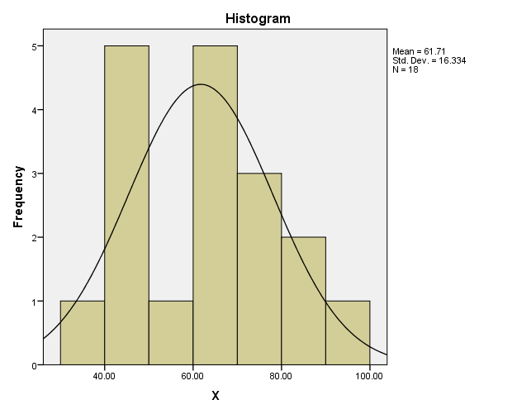

Reading Anxiety

|  |  |  |  |  |  |  |  |
| --- | --- | --- | --- | --- | --- | --- | --- |
| NO. | STUDENTS | THE RESULT OF STUDENTS' READING COMPREHENSION TEST | | | | | Category |
| The Main Idea (1-13) | Supporting Details (14-26) | Vocabulary (27-39) | Inference (40-50) | Score |
| 1. | Student 1 | 24 | 24 | 24 | 22 | 94 | Good to Excellent |
| 2. | Student 2 | 24 | 24 | 20 | 22 | 90 | Good to Excellent |
| 3. | Student 3 | 24 | 24 | 20 | 22 | 90 | Good to Excellent |
| 4. | Student 4 | 24 | 24 | 10 | 16 | 74 | Average to Good |
| 5. | Student 5 | 20 | 16 | 18 | 12 | 66 | Average to Good |
| 6. | Student 6 | 14 | 14 | 16 | 6 | 50 | Poor to Average |
| 7. | Student 7 | 6 | 14 | 14 | 14 | 48 | Poor |
| 8. | Student 8 | 10 | 12 | 14 | 8 | 44 | Poor |
| 9. | Student 9 | 6 | 14 | 14 | 10 | 44 | Poor |
| 10. | Student 10 | 8 | 10 | 10 | 4 | 32 | Poor |
| 11. | Student 11 | 8 | 8 | 6 | 8 | 30 | Poor |
| 12. | Student 12 | 4 | 14 | 6 | 6 | 30 | Poor |
| 13. | Student 13 | 12 | 6 | 8 | 4 | 30 | Poor |
| 14. | Student 14 | 10 | 8 | 8 | 2 | 28 | Poor |
| 15. | Student 15 | 4 | 10 | 2 | 10 | 26 | Poor |
| 16. | Student 16 | 8 | 4 | 10 | 2 | 24 | Poor |
| 17. | Student 17 | 0 | 6 | 8 | 4 | 18 | Poor |
| 18. | Student 18 | 6 | 4 | 4 | 2 | 16 | Poor |
|  |  | 212 | 236 | 212 | 174 |  |  |

|  |  |  |  |  |  |  |
| --- | --- | --- | --- | --- | --- | --- |
|  | Descriptive Statistics | | | | | |
| No. | Indicator | N | Minimum | Maximum | Mean | Std. Deviation |
|  | The Main Idea | 1 | 212.00 | 212.00 | 212.0000 | . |
|  | Supporting Details | 1 | 236.00 | 236.00 | 236.0000 | . |
|  | Vocabulary | 1 | 212.00 | 212.00 | 212.0000 | . |
|  | Inference | 1 | 174.00 | 174.00 | 174.0000 | . |
|  | Valid N (listwise) | 1 |  |  |  |  |

**ANALYSIS WITH SPSS**

|  |  |  |
| --- | --- | --- |
| **Statistics** | | |
| Reading Comprehension | | |
| N | Valid | 18 |
| Missing | 0 |
| Mean | | 46.3333 |
| Std. Error of Mean | | 6.06123 |
| Median | | 38.0000 |
| Mode | | 30.00 |
| Std. Deviation | | 25.71564 |
| Minimum | | 16.00 |
| Maximum | | 94.00 |
| Sum | | 834.00 |

|  |  |  |  |  |  |
| --- | --- | --- | --- | --- | --- |
| **Reading Comprehension** | | | | | |
|  | | Frequency | Percent | Valid Percent | Cumulative Percent |
| Valid | 16.00 | 1 | 5.6 | 5.6 | 5.6 |
| 18.00 | 1 | 5.6 | 5.6 | 11.1 |
| 24.00 | 1 | 5.6 | 5.6 | 16.7 |
| 26.00 | 1 | 5.6 | 5.6 | 22.2 |
| 28.00 | 1 | 5.6 | 5.6 | 27.8 |
| 30.00 | 3 | 16.7 | 16.7 | 44.4 |
| 32.00 | 1 | 5.6 | 5.6 | 50.0 |
| 44.00 | 2 | 11.1 | 11.1 | 61.1 |
| 48.00 | 1 | 5.6 | 5.6 | 66.7 |
| 50.00 | 1 | 5.6 | 5.6 | 72.2 |
| 66.00 | 1 | 5.6 | 5.6 | 77.8 |
| 74.00 | 1 | 5.6 | 5.6 | 83.3 |
| 90.00 | 2 | 11.1 | 11.1 | 94.4 |
| 94.00 | 1 | 5.6 | 5.6 | 100.0 |
| Total | 18 | 100.0 | 100.0 |  |

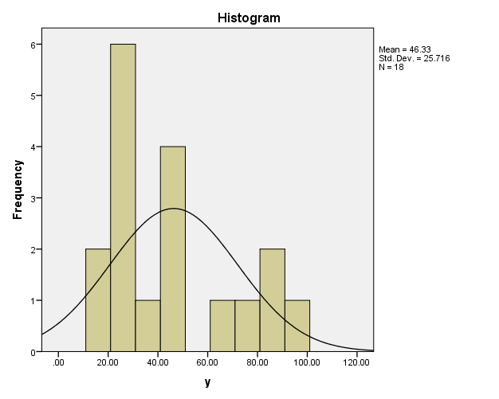

Reading Comprehension

|  |  |  |  |  |  |
| --- | --- | --- | --- | --- | --- |
| **THE CORRELATION BETWEEN READING ANXIETY**  **AND STUDENTS’ READING COMPREHENSION** | | | | | |
| **No.** | **X** | **Y** | **XY** | **X2** | **Y2** |
| 1. | 70.4 | 94 | 6.617 | 4.956 | 8.836 |
| 2. | 80.8 | 90 | 7.272 | 6.528 | 8.100 |
| 3. | 60 | 90 | 5.400 | 3.600 | 8.100 |
| 4. | 46.4 | 74 | 3.433 | 2.152 | 5.476 |
| 5. | 47.2 | 66 | 3.115 | 2.227 | 4.356 |
| 6. | 30.4 | 50 | 1.520 | 924.1 | 2.500 |
| 7. | 62.4 | 48 | 2.995 | 3.893 | 2.304 |
| 8. | 47.2 | 44 | 2.076 | 2.227 | 1.936 |
| 9. | 40 | 44 | 1.760 | 1.600 | 1.936 |
| 10. | 63.2 | 32 | 2.022 | 3.994 | 1.024 |
| 11. | 85.6 | 30 | 2.568 | 7.327 | 900 |
| 12. | 76 | 30 | 2.280 | 5.776 | 900 |
| 13. | 71.2 | 30 | 2.136 | 5.069 | 900 |
| 14. | 49.6 | 28 | 1.388 | 2.460 | 784 |
| 15. | 63.2 | 26 | 1.643 | 3.994 | 676 |
| 16. | 92 | 24 | 2.208 | 8.464 | 576 |
| 17. | 57.6 | 18 | 1.036 | 3.317 | 324 |
| 18. | 67.6 | 16 | 1.081 | 4.569 | 256 |
|  | **∑X = 1.110** | **∑Y = 834** | **∑XY = 50.550** | **∑X2 = 73.077** | **∑Y2 = 49.884** |

**THE PEARSON PRODUCT MOMENT FORMULA**

$$rxy=\frac{N.\left(\sum{XY}\right)-\left(\sum{X}\right) \left(\sum{Y}\right)}{\sqrt{\left[N.\sum{X^{2}-{\left(\sum{X}\right)}^{2}}\right]\left[N.\sum{Y^{2}-{\left(\sum{Y}\right)}^{2}}\right]}}$$

$$rxy=\frac{18.\left(50.550\right)-\left(1.110\right) \left(834\right)}{\sqrt{\left[18. 73.077 -{\left(1.110\right)}^{2}\right]\left[18. 49.884-{\left(834\right)}^{2}\right]}}$$

$$rxy=\frac{\left(909.900\right)-\left(925.740\right)}{\sqrt{\left[1.315.368 -1.232.100\right]\left[897.912-695.556\right]}}$$

$$rxy=\frac{\left(-15.840\right)}{\sqrt{\left[83.268\right]\left[202.356\right]}}$$

$$rxy=\frac{\left(-15.840\right)}{\sqrt{\left[16.849\right]}}$$

$$rxy=\frac{\left(-15.840\right)}{129.803}$$

$$rxy= -0.12$$

**INTERPRETATION OF CORRELATION COEFFICIENT**

|  |  |
| --- | --- |
| **Coefficient Interval** | **Level of Relationship** |
| 0.00 – 0.199 | Very Low |
| 0.20 – 0.399 | Low |
| 0.40 – 0.599 | Medium |
| 0.60 – 0.799 | Strong |
| 0.80 – 1.000 | Very Strong |

Reference; Sugiyono (2017:228) in Sanny (2020)

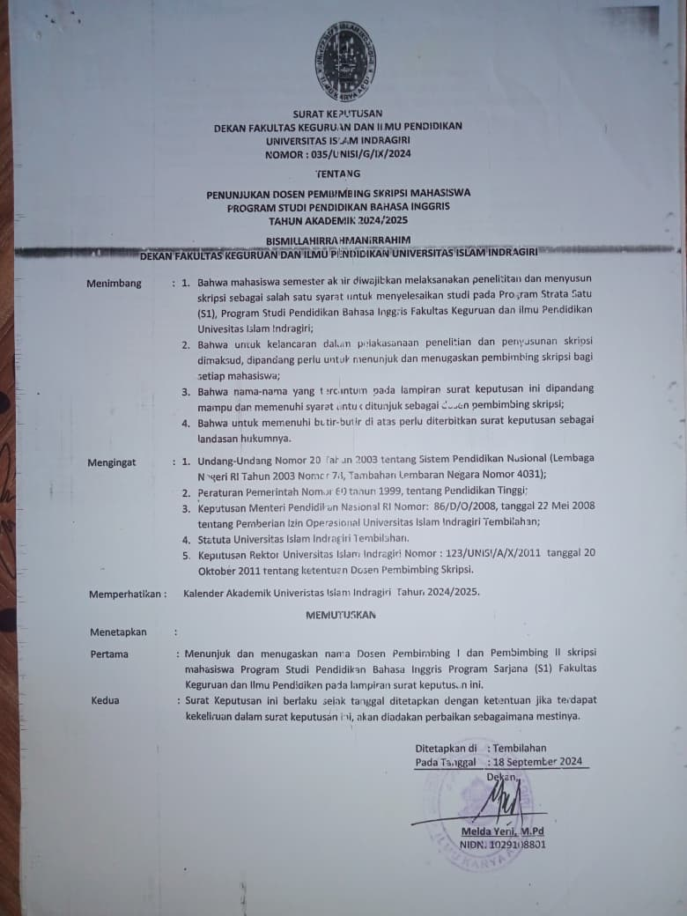

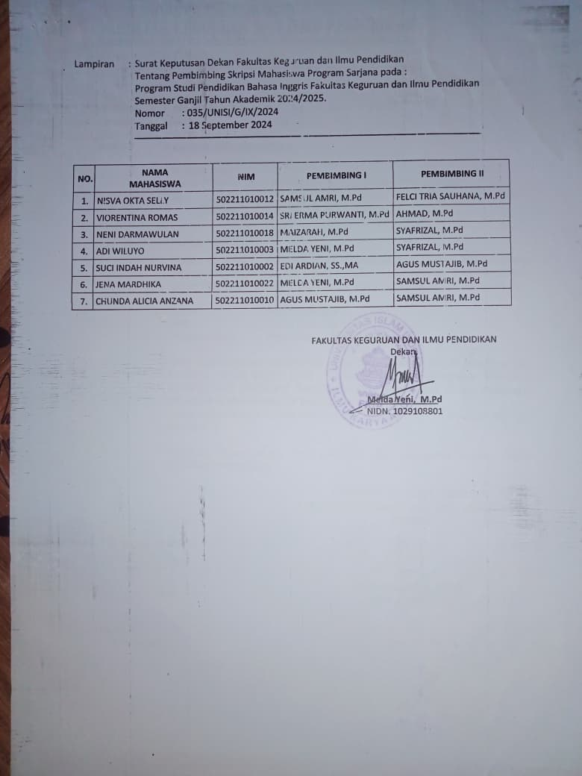

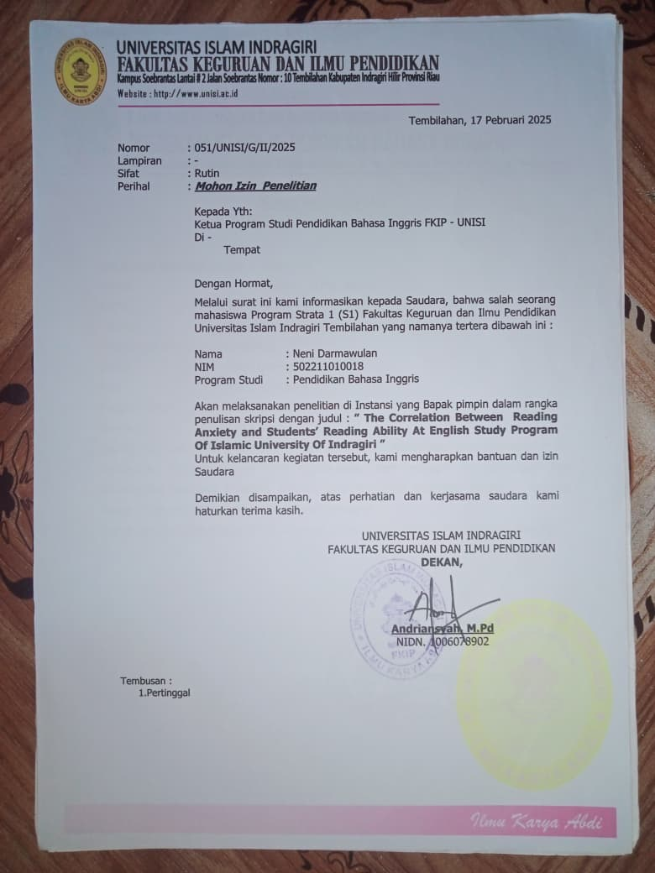

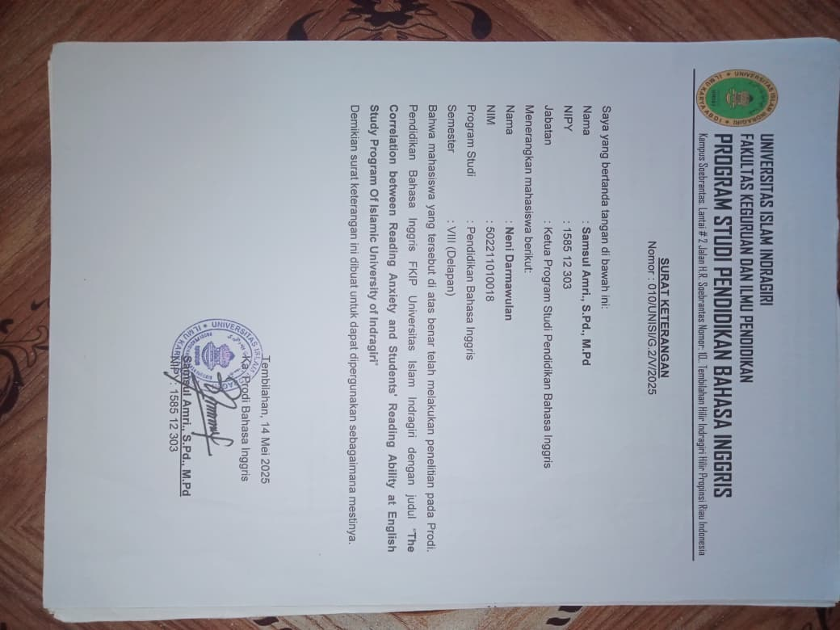

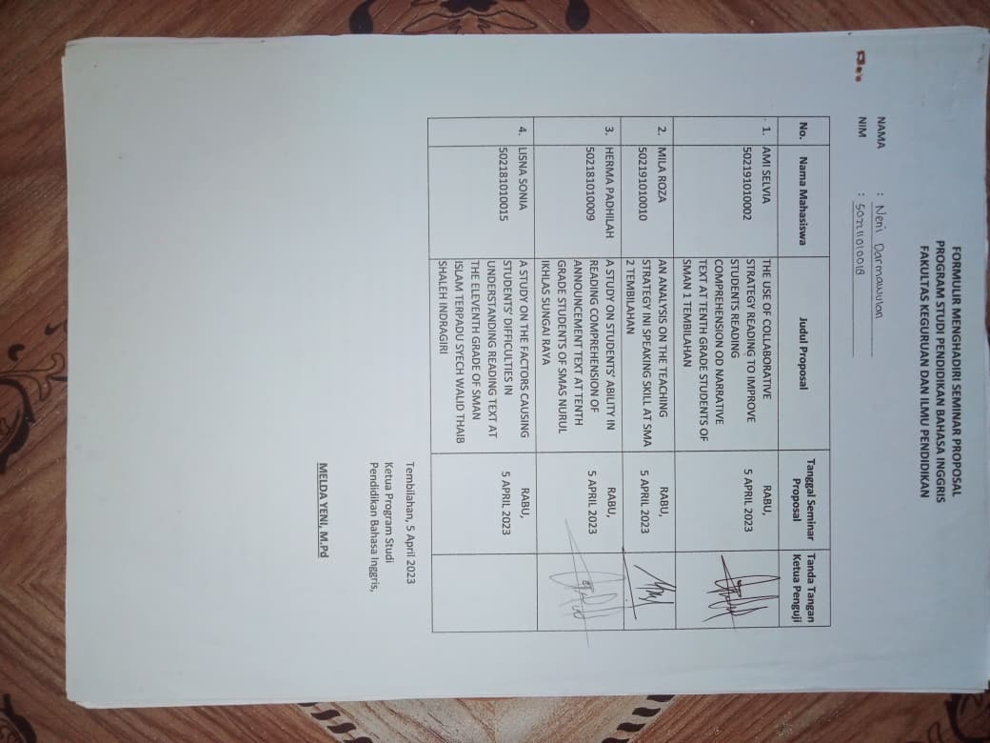

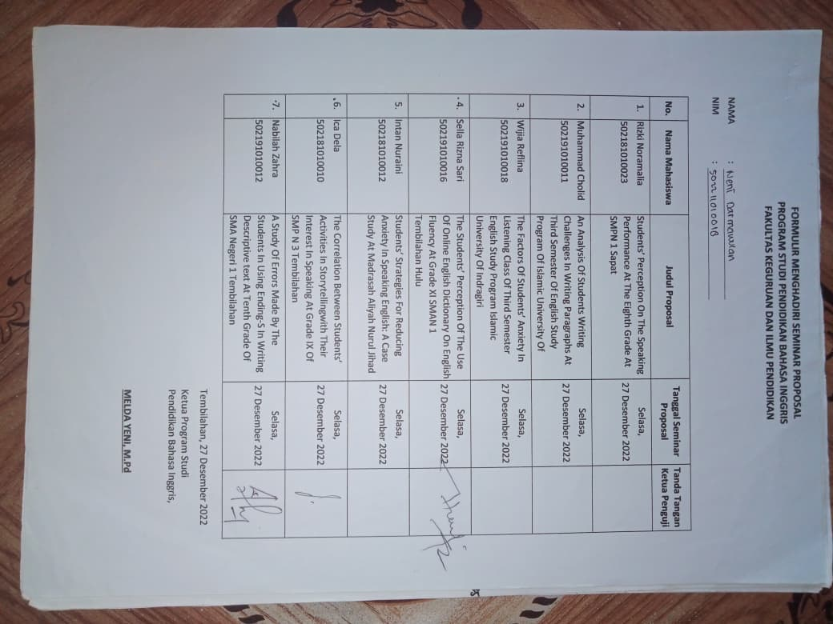

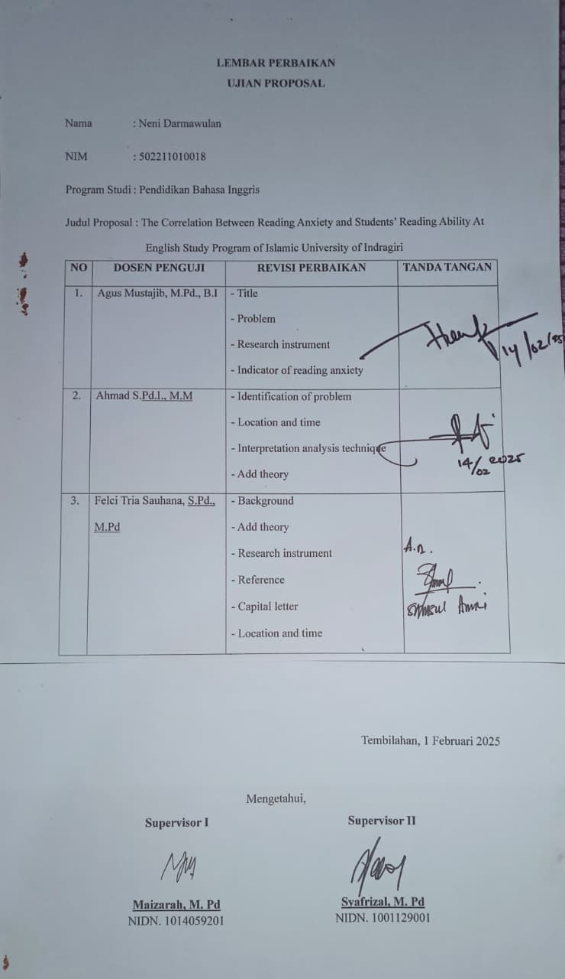

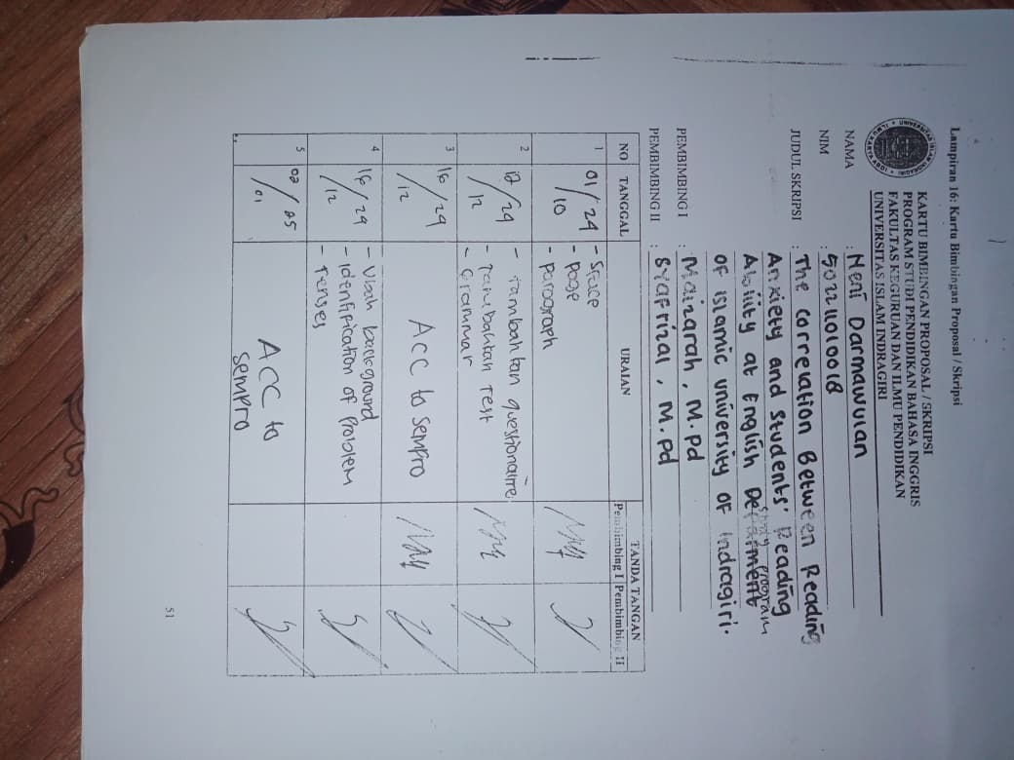

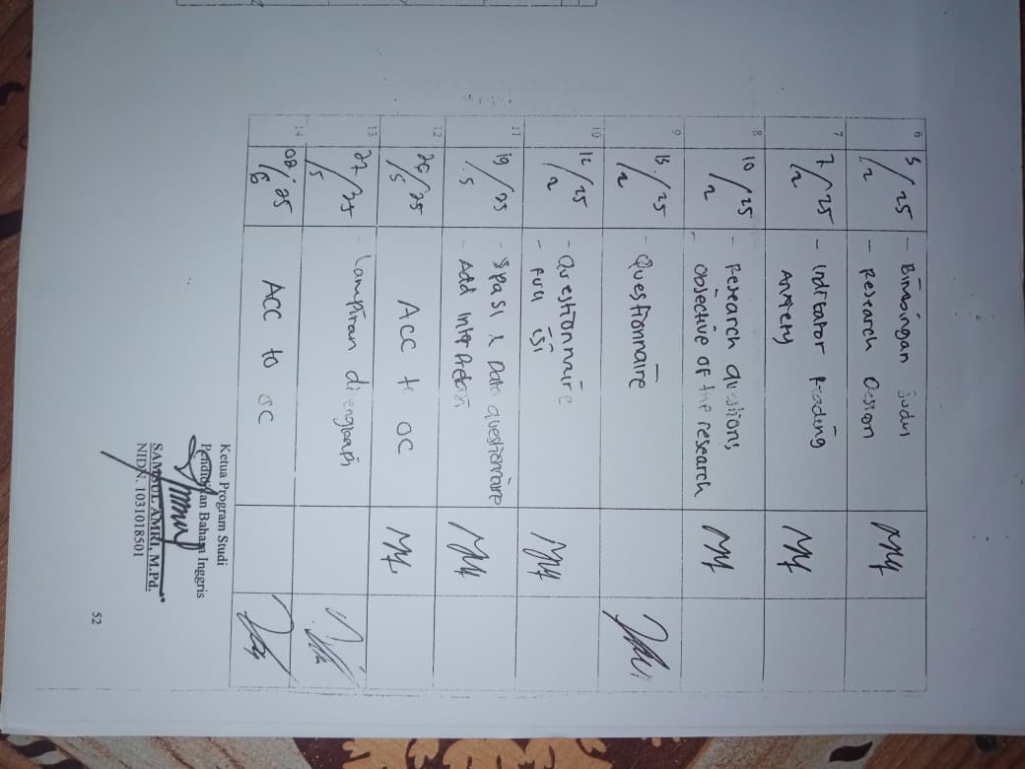

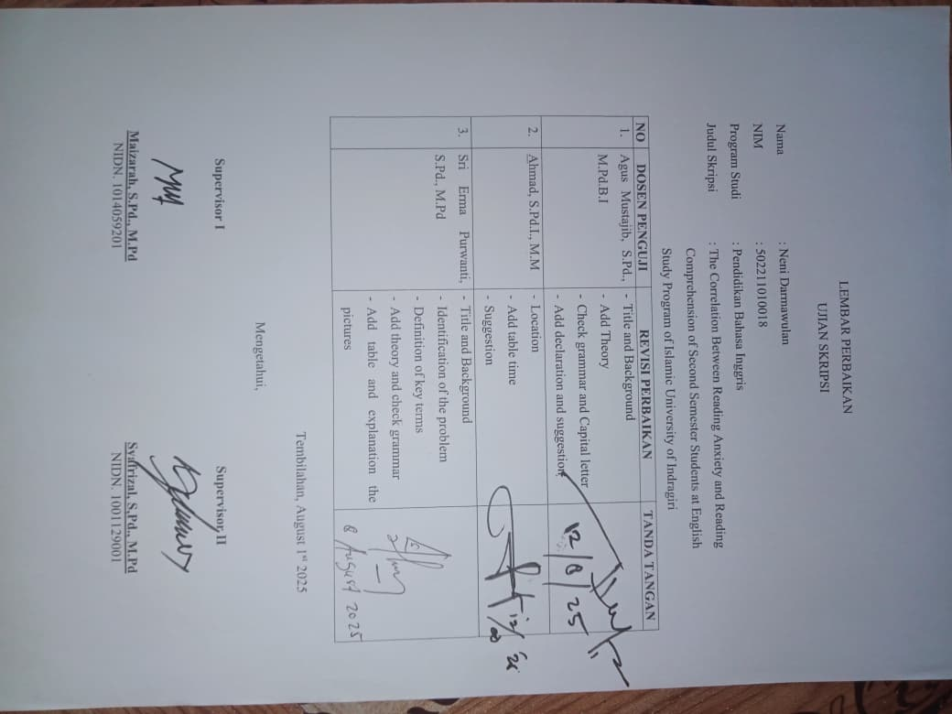

**Documentation**

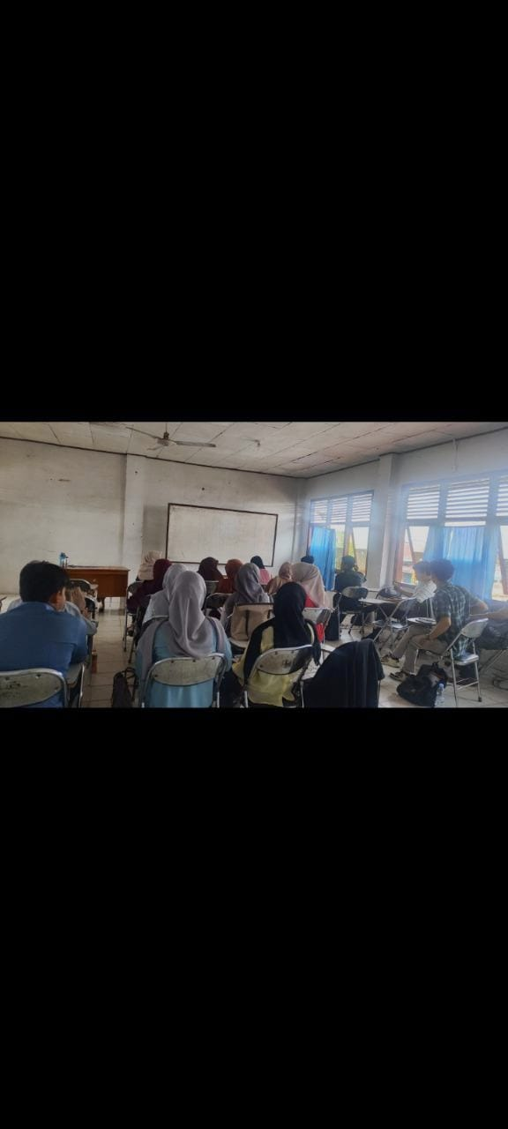

**Picture 1. The participants responding the questionnaire**

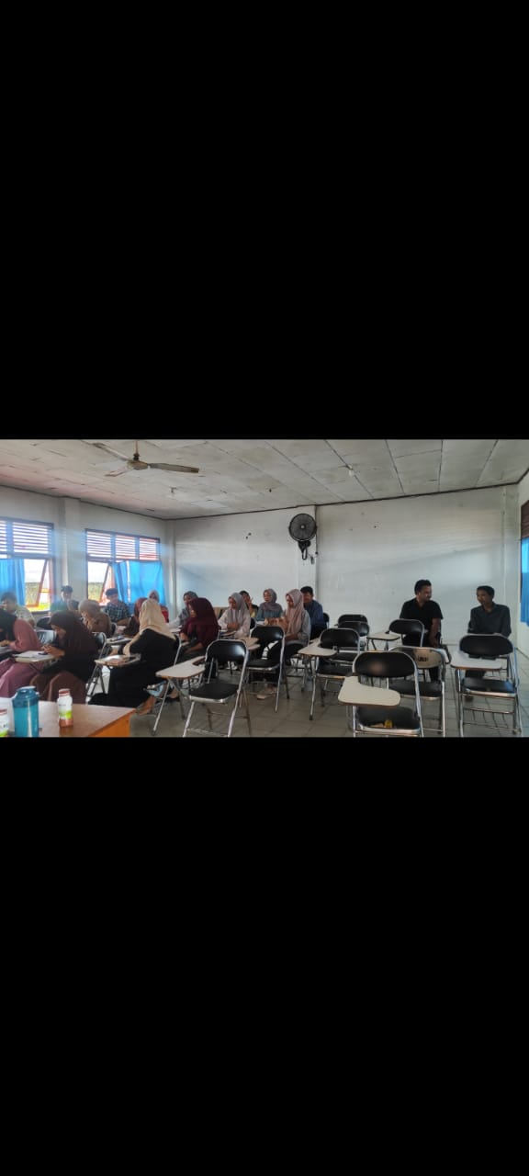

**Picture 2. The participants were taking reading test**

|  |  |  |  |  |  |  |
| --- | --- | --- | --- | --- | --- | --- |
| unisi | **UNIVERSITAS ISLAM INDRAGIRI**  **FAKULTAS KEGURUAN DAN ILMU PENDIDIKAN**  **PROGRAM STUDI PENDIDIKAN BAHASA INGGRIS** | | | | | |
| **RENCANA PEMBELAJARAN SEMESTER** | | | | | | |
| **MATA KULIAH (MK)** | **KODE** | | **RUMPUN MK** | **BOBOT SKS** | | **SEMESTER** |
| **Intermediate Reading** | **(PBI22 2012)** | |  | **2** | | **II** |
| **PENGESAHAN** | **DOSEN PENGAMPU** | | | **KOORDINATOR**  **(jika ada)** | | **Ka. PRODI** |
|  | Maizarah, M.Pd | | |  | | Samsul Amri, M.Pd |
| **Capaian Pembelajaran** | **CPL-Prodi (Capaian Pembelajaran Lulusan Program Studi)** | | | | | |
| **Sikap** | CP-S1. Bertakwa kepada Tuhan Yang Maha Esa dan mampu menunjukkan sikap religius;  CP-S2. Menjunjung tinggi nilai kemanusiaan dalam menjalankan tugas berdasarkan  agama,moral, dan etika;  CP-S3. Berkontribusi dalam peningkatan mutu kehidupan bermasyarakat, berbangsa, bernegara, dan kemajuan peradaban berdasarkan Pancasila;  CP-S8. Menginternalisasi nilai, norma, dan etika akademik;  CP-S9. Menunjukkan sikap bertanggungjawab atas pekerjaan di bidang keahliannya secara mandiri. | | | | |
| **PENGUASAAN PENGETAHUAN** | CP-PU3. Menguasai konsep teoritis tentang tata Bahasa, budaya dan model pembelajaran bahasa  dalam bidang bahasa Inggris;  CP-PU4. Menguasai strategi dan teknik tertentu untuk memahami informasi tertulis maupun lisan dalam berbagai konteks. | | | | |
| **KEMAMPUANBIDANG UMUM** | CP-KU1. Mampu menerapkan pemikiran logis, kritis, sistematis, dan inovatif dalam konteks pengembangan atau implementasi ilmu pengetahuan dan teknologi yang memperhatikan dan menerapkan nilai humaniora yang sesuai dengan bidang keahliannya.  CP-KU2. Mampu menunjukkan kinerja mandiri, bermutu, dan terukur; | | | | |
| **KEMAMPUANBIDANG KHUSUS** | CP-KK1. Mampu berbahasa Inggris secara lisan maupun tulisan dengan baik dan benar sebagai calon pendidik bahasa Inggris dan memiliki nilai skor Test of English as a Foreign Language (TOEFL) minimal 450.  CP-KK4. Mampu memanfaatkan IPTEKS untuk mengembangkan proses pembelajaran pada bidang Pendidikan Bahasa inggris. | | | | |
|  |  | **CPMK (Capaian Pembelajaran Mata Kuliah)** | | | | |
|  | **CPMK Umum** | Mahasiswa memahami The Concepts of Reading, Reading Strategies, Paragraph, Texts, Reading Phases, dan Text Genre. | | | | |
|  | **CPMK Khusus** | Mahasiswa diharapkan dapat mengenal dan mengerti serta dapat mengaplikasikan reading strategy, mampu membaca sesuai degan reading phases, mampu membaca dan menganalisis paragraph dan texts, mampu juga mengenal jenis texts, kemudian mampu memahami teks / artikel bahasa Inggris dengan baik dan kontekstual. | | | | |
| **Deskripsi Singkat MK** | Mata kuliah Intermediate Reading ini merupakan lanjutan dari mata kuliah Basic Reading yang didistribusikan pada semester I. Dalam mata kuliah ini akan dibahas tentang ***strategi membaca*** yang lebih komplit yang dapat digunakan mahasiswa untuk kegiatan membaca yang dilakukannya. Kemudian akan disampaikan juga ***pase (reading phase)*** yang dilalui pembaca dan strategi – strategi membaca yang dapat digunakan dalam melakukan kegiatan membaca. Selain itu juga akan dibahas ***komponen paragraf dan teks*** dengan lebih lengkap sehingga mahasiswa mampu menganalisa paragraf maupun teks berbahasa Inggris dengan baik, kemudian dapat memahami teks berbahasa Inggris dengan baik dan kontekstual. Selain dari materi tersebut di atas mahasiswa juga diberikan materi berupa jenis teks dengan materi ***Text Genre.*** Kemudian diberikan kajian artikel berbahasa Inggris.  Selain itu mahasiswa akan diberikan latihan-latihan pembahasan teks untuk membiasakan mahasiswa dalam menganalisa dan memahami teks, sehingga ketika mahasiswa selesai mengikuti perkuliahan ini dapat memahamai teks dengan lebih komplit. | | | | | |
| **Bahan Kajian:**  **Materi Pembelajaran** | 1. Descriptive Text 2. Procedure Text 3. Recount Text 4. Report Text 5. Narrative Text 6. Expository Text | | | | 1. Hortatory Exposition 2. Analytical Exposition 3. Argumentative Text 4. Expository Text 5. Spoof Text 6. Anecdote Text | |
| **Pustaka Utama** | 1. Bean, T.W., Readence, J.E., & Baldwin, R.S. (2011). Content area literacy: An integrated approach, (10th ed.). Dubuque, Iowa:  Kendall/Hunt. 2. Klingner J. & Vaughn S. (1999). Promoting reading comprehension, content learning, and English acquisition through collaborative strategic reading (CSR). The Reading Teacher, 52. No. 7 3. Rapoport Judy, et. al., 2010. *Reading Academic English,*  The Mofet Institute 4. [Reading Comprehension Fix-Up Skills: A Classroom Toolkit](http://www.interventioncentral.org/academic-interventions/reading-comprehension/reading-comprehension-fix-skills-classroom-toolkit). (n.d.). Retrieved on April 15, 2015. 5. Wahidi, Rachmat. 2009. *Genre of the text*. Property of Umbrella Corporation. 6. <https://educhannel.id/blog/artikel/reading-and-comprehension.html> 7. <https://wts.indiana.edu/writing-guides/paragraphs-and-topic-sentences.html> | | | | | |

|  |  |  |  |  |  |  |  |  |
| --- | --- | --- | --- | --- | --- | --- | --- | --- |
| **Minggu ke-** | **Capaian Pembelajaran Mingguan** | **Materi Pembelajaran** | **Metode/ Strategi Pembelajaran** | **Aktifitas Pembelajaran/**  **Pengalaman Mahasiswa** | **Sumber Belajar/**  **Bahan Ajar** | **Penilaian** | | |
| **Indikator Penilaian** | **Bentuk Penilaian** | **Bobot** |
| 1 | Mahasiswa mengetahui tujuan pembelajaran | Class Orientation | Lecturing  Discussion | Regulation  Course Orientation | RPS | Kehadiran | - | 2,5% |
| 2-7 | Mahasiswa mengetahui dan memahami berbagi genre teks dalam bahasa inggris | Using some types of texts for effective reading | Lecturing  Discussion | Descriptive TextProcedure TextRecount Text  1. Report Text 2. Narrative Text 3. Expository Text  Analytical Exposition | Modul Pembelajaran, paper | Kemampuan memahami dan mejelaskan genre teks | Group Presentation  Multiple choice  Essay | 2,5% |
| 8 |  | **UTS** |  |  |  |  | Multiple choice  Essay | 30% |
| 9-14 | Mahasiswa mengetahui dan memahami berbagai genre teks dalam bahasa inggris | Using some types of texts for effective reading | Lecturing  Discussion | Hortatory ExpositionArgumentative TextExpository TextSpoof TextAnecdote Text | Modul Pembelajaran, paper | Kemampuan memahami dan mejelaskan genre teks | Group Presentation  Multiple choice  Essay | 2,5% |
| 15 | Mahasiswa mampu menjawab soal reading comprehension dengan cepat dan tepat | Reading Comprehension using some types of texts | Lecturing | Test of reading comprehension | Modul Pembelajaran | Kemampuan menjawab soal reading comprehension | Multiple Choice | 2,5% |
| 16 |  | **UAS** |  |  |  |  | Multiple Choice | 35% |

**Komponen Penilaian**

|  |  |  |
| --- | --- | --- |
| **No** | **Scoring Component** | **Bobot** |
| 1 | Attendance & Performance | 10% |
| 2 | Task (Structural & Individual) | 25% |
| 3 | Mid Test | 30% |
| 4 | Final Test | 35% |
| **Total** | | 100% |

**Rentang Nilai**

|  |  |  |
| --- | --- | --- |
| **NO.** | **Rentang Nilai** | |
| **Angka** | **Huruf** |
| 1. | 90-100 | A |
| 2. | 85-89,9 | A- |
| 3. | 80-84,9 | B+ |
| 4. | 75-79,9 | B |
| 5. | 70-74,9 | B- |
| 6. | 65-69,9 | C+ |
| 7. | 60-64,9 | C |
| 8. | 55-59,9 | C- |
| 9. | 50-54,9 | D |
| 10. | 0-49,9 | E |

# SILABUS

1. **Deskripsi mata kuliah**

Mata kuliah Intermediate Reading ini merupakan lanjutan dari mata kuliah Basic Reading yang didistribusikan pada semester I. Dalam mata kuliah ini akan dibahas tentang ***strategi membaca*** yang lebih komplit yang dapat digunakan mahasiswa untuk kegiatan membaca yang dilakukannya. Kemudian akan disampaikan juga ***pase (reading phase)*** yang dilalui pembaca dan strategi-strategi membaca yang dapat digunakan dalam melakukan kegiatan membaca. Selain itu juga akan dibahas ***komponen paragraf dan teks*** dengan lebih lengkap sehingga mahasiswa mampu menganalisa paragraf maupun teks berbahasa Inggris dengan baik, kemudian dapat memahami teks berbahasa Inggris dengan baik dan kontekstual. Selain dari materi tersebut di atas mahasiswa juga diberikan materi berupa jenis teks dengan materi ***Text Genre.*** Kemudian diberikan kajian artikel berbahasa Inggris.

Selain itu mahasiswa akan diberikan latihan-latihan pembahasan teks untuk membiasakan mahasiswa dalam menganalisa dan memahami teks, sehingga ketika mahasiswa selesai mengikuti perkuliahan ini dapat memahamai teks dengan lebih komplit.

# Identitias mata kuliah

Nama Mata Kuliah : Reading 2

Kode : PBI22 2012

Jumlah SKS : 2 SKS

Semester : II

Jurusan : Pendidikan Bahasa Inggris

Status Mata Kuliah : Mata Kuliah Wajib

Dosen : Maizarah, M. Pd

# Tujuan Mata kuliah

Tujuan dari mata kuliah ini adalah mahasiswa diharapkan dapat mengenal dan mengerti serta dapat mengaplikasikan reading strategy, mampu membaca sesuai degan reading phases, mampu membaca dan menganalisis paragraph dan texts, mampu juga mengenal jenis texts, kemudian mampu memahami teks / artikel bahasa Inggris dengan baik dan kontekstual.

# Pendekatan dalam Pembelajaran

Ekspositori dan Inquiri

Metode : Ceramah, Tanya jawab dan diskusi kelas

Tugas : Mendiskusikan materi, membaca teks, melaporkan bacaan

Media : Video, buku pelajaran, laptop.

# Evaluasi Hasil Belajar

Keberhasilan mahasiswa dalam perkuliahan ini ditentukan oleh prestasi yang bersangkutan dalam:

* 1. Kehadiran
  2. Aktivitas di kelas
  3. UTS
  4. UAS
  5. Tugas Perkuliahan

# Rincian Materi Perkuliahan Tiap Pertemuan

|  |  |
| --- | --- |
| Pertemuan 1 | Class Orientation |
| Pertemuan 2-7 | Using some types of texts for effective reading |
| Pertemuan 8 | **UTS** |
| Pertemuan 9-14 | Using some types of texts for effective reading |
| Pertemuan 15 | Review all types of text |
| Pertemuan 16 | **UAS** |

**Daftar pustaka**

1. Bean, T.W., Readence, J.E., & Baldwin, R.S. (2011). Content area literacy: An integrated approach, (10th ed.). Dubuque, Iowa:  Kendall/Hunt.
2. Klingner J. & Vaughn S. (1999). Promoting reading comprehension, content learning, and English acquisition through collaborative strategic reading (CSR). The Reading Teacher, 52. No. 7
3. Rapoport Judy, et. al., 2010. *Reading Academic English,*  The Mofet Institute
4. [Reading Comprehension Fix-Up Skills: A Classroom Toolkit](http://www.interventioncentral.org/academic-interventions/reading-comprehension/reading-comprehension-fix-skills-classroom-toolkit). (n.d.). Retrieved on April 15, 2015.
5. Wahidi, Rachmat. 2009. *Genre of the text*. Property of Umbrella Corporation.
6. <https://educhannel.id/blog/artikel/reading-and-comprehension.html>

<https://wts.indiana.edu/writing-guides/paragraphs-and-topic-sentences.html>

**RESEARCH BIOGRAPHY**

Nama Lengap : Neni Darmawulan

Tempat/Tanggal Lahir : Sungai Akar, 25 December 2002

Program Studi : Pendidikan Bahasa Inggris

Konsentrasi : Pendidikan Bahasa Inggris

Pekerjaan : Mahasiswa

**Education**

(2008 - 2014) SD : SDN 017 Sencalang

(2014 - 2017) SLTP : SMPN 06 Keritang

(2017 - 2020) SLTA : SMKS Pengalihan Keritang

(2021 - 2025) S1 : Unive rsitas Islam Indragiri