**APPENDIX I**

**Questionaire For the Students**

**Instructions**

1. **This Questionaire contains 3 questions**

(Angket ini berisi 3 pertanyaan)

1. **Please select one of the titles below and then create a text procedure one of the using the topic you selected**

(Pilihlah salah satu topic dibawah ini kemudian buatlah prosedur teks menggunakan salah satu topik yang telah di pilih)

**1. How to make apple pudding**

**2. How to make iced fruid**

**3. How to cook rice**

**APPENDIX II**

**Name :**

**Class :**

**Questionaire For the Students**

**Instructions**

1. **This Questionaire contains 18 Statements**

***(Angket ini berisi 18 pernyataan)***

1. **Match the statements with the answer option that has been available in several categories. *(Cocokkan pernyataan dengan pilihan jawaban yang telah disediakan dalam beberapa kategori)***

**SA = Strongly Agree**

**A = Agree**

**N = Neutral**

**D = Disagree**

**SD = Strongly Disagree**

**SS = Sangat setuju**

**S = Setuju**

**N = Netral**

**TS = Tidak setuju**

**STS = Sangat tidak setuju**

1. **Answer based on your ownbeliefs *(Jawablah dengan keyakinan anda sendiri)***
2. **Thank you so much for your willingnessto fill this questionnaire *(Terima kasih atas kesediaannya mengisi angket ini)***

|  |  |  |  |  |  |  |
| --- | --- | --- | --- | --- | --- | --- |
| **NO** | **STATEMENTS** | **SA** | **A** | **N** | **D** | **SD** |
|  | I concentrate when learning English on the ability to write procedure texts*.(Saya berkonsentrasi saat belajar bahasa inggris pada kemampuan menulis teks prosedur)* |  |  |  |  |  |
|  | I can't concentrate when studying English on the ability to write procedure texts . *(Saya tidak bisa berkonsentrasi saat belajar bahasa inggris pada kemampuan menulis teks prosedur)* |  |  |  |  |  |
|  | I am always enthusiastic about learning English because I am very curious about text procedures. *(Saya selalu semangat belajar bahasa inggris karena saya sangat ingin tahu tentang prosedur teks)* |  |  |  |  |  |
|  | I am not enthusiastic about learning English because I am not curious about text procedures.  *(Saya tidak semangat belajar bahasa inggris karena saya tidak ingin tahu tentang prosedur teks)* |  |  |  |  |  |
|  | I am enthusiastic about learning English about procedure texts with my friends in class. *(saya semangat belajar bahasa inggris tentang procedure text bersama sama teman dikelas)* |  |  |  |  |  |
|  | Writing procedure text is a necessity in learning English because it is very important. *(Menulis teks prosedur merupakan kebutuhan pada pembelajaran bahasa inggris)* |  |  |  |  |  |
|  | I nee tolearn procedure text to train my learning skill in learning English *(Saya membutuhkan belajar prosedur teks untuk melatih kemampuan belajar saya pada pembelajaran bahasa inggris)* |  |  |  |  |  |
|  | I am not need to learn procedure text on my skill study (*Saya tidak membutuhkan belajar procedure text pada kemampuan belajar saya)* |  |  |  |  |  |
|  | I like writing procedure texts if my parents support me in doing my homework at home*. (Saya suka menulis teks prosedur jika orang tua saya mendukung saya mengerjakan PR dirumah)* |  |  |  |  |  |
|  | I don't like writing procedure texts if my parents don't support me when doing my homework at home, this makes me bored. *(Saya tidak suka menulis teks prosedur jika orang tua saya tidak mendukung saat mengerjakan PR dirumah, hal ini membuat saya bosan)* |  |  |  |  |  |
|  | I would be interested in writing procedure texts if my parents give me encouragement at home. *(Saya akan tertarik menulis teks prosedur*  *jika orang tua saya memberi semangat dirumah)* |  |  |  |  |  |
|  | I would be more interested in writing procedure text if the teacher was friendly to the students. (saya akan lebih tertarik menulis teks prosedur jika guru nya ramah kepada siswa.) |  |  |  |  |  |
|  | I would be more interested in writing procedure texts if the teacher was friendly to the students. *(Saya akan lebih tertarik menulis teks prosedur jika guru nya ramah kepada siswa).* |  |  |  |  |  |
|  | I would be more interested in writing procedure texts if the learning material was good and not boring. *(Saya akan lebih tertarik menulis teks prosedur jika materi pembelajaran nya baik dan tidak membosankan)* |  |  |  |  |  |
|  | I will find it easy to write procedure texts if the teaching methods used are varied*. (saya akan mudah menulis teks prosedur jika metode pengajaran yang digunakan bervariasi)* |  |  |  |  |  |
|  | Having a good social environment will be fun when writing procedure texts. *(Mempunyai lingkungan masyarakat yang baik akan menyenangkan ketika menulis teks prosedur)* |  |  |  |  |  |
|  | Having social friends will be fun when writing procedure texts at school. *(Mempunyai teman yang gaul akan menyenangkan ketika menulis teks prosedur di sekolah.* |  |  |  |  |  |
|  | Writing procedural text will be more fun if you do it with fun friends. ( Menulis teks posedur akan lebih menyenangkan jika bersama teman yang asik). |  |  |  |  |  |

**Appendix lll r table**

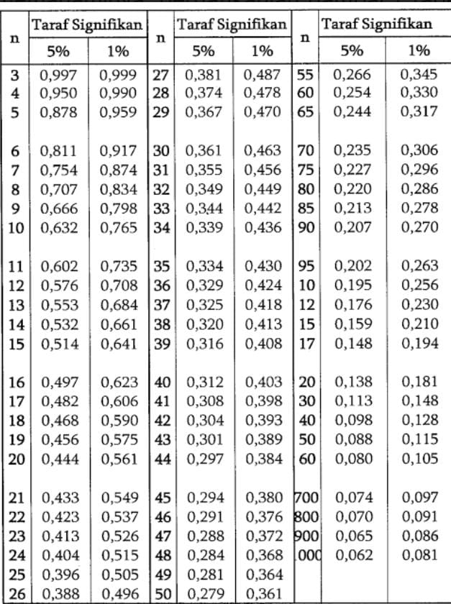

**Appendix lV Do the research in class IX A,B,C,D 16 Mei 2025**

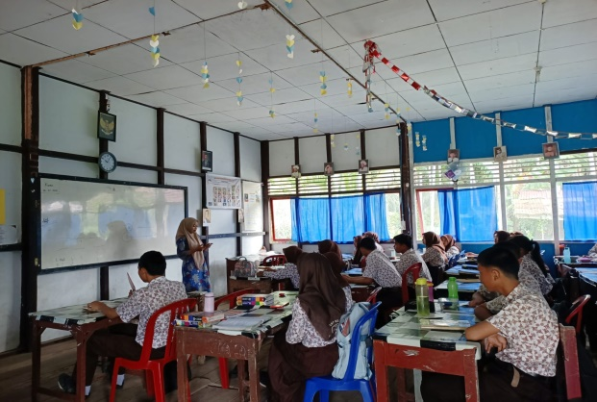



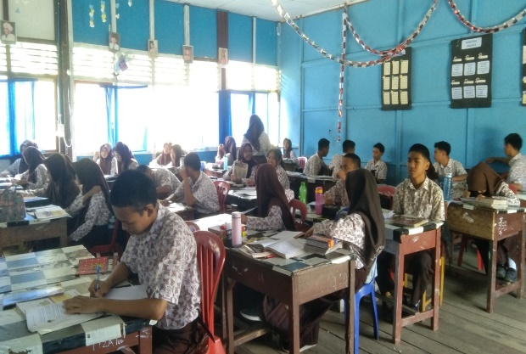

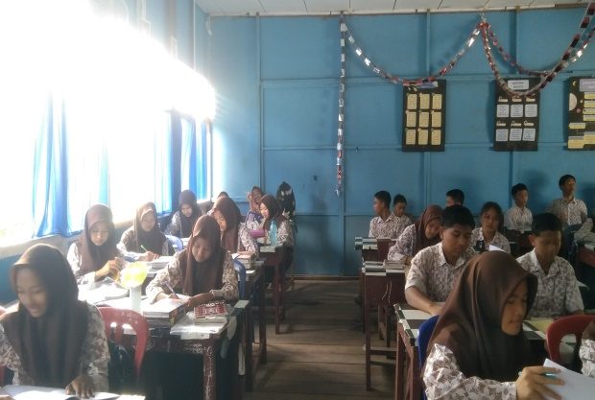

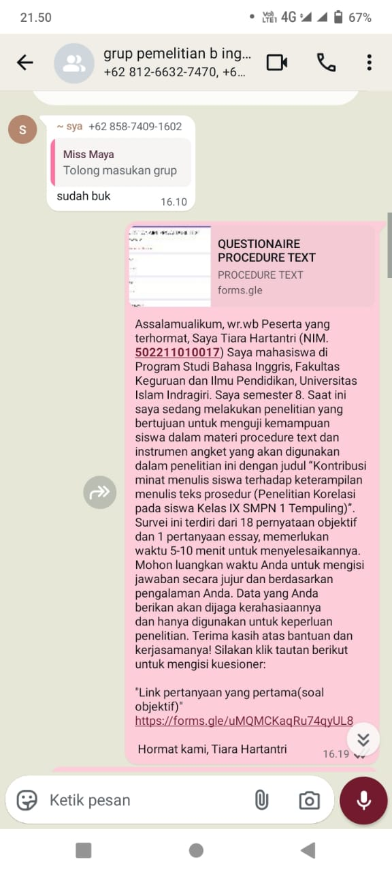

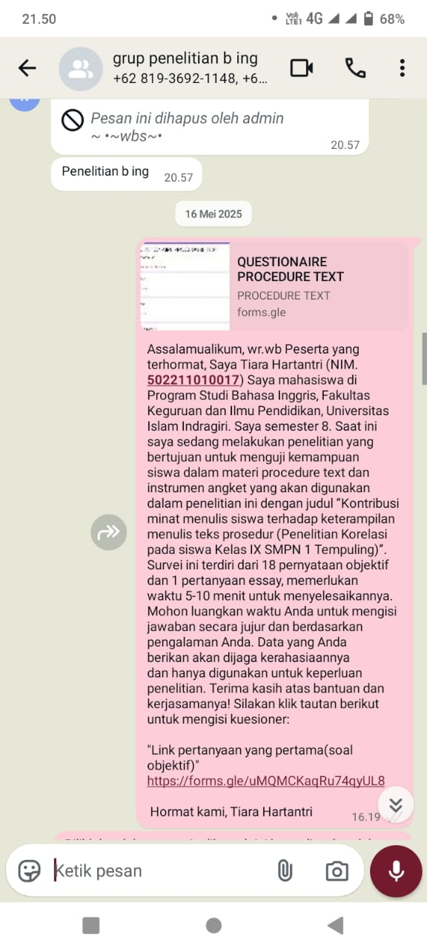

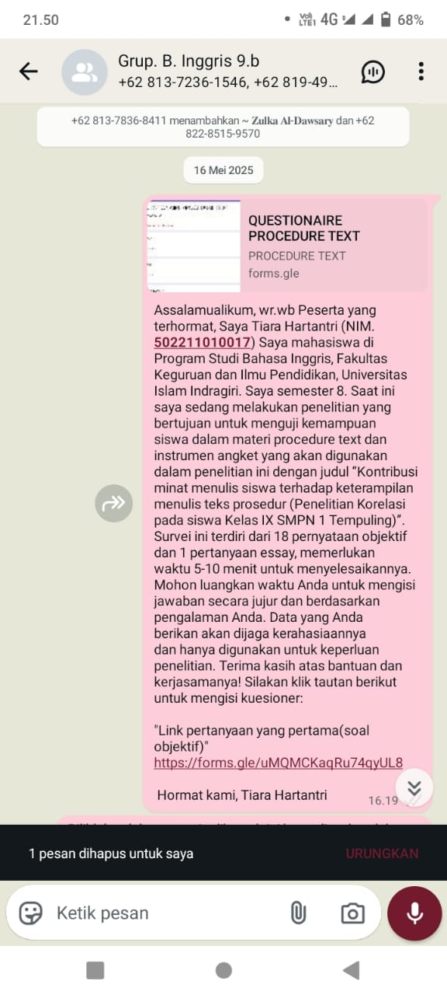

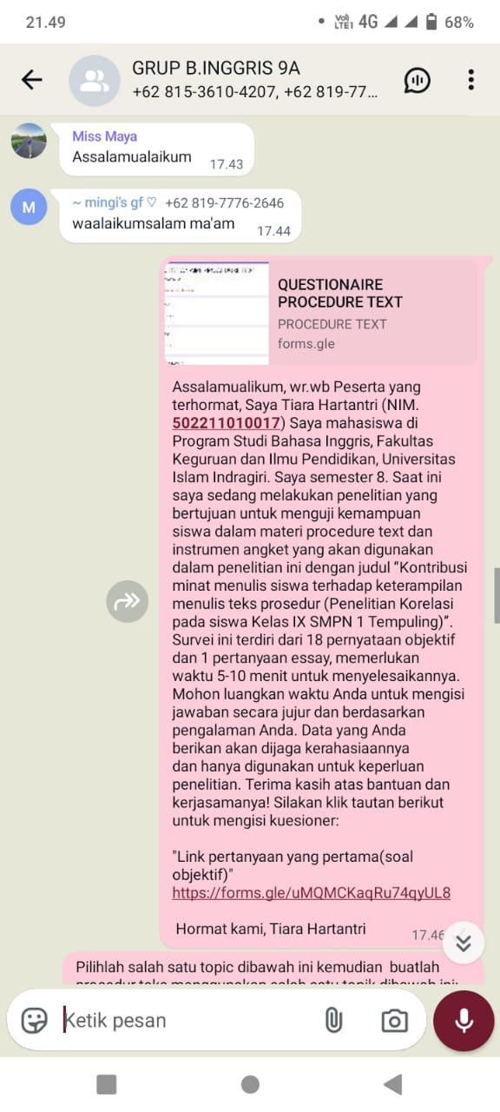

**Appendix V Pictures ACC to join seminar on proposal, ACC to join Oral Comprehensive and ACC to be an Article**

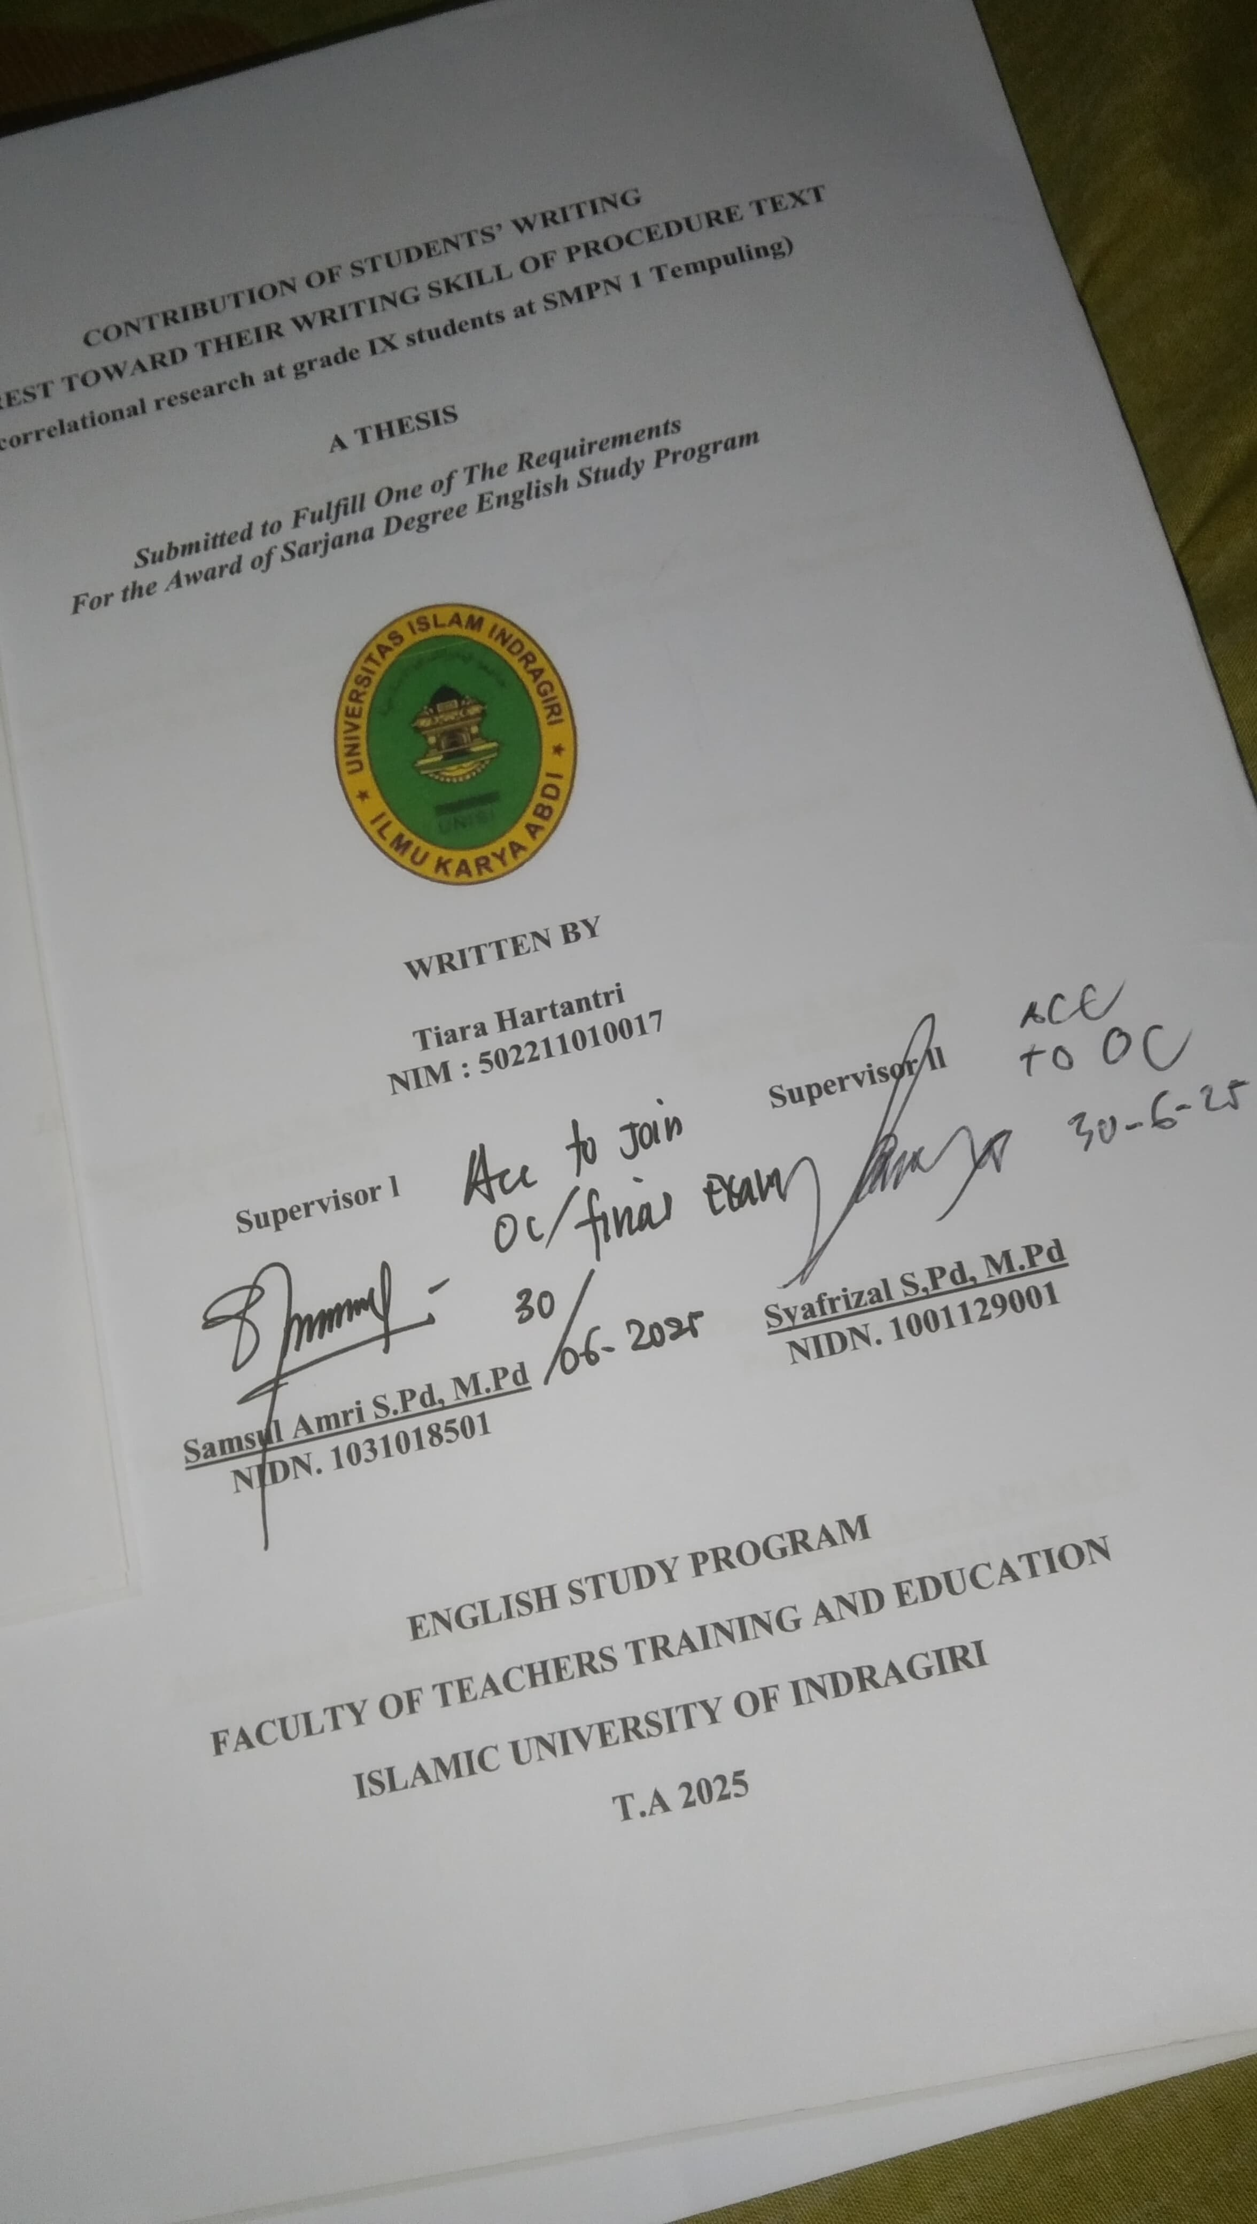

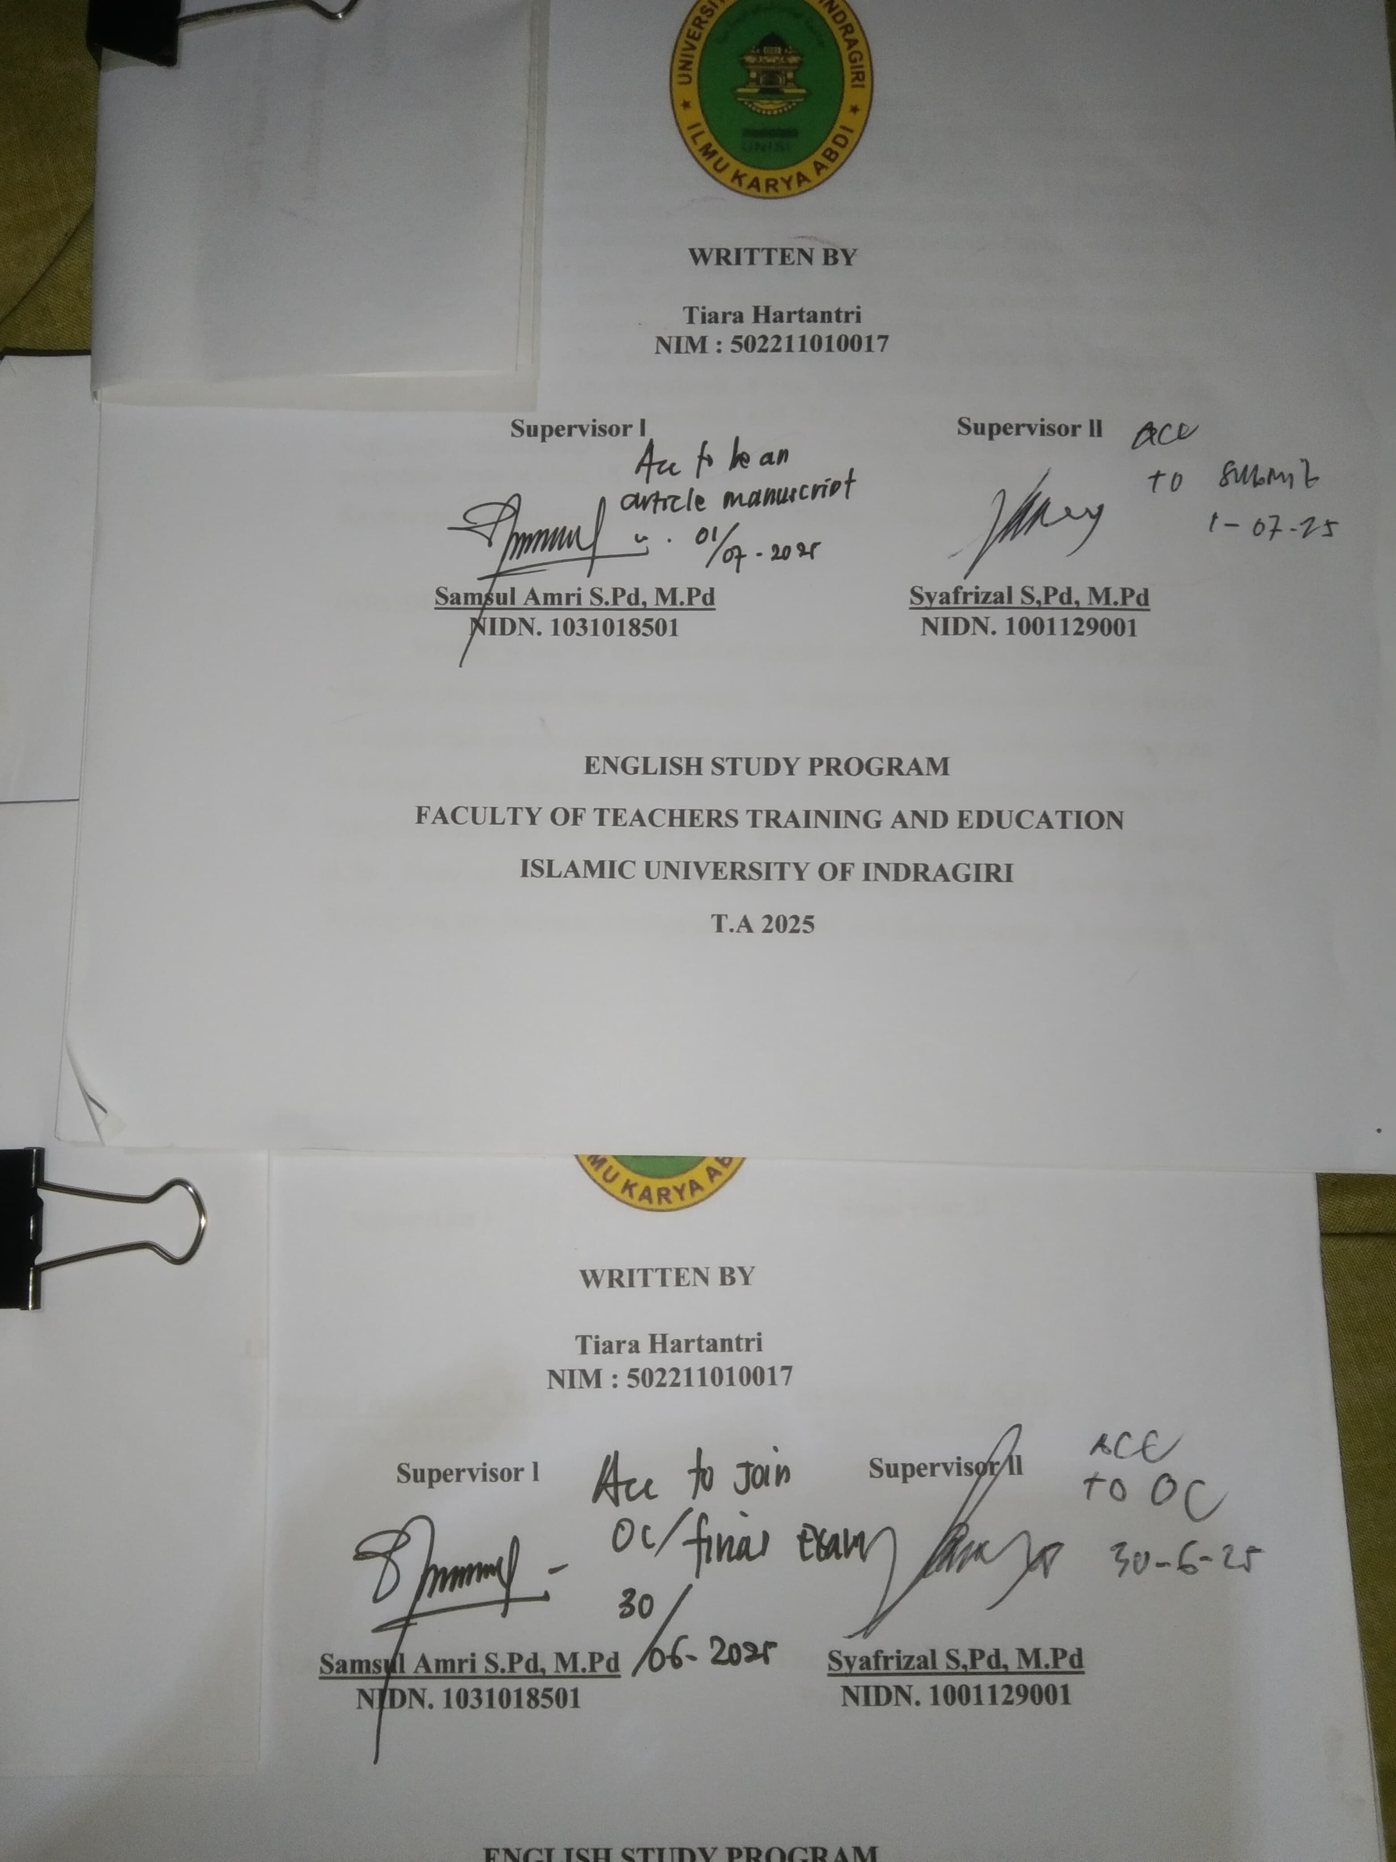

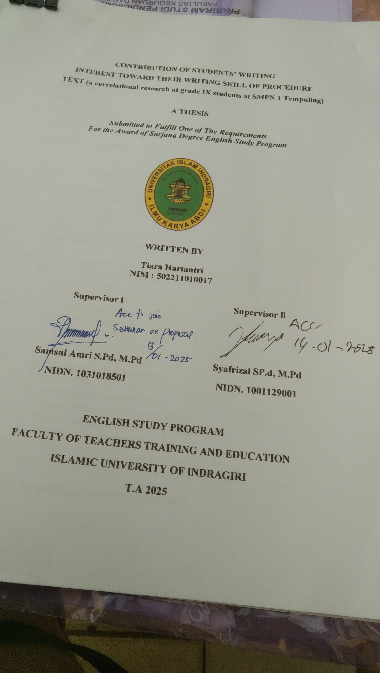

**Appendix VI Result the data of Procedure text**

|  |  |  |  |  |  |  |  |  |  |  |  |  |  |  |  |  |  |  |  |  |  |  |  |  |  |  |  |  |  |  |  |  |  |  |  |  |  |  |  |
| --- | --- | --- | --- | --- | --- | --- | --- | --- | --- | --- | --- | --- | --- | --- | --- | --- | --- | --- | --- | --- | --- | --- | --- | --- | --- | --- | --- | --- | --- | --- | --- | --- | --- | --- | --- | --- | --- | --- | --- |
| **NO** | **Name** | **To answered of respondent to number of item interest.** | | | | | | | | | | | | | | | | | | | | | | | | | | | | | | | | | | | | **Sum** | **Total** |
| 1 | 2 | 3 | 4 | 5 | 6 | 7 | 8 | 9 | 10 | | 11 | | | 12 | | | | 13 | | | 14 | | | 15 | | 16 | | | 17 | | | | 18 | | |  |  |
| 1 | Nazwa Salsabila | 4 | 3 | 3 | 4 | 4 | 3 | 4 | 4 | 4 | 1 | | 5 | | | 5 | | | | 3 | | | 4 | | | 3 | | 4 | | | 3 | | | | 5 | | | 66 | 73,33 |
| 2 | Qonita Lothvia | 4 | 4 | 5 | 5 | 5 | 5 | 5 | 5 | 5 | 3 | | 4 | | | 5 | | | | 5 | | | 5 | | | 5 | | 5 | | | 3 | | | | 5 | | | 83 | 92,22 |
| 3 | Nor Afifah Binti Sutikno | 5 | 2 | 5 | 5 | 5 | 4 | 5 | 5 | 4 | 5 | | 5 | | | 5 | | | | 4 | | | 5 | | | 5 | | 4 | | | 3 | | | | 5 | | | 81 | 90 |
| 4 | Septiani Putri | 4 | 4 | 4 | 4 | 5 | 5 | 5 | 5 | 4 | 4 | | 5 | | | 5 | | | | 5 | | | 5 | | | 4 | | 4 | | | 4 | | | | 5 | | | 81 | 90 |
| 5 | Aisyah | 4 | 4 | 5 | 4 | 5 | 1 | 4 | 5 | 4 | 4 | | 5 | | | 4 | | | | 4 | | | 4 | | | 4 | | 4 | | | 4 | | | | 4 | | | 73 | 81,11 |
| 6 | Sahran | 3 | 3 | 3 | 3 | 3 | 3 | 5 | 3 | 3 | | 3 | 3 | | | 3 | | | | 3 | | | 4 | | | 3 | | 4 | | | 5 | | | | 5 | | | 62 | 68,88 |
| 7 | Rahel Salmanda | 4 | 4 | 3 | 4 | 4 | 4 | 4 | 4 | 4 | | 3 | 3 | | | 4 | | | | 3 | | | 4 | | | 3 | | 4 | | | 3 | | | | 4 | | | 66 | 73,33 |
| 8 | Muhammad Fahri Syaputra | 3 | 3 | 3 | 3 | 3 | 3 | 3 | 3 | 4 | | 3 | 3 | | | 5 | | | | 5 | | | 3 | | | 5 | | 5 | | | 5 | | | | 5 | | | 67 | 74,44 |
| 9 | Zahratu Sita | 5 | 3 | 3 | 3 | 4 | 3 | 4 | 2 | 3 | | 1 | 4 | | | 5 | | | | 3 | | | 3 | | | 1 | | 3 | | | 3 | | | | 4 | | | 57 | 63,33 |
| 10 | Muhamad Abdel | 5 | 1 | 4 | 4 | 3 | 3 | 4 | 3 | 4 | | 4 | 4 | | | 5 | | | | 4 | | | 5 | | | 3 | | 4 | | | 4 | | | | 5 | | | 69 | 76,66 |
| 11 | M.Abdi Nazario | 4 | 2 | 4 | 1 | 5 | 2 | 5 | 2 | 4 | | 2 | 4 | | | 5 | | | | 4 | | | 4 | | | 5 | | 5 | | | 4 | | | | 5 | | | 67 | 74,44 |
| 12 | Fuji Afsy | 3 | 3 | 3 | 3 | 3 | 3 | 4 | 4 | 3 | | 5 | 3 | | | 5 | | | | 3 | | | 4 | | | 3 | | 4 | | | 3 | | | | 4 | | | 63 | 70 |
| 13 | Yuliana | 4 | 4 | 4 | 4 | 5 | 4 | 4 | 4 | 4 | | 4 | 4 | | | 4 | | | | 4 | | | 4 | | | 4 | | 4 | | | 4 | | | | 4 | | | 73 | 81,11 |
| 14 | Kalila Azra Faizatullah | 3 | 3 | 3 | 3 | 2 | 1 | 4 | 4 | 4 | | 4 | 5 | | | 4 | | | | 3 | | | 4 | | | 4 | | 3 | | | 3 | | | | 4 | | | 61 | 67,77 |
| 15 | Rahmat Dani | 5 | 4 | 3 | 3 | 5 | 5 | 5 | 4 | 5 | | 2 | 3 | | | 4 | | | | 5 | | | 5 | | | 3 | | 5 | | | 4 | | | | 4 | | | 74 | 82,22 |
| 16 | Azriyanto Wijaya Putra | 4 | 4 | 3 | 4 | 5 | 4 | 5 | 4 | 3 | | 3 | 4 | | | 5 | | | | 5 | | | 5 | | | 3 | | 5 | | | 4 | | | | 5 | | | 75 | 83,33 |
| 17 | Zulka Perdana | 4 | 4 | 4 | 4 | 4 | 4 | 4 | 4 | 1 | | 5 | | 2 | | | 2 | | | | 2 | | 2 | | | 4 | | | 3 | | | 3 | | | 4 | | | 60 | 66,66 |
| 18 | Silvina Ridam Tamin | 5 | 4 | 3 | 4 | 3 | 4 | 4 | 4 | 3 | | 4 | | 4 | | | 5 | | | | 5 | | 4 | | | 3 | | | 4 | | | 3 | | | 4 | | | 70 | 77,77 |
| 19 | Putri Mahni | 4 | 4 | 4 | 4 | 4 | 4 | 5 | 4 | 2 | | 4 | | 3 | | | 5 | | | | 4 | | 4 | | | 4 | | | 5 | | | 3 | | | 5 | | | 72 | 80 |
| 20 | Kalila Azra Faizatullah | 3 | 3 | 3 | 4 | 3 | 4 | 3 | 4 | 5 | | 2 | | 5 | | | 5 | | | | 4 | | 5 | | | 4 | | | 3 | | | 3 | | | 4 | | | 67 | 74,44 |
| 21 | Rizkia Lestari | 5 | 3 | 5 | 5 | 5 | 1 | 5 | 4 | 5 | | 4 | | 4 | | | 4 | | | | 5 | | 5 | | | 5 | | | 5 | | | 3 | | | 3 | | | 76 | 84,44 |
| 22 | Rania Alfirna | 5 | 4 | 5 | 5 | 3 | 5 | 5 | 5 | 3 | | 4 | | 4 | | | 4 | | | | 5 | | 3 | | | 4 | | | 3 | | | 3 | | | 3 | | | 73 | 81,11 |
| 23 | Alliya Ramadani | 5 | 4 | 5 | 5 | 4 | 4 | 5 | 5 | 4 | | 3 | | 4 | | | 5 | | | | 5 | | 5 | | | 5 | | | 3 | | | 2 | | | 5 | | | 78 | 86,66 |
| 24 | Muhammad Ihsan Shiddiq | 5 | 5 | 5 | 5 | 5 | 4 | 5 | 4 | 4 | | 3 | | 5 | | | 4 | | | | 4 | | 5 | | | 5 | | | 4 | | | 3 | | | 4 | | | 79 | 87,77 |
| 25 | Muhammad Fachri | 4 | 3 | 4 | 4 | 5 | 3 | 4 | 2 | 3 | | 3 | | 4 | | | 4 | | | | 4 | | 4 | | | 5 | | | 5 | | | 3 | | | 5 | | | 69 | 76,66 |
| 26 | Zaskia Zulaika Azzahra | 5 | 4 | 4 | 4 | 3 | 4 | 5 | 4 | 3 | | 3 | | 5 | | | 4 | | | | 5 | | 5 | | | 4 | | | 4 | | | 4 | | | 5 | | | 75 | 83,33 |
| 27 | Dwi Julhijawati Sabtiani | 5 | 4 | 5 | 4 | 5 | 3 | 4 | 4 | 3 | | 1 | | 3 | | | | 5 | | | | 3 | 5 | | | | 5 | | | 5 | | | 5 | | | 5 | | 74 | 82,22 |
| 28 | Srinita | 5 | 4 | 5 | 2 | 5 | 4 | 5 | 4 | 5 | | 3 | | 5 | | | | 5 | | | | 5 | 5 | | | | 5 | | | 5 | | | 3 | | | 5 | | 80 | 88,88 |
| 29 | Dewa Sahputra | 5 | 3 | 4 | 4 | 4 | 4 | 4 | 4 | 3 | | 4 | | 3 | | | | 5 | | | | 4 | 4 | | | | 4 | | | 4 | | | 4 | | | 4 | | 71 | 78,88 |
| 30 | Putri Shafa Salsabila | 4 | 4 | 4 | 4 | 4 | 5 | 5 | 5 | 5 | | 4 | | 4 | | | | 4 | | | | 4 | 5 | | | | 5 | | | 5 | | | 3 | | | 4 | | 78 | 86,66 |
| 31 | Defa Khapilardo | 5 | 3 | 4 | 4 | 4 | 4 | 4 | 4 | 3 | | 4 | | 3 | | | | 5 | | | | 4 | 4 | | | | 4 | | | 4 | | | 4 | | | 4 | | 71 | 78,88 |
| 32 | Arpaty Satya Azeem | 3 | 3 | 3 | 3 | 3 | 3 | 3 | 3 | 3 | | 3 | | 3 | | | | 3 | | | | 3 | 3 | | | | 3 | | | 3 | | | 3 | | | 3 | | 54 | 60 |
| 33 | Safa Surianti | 4 | 4 | 3 | 4 | 5 | 4 | 5 | 4 | 3 | | 5 | | 4 | | | | 4 | | | | 3 | 5 | | | | 5 | | | 4 | | | 5 | | | 5 | | 76 | 84,44 |
| 34 | Imil Marisa | 4 | 4 | 5 | 4 | 5 | 3 | 5 | 5 | 3 | | 4 | | 3 | | | | 3 | | | | 5 | 3 | | | | 3 | | | 5 | | | 3 | | | 3 | | 70 | 77,77 |
| 35 | Siti Fatimah | 4 | 2 | 5 | 4 | 4 | 3 | 5 | 4 | 5 | | 3 | | 4 | | | | 5 | | | | 4 | 4 | | | | 5 | | | 3 | | | 5 | | | 5 | | 74 | 82,22 |
| 36 | M.Rizki Saputra | 4 | 4 | 3 | 4 | 3 | 4 | 4 | 4 | 3 | | 3 | | 3 | | | | 5 | | | | 4 | 5 | | | | 4 | | | 4 | | | 1 | | | 3 | | 65 | 72,22 |
| 37 | Syafiq Wildan Basysar | 5 | 4 | 5 | 5 | 5 | 1 | 5 | 5 | 3 | | 3 | | | 5 | | | 5 | | | | 5 | | 5 | | | 5 | | | 5 | | | 5 | | | 5 | | 81 | 90 |
| 38 | Nurhaliza | 5 | 4 | 5 | 4 | 5 | 4 | 5 | 4 | 4 | | 3 | | | 5 | | | 4 | | | | 5 | | 4 | | | 5 | | | 5 | | | 4 | | | 4 | | 79 | 87,77 |
| 39 | Rinita Yulianti | 5 | 4 | 5 | 4 | 5 | 5 | 5 | 5 | 5 | | 4 | | | 5 | | | 5 | | | | 5 | | 5 | | | 5 | | | 5 | | | 3 | | | 4 | | 84 | 93,33 |
| 40 | Gisya Putri | 4 | 4 | 4 | 4 | 5 | 2 | 5 | 5 | 3 | | 3 | | | 4 | | | 3 | | | | 4 | | 4 | | | 5 | | | 5 | | | 2 | | | 4 | | 70 | 77,77 |
| 41 | M.Vicki Arjuna Futra | 4 | 3 | 4 | 4 | 5 | 4 | 5 | 2 | 5 | | 3 | | | 4 | | | 5 | | | | 5 | | 4 | | | 5 | | | 4 | | | 4 | | | 5 | | 75 | 83,33 |
| 42 | Syahira Adelia Maulida | 5 | 4 | 5 | 5 | 4 | 3 | 4 | 5 | 2 | | 4 | | | 5 | | | 5 | | | | 3 | | 5 | | | 5 | | | 3 | | | 3 | | | 5 | | 75 | 83,33 |
| 43 | Nurul Faiza Safitri | 3 | 4 | 4 | 4 | 4 | 4 | 4 | 4 | 3 | | 3 | | | 4 | | | 4 | | | | 4 | | 4 | | | 4 | | | 3 | | | 4 | | | 5 | | 69 | 76,66 |
| 44 | M.Khairil | 4 | 5 | 4 | 5 | 4 | 4 | 4 | 4 | 4 | | 4 | | | 4 | | | 4 | | | | 4 | | 4 | | | 4 | | | 4 | | | 4 | | | 4 | | 74 | 82,22 |
| 45 | M.Irpan Pajarrullah | 3 | 3 | 2 | 3 | 4 | 3 | 4 | 3 | 3 | | 3 | | | 4 | | | 4 | | | | 4 | | 4 | | | 3 | | | 3 | | | 4 | | | 4 | | 61 | 67,77 |
| 46 | Mulia Aprila Salwa | 5 | 5 | 5 | 5 | 5 | 5 | 5 | 5 | 5 | | 5 | | | 5 | | | 5 | | | | 5 | | 5 | | | 5 | | | 5 | | | 5 | | | 5 | | 90 | 100 |
| 47 | Ahmad Husyairi | 4 | 3 | 5 | 4 | 4 | 4 | 4 | 5 | 3 | | 3 | | | 3 | | | | 4 | | | 4 | | | 4 | | 3 | 4 | | | | | | 3 | | | 4 | 68 | 75,55 |
| 48 | Sovia Lacjuba | 3 | 1 | 3 | 5 | 4 | 4 | 3 | 4 | 4 | | 4 | | | 4 | | | | 5 | | | 4 | | | 4 | | 3 | 4 | | | | | | 3 | | | 4 | 66 | 73,33 |
| 49 | Reftia Saputri | 4 | 3 | 3 | 4 | 5 | 4 | 4 | 4 | 3 | | 3 | | | 3 | | | | 5 | | | 4 | | | 4 | | 3 | 3 | | | | | | 3 | | | 5 | 67 | 74,44 |
| 50 | Ikhsan Pratama | 3 | 3 | 3 | 4 | 4 | 5 | 5 | 4 | 4 | | 3 | | | 4 | | | | 3 | | | 4 | | | 3 | | 4 | 4 | | | | | | 3 | | | 4 | 67 | 74,44 |
| 51 | Ani | 4 | 3 | 5 | 5 | 4 | 3 | 4 | 4 | 5 | | 4 | | | 4 | | | | 3 | | | 4 | | | 5 | | 4 | 5 | | | | | | 4 | | | 4 | 74 | 82,22 |
| 52 | Marsha Juwita | 3 | 3 | 3 | 4 | 3 | 4 | 4 | 4 | 3 | | 3 | | | 3 | | | | 3 | | | 4 | | | 4 | | 4 | 3 | | | | | | 3 | | | 3 | 61 | 67,77 |
| Total | | | | | | | | | | | | | | | | | | | | | | | | | | | | | | | | | | | | | | 3711 | 4123,11 |
| Average | | | | | | | | | | | | | | | | | | | | | | | | | | | | | | | | | | | | | | 71,3%  good | 79,2 |

**Appendix VII The result (Anaysis students’ interest) at grade IX Students of SMP Negeri 1 Tempuling**

|  |  |  |  |  |  |  |  |
| --- | --- | --- | --- | --- | --- | --- | --- |
| **NO** | **Interval** | **Likert scale** | **Absolute** | **Score** | $$\frac{F}{N }X100\%$$ | **Interpretation** |  |
| Q1 | 0%-20%  21%-40%  41%-60%  61%-80%  81%-100% | SA  A  N  D  SD | 19  22  11  0  0 | 95  88  33  0  0 | $\frac{216}{260}$ x100  = 83,07% | Strongest |
|  | Amount |  |  | 216 |  |  |
| Q2 | 0%-20%  21%-40%  41%-60%  61%-80%  81%-100% | SA  A  N  D  SD | 3  25  19  4  1 | 15  100  57  8  1 | $$\frac{181}{260} x 100$$ = 69,61% | Strong |
|  | Amount |  |  | 181 |  |  |
| Q3 | 0%-20%  21%-40%  41%-60%  61%-80%  81%-100% | SA  A  N  D  SD | 18  15  18  1  0 | 90  60  54  2  0 | $$\frac{206}{260} x 100$$ =79,23% | Strong |
|  | Amount |  |  | 206 |  |  |
| Q4 | 0%-20%  21%-40%  41%-60%  61%-80%  81%-100% | SA  A  N  D  SD | 12  30  8  1  1 | 60  120  24  2  1 | $$\frac{207}{260} x 100$$ =79,61% | Strong |
|  | Amount |  |  | 207 |  |  |
| Q5 | 0%-20%  21%-40%  41%-60%  61%-80%  81%-100% | SA  A  N  D  SD | 22  18  10  1  0 | 110  72  30  2  0 | $$\frac{214}{260} x 100$$ =82,30% | Strongest |
|  | Amount |  |  | 214 |  |  |
| Q6 | 0%-20%  21%-40%  41%-60%  61%-80%  81%-100% | SA  A  N  D  SD | 8  24  14  1  4 | 40  96  42  2  4 | $$\frac{184}{260} x 100$$ = 70,76% | Strong |
|  | Amount |  |  | 184 |  |  |
| Q7 | 0%-20%  21%-40%  41%-60%  61%-80%  81%-100% | SA  A  N  D  SD | 25  23  4  0  0 | 125  92  12  0  0 | $$\frac{229}{260} x 100$$ = 88,07% | Strongest |
|  | Amount |  |  | 229 |  |  |
| Q8 | 0%-20%  21%-40%  41%-60%  61%-80%  81%-100% | SA  A  N  D  SD | 14  23  5  4  0 | 70  92  15  8  0 | $$\frac{185}{260} x 100$$ = 71,15% | Strong |
|  | Amount |  |  | 185 |  |  |
| Q9 | 0%-20%  21%-40%  41%-60%  61%-80%  81%-100% | SA  A  N  D  SD | 11  16  22  2  2 | 55  64  66  4  2 | $$\frac{191}{260} x 100$$ = 73,46% | Strong |
|  | Amount |  |  | 191 |  |  |
| Q10 | 0%-20%  21%-40%  41%-60%  61%-80%  81%-100% | SA  A  N  D  SD | 5  18  22  3  3 | 25  72  66  6  3 | $$\frac{172}{260} x 100$$ = 66,15% | Strong |
|  | Amount |  |  | 172 |  |  |
| Q11 | 0%-20%  21%-40%  41%-60%  61%-80%  81%-100% | SA  A  N  D  SD | 14  18  15  1  0 | 70  72  45  2  0 | $$\frac{189}{260} x 100$$ =72,69% | Strong |
|  | Amount |  | | 189 |  |  |
|  | | | |
|  |  |  | |
| Q12 | 0%-20%  21%-40%  41%-60%  61%-80%  81%-100% | SA  A  N  D  SD | 27  17  7  1  0 | 135  68  21  2  0 | $$\frac{226}{260} x 100$$ = 86,92% | Strongest |
|  | Amount |  |  | 226 |  |  |
| Q13 | 0%-20%  21%-40%  41%-60%  61%-80%  81%-100% | SA  A  N  D  SD | 17  24  10  1  0 | 85  96  30  2  0 | $$\frac{213}{260} x 100$$ = 81,92% | Strongest |
|  | Amount |  |  | 213 |  |  |
| Q14 | 0%-20%  21%-40%  41%-60%  61%-80%  81%-100% | SA  A  N  D  SD | 21  24  5  1  0 | 105  96  15  2  0 | $$\frac{218}{260} x 100$$ = 83,84% | Strongest |
|  | Amount |  |  | 218 |  |  |
| Q15 | 0%-20%  21%-40%  41%-60%  61%-80%  81%-100% | SA  A  N  D  SD | 20  16  14  0  1 | 100  64  42  0  1 | $$\frac{207}{260} x 100$$ = 79,61% | Strong |
|  | Amount |  |  | 207 |  |  |
| Q16 | 0%-20%  21%-40%  41%-60%  61%-80%  81%-100% | SA  A  N  D  SD | 18  18  13  0  0 | 90  72  39  0  0 | $$\frac{201}{260} x 100$$ = 77,30% | Strong |
|  | Amount |  |  | 201 |  |  |
| Q17 | 0%-20%  21%-40%  41%-60%  61%-80%  81%-100% | SA  A  N  D  SD | 7  16  26  2  1 | 35  64  78  4  1 | $$\frac{182}{260} x 100$$ = 70% | Strong |
|  | Amount |  |  | 182 |  |  |
| Q18 | 0%-20%  21%-40%  41%-60%  61%-80%  81%-100% | SA  A  N  D  SD | 22  23  6  0  0 | 110  92  18  0  0 | $$\frac{208}{260} x 100$$ = 80% | Strong |
|  | Amount |  |  | 208 |  |  |
|  |  |  |  |  |  |  |

**Appendix VIII The Students’ Individuals Score of Writing Test**

|  |  |  |  |  |  |  |  |  |
| --- | --- | --- | --- | --- | --- | --- | --- | --- |
| NO | Name of students | Content | Organization | Vocabulary | Language use | Mechanics | Total | Classification |
|  | Scoring | 30 | 20 | 20 | 25 | 5 | 100 |  |
| 1 | Nazwa Salsabila | 30 | 20 | 20 | 23 | 4 | 97 | Very good |
| 2 | Qonita Lothvia | 25 | 20 | 15 | 20 | 4 | 84 | Very good |
| 3 | Nor Afifah Binti Sutikno | 20 | 20 | 15 | 18 | 3 | 76 | Good |
| 4 | Septiani Putri | 20 | 15 | 18 | 15 | 4 | 72 | Good |
| 5 | Aisyah | 25 | 18 | 16 | 24 | 3 | 86 | Very good |
| 6 | Sahran | 28 | 20 | 15 | 24 | 4 | 91 | Very good |
| 7 | Rahel Salmanda | 20 | 15 | 17 | 22 | 3 | 77 | Good |
| 8 | Muhammad Fahri Syaputra | 25 | 20 | 15 | 18 | 2 | 80 | Very good |
| 9 | Zahratu Sita | 20 | 20 | 15 | 15 | 4 | 74 | Good |
| 10 | Muhamad Abdel | 15 | 20 | 18 | 10 | 2 | 65 | Good |
| 11 | M.Abdi Nazario | 20 | 18 | 15 | 24 | 4 | 81 | Very good |
| 12 | Fuji Afsy | 18 | 15 | 20 | 22 | 2 | 77 | Good |
| 13 | Yuliana | 20 | 20 | 12 | 20 | 4 | 76 | Good |
| 14 | Kalila Azra Faizatullah | 25 | 20 | 20 | 22 | 3 | 90 | Very good |
| 15 | Rahmat Dani | 25 | 18 | 18 | 22 | 4 | 87 | Very good |
| 16 | Azriyanto Wijaya Putra | 22 | 16 | 18 | 20 | 4 | 80 | Very good |
| 17 | Zulka Perdana | 28 | 20 | 20 | 23 | 4 | 95 | Very good |
| 18 | Silvina Ridam Tamin | 25 | 20 | 20 | 22 | 3 | 90 | Very good |
| 19 | Putri Mahni | 20 | 20 | 20 | 23 | 3 | 86 | Very good |
| 20 | Kalila Azra Faizatullah | 27 | 18 | 17 | 23 | 4 | 89 | Very good |
| 21 | Rizkia Lestari | 25 | 20 | 18 | 24 | 4 | 91 | Very good |
| 22 | Rania Alfirna | 26 | 18 | 15 | 22 | 3 | 84 | Very good |
| 23 | Alliya Ramadani | 25 | 18 | 18 | 23 | 3 | 87 | Very good |
| 24 | Muhammad Ihsan Shiddiq | 28 | 16 | 20 | 24 | 4 | 92 | Very good |
| 25 | Muhammad Fachri | 25 | 20 | 20 | 22 | 4 | 91 | Very good |
| 26 | Zaskia Zulaika Azzahra | 22 | 17 | 17 | 23 | 4 | 83 | Very good |
| 27 | Dwi Julhijawati Sabtiani | 25 | 15 | 15 | 24 | 3 | 82 | Very good |
| 28 | Srinita | 23 | 16 | 18 | 23 | 3 | 83 | Very good |
| 29 | Dewa Sahputra | 15 | 16 | 18 | 20 | 3 | 72 | Good |
| 30 | Putri Shafa Salsabila | 18 | 15 | 15 | 22 | 3 | 73 | Good |
| 31 | Defa Khapilardo | 20 | 18 | 18 | 22 | 4 | 82 | Very good |
| 32 | Arpaty Satya Azeem | 24 | 18 | 16 | 23 | 3 | 84 | Very good |
| 33 | Safa Surianti | 27 | 15 | 18 | 22 | 3 | 85 | Very good |
| 34 | Imil Marisa | 22 | 16 | 17 | 24 | 4 | 83 | Very good |
| 35 | Siti Fatimah | 20 | 18 | 15 | 24 | 4 | 81 | Very good |
| 36 | M.Rizki Saputra | 18 | 20 | 16 | 25 | 3 | 82 | Very good |
| 37 | Syafiq Wildan Basysar | 20 | 18 | 18 | 22 | 4 | 82 | Very good |
| 38 | Nurhaliza | 25 | 17 | 18 | 22 | 4 | 86 | Very good |
| 39 | Rinita Yulianti | 28 | 16 | 20 | 23 | 4 | 91 | Very good |
| 40 | Gisya Putri | 26 | 20 | 18 | 21 | 3 | 88 | Very good |
| 41 | M.Vicki Arjuna Futra | 20 | 18 | 18 | 22 | 4 | 82 | Very good |
| 42 | Syahira Adelia Maulida | 20 | 15 | 20 | 23 | 3 | 81 | Very good |
| 43 | Nurul Faiza Safitri | 20 | 20 | 20 | 24 | 3 | 87 | Very good |
| 44 | M.Khairil | 22 | 20 | 16 | 24 | 4 | 86 | Very good |
| 45 | M.Irpan Pajarrullah | 28 | 18 | 18 | 23 | 4 | 91 | Very good |
| 46 | Mulia Aprila Salwa | 23 | 15 | 16 | 23 | 5 | 82 | Very good |
| 47 | Ahmad Husyairi | 23 | 18 | 18 | 22 | 5 | 86 | Very good |
| 48 | Sovia Lacjuba | 25 | 16 | 16 | 21 | 4 | 82 | Very good |
| 49 | Reftia Saputri | 27 | 16 | 15 | 24 | 5 | 87 | Very good |
| 50 | Ikhsan Pratama | 20 | 17 | 20 | 23 | 4 | 84 | Very good |
| 51 | Ani | 20 | 18 | 18 | 23 | 3 | 82 | Very good |
| 52 | Marsha Juwita | 25 | 18 | 16 | 22 | 4 | 85 | Very good |
| Total | | | | | | | 4350 |  |
| Average | | | | | | | 83,6% | Very good level |