REVISISKRIPSI202579
OKE.docx
byStudentTurnitin

Submissiondate:10-Oct-202505:57AM(UTC-0700)
SubmissionID:2786923415
Filename:REVISI_SKRIPSI_2025_79_OKE.docx(298.96K)
Wordcount:12769
Charactercount:76361

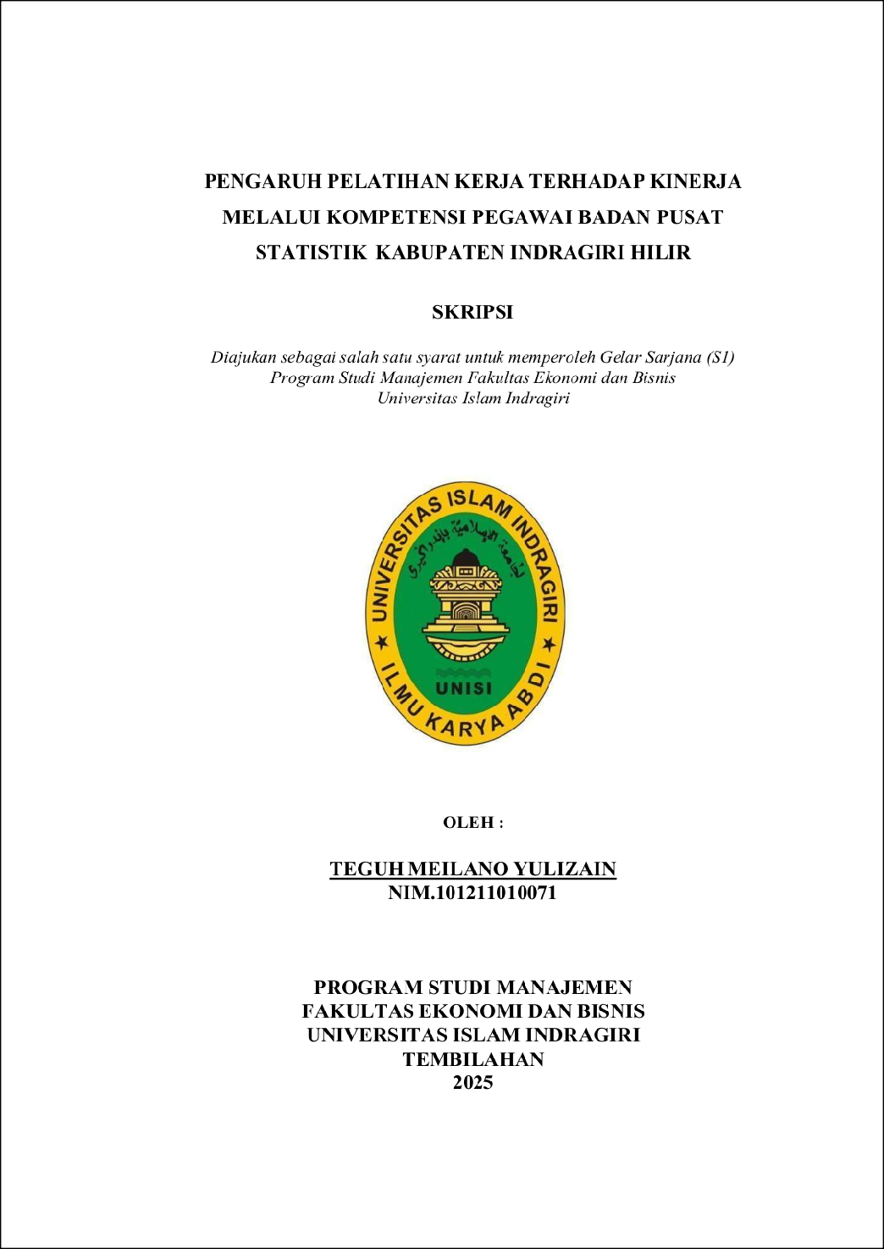
57
1

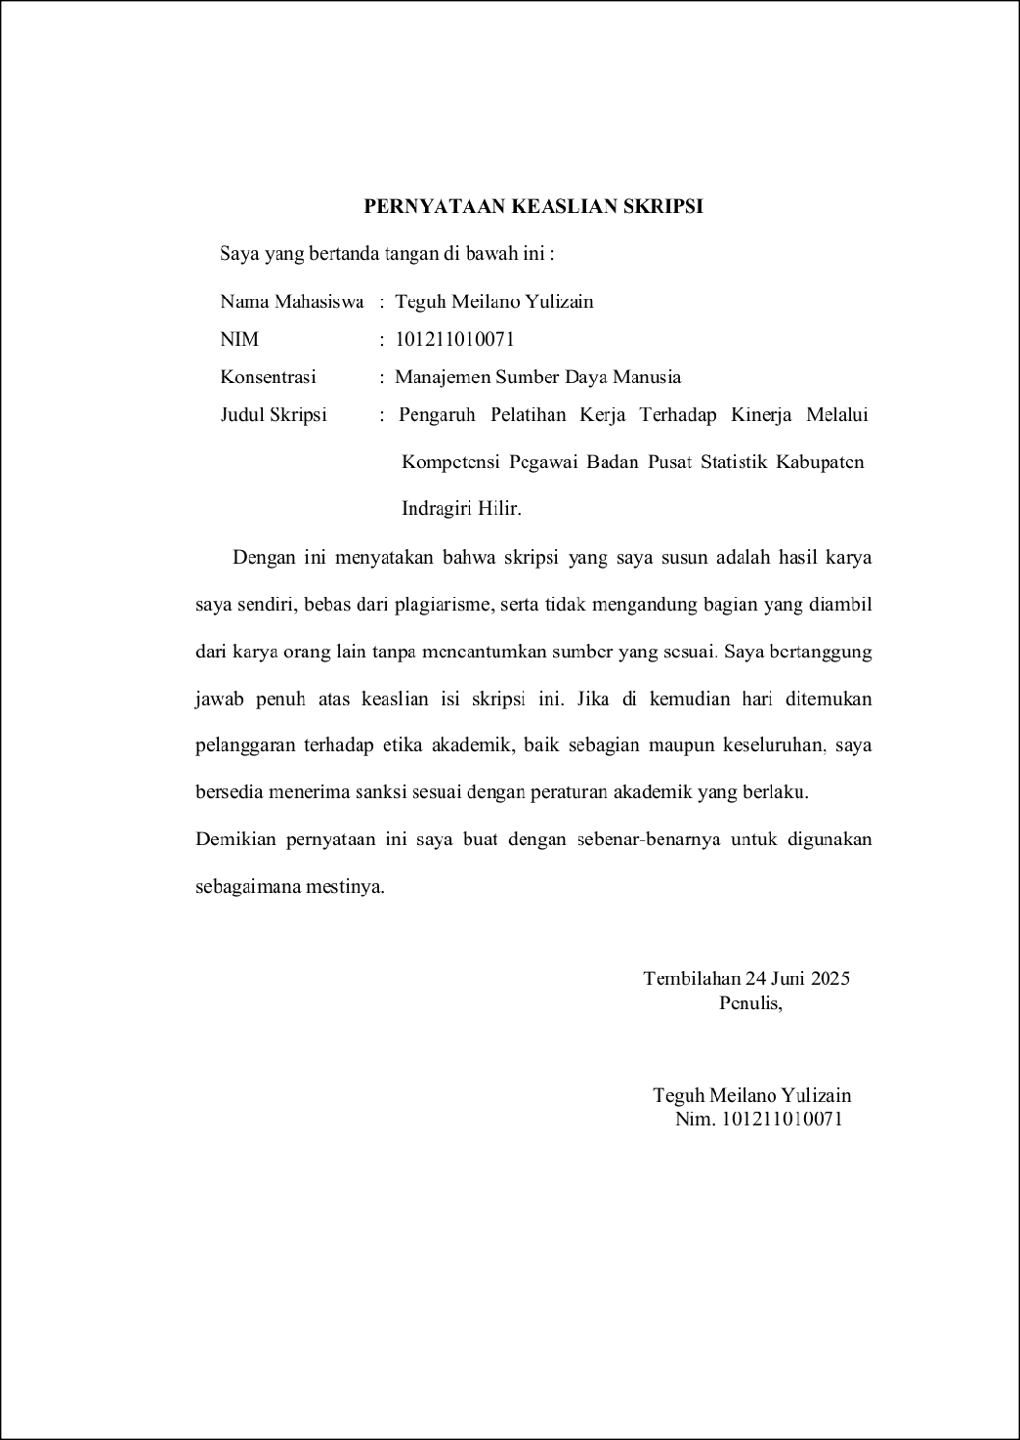
123
1
1

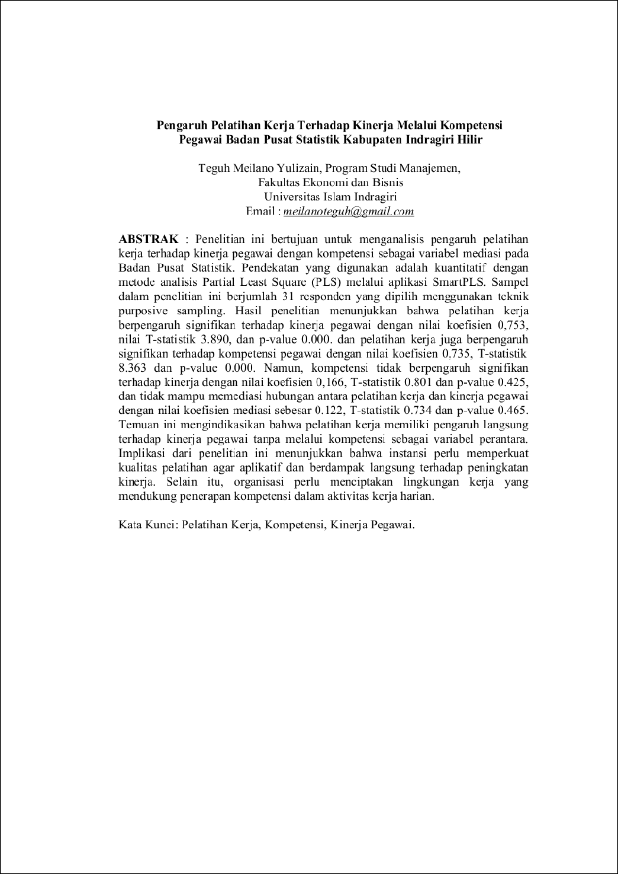
3
1
112
4
142
96
78
160
67
38
4

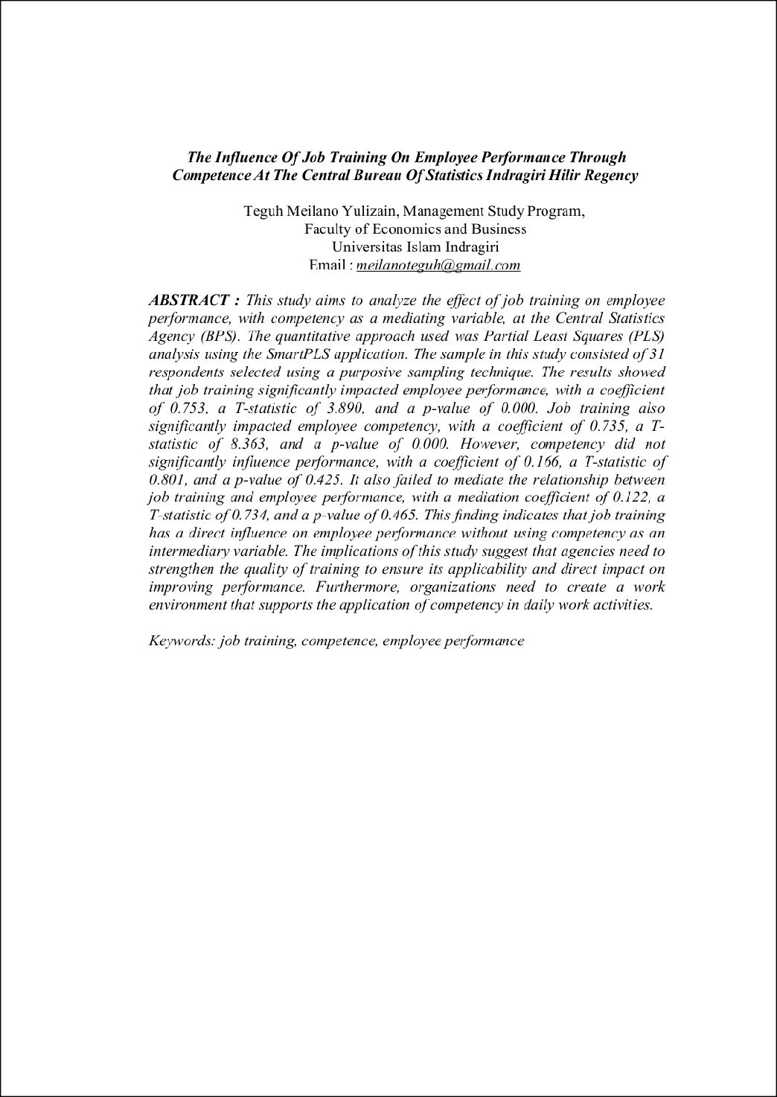
1
1
37
32
92
86
165
141
128
32
81

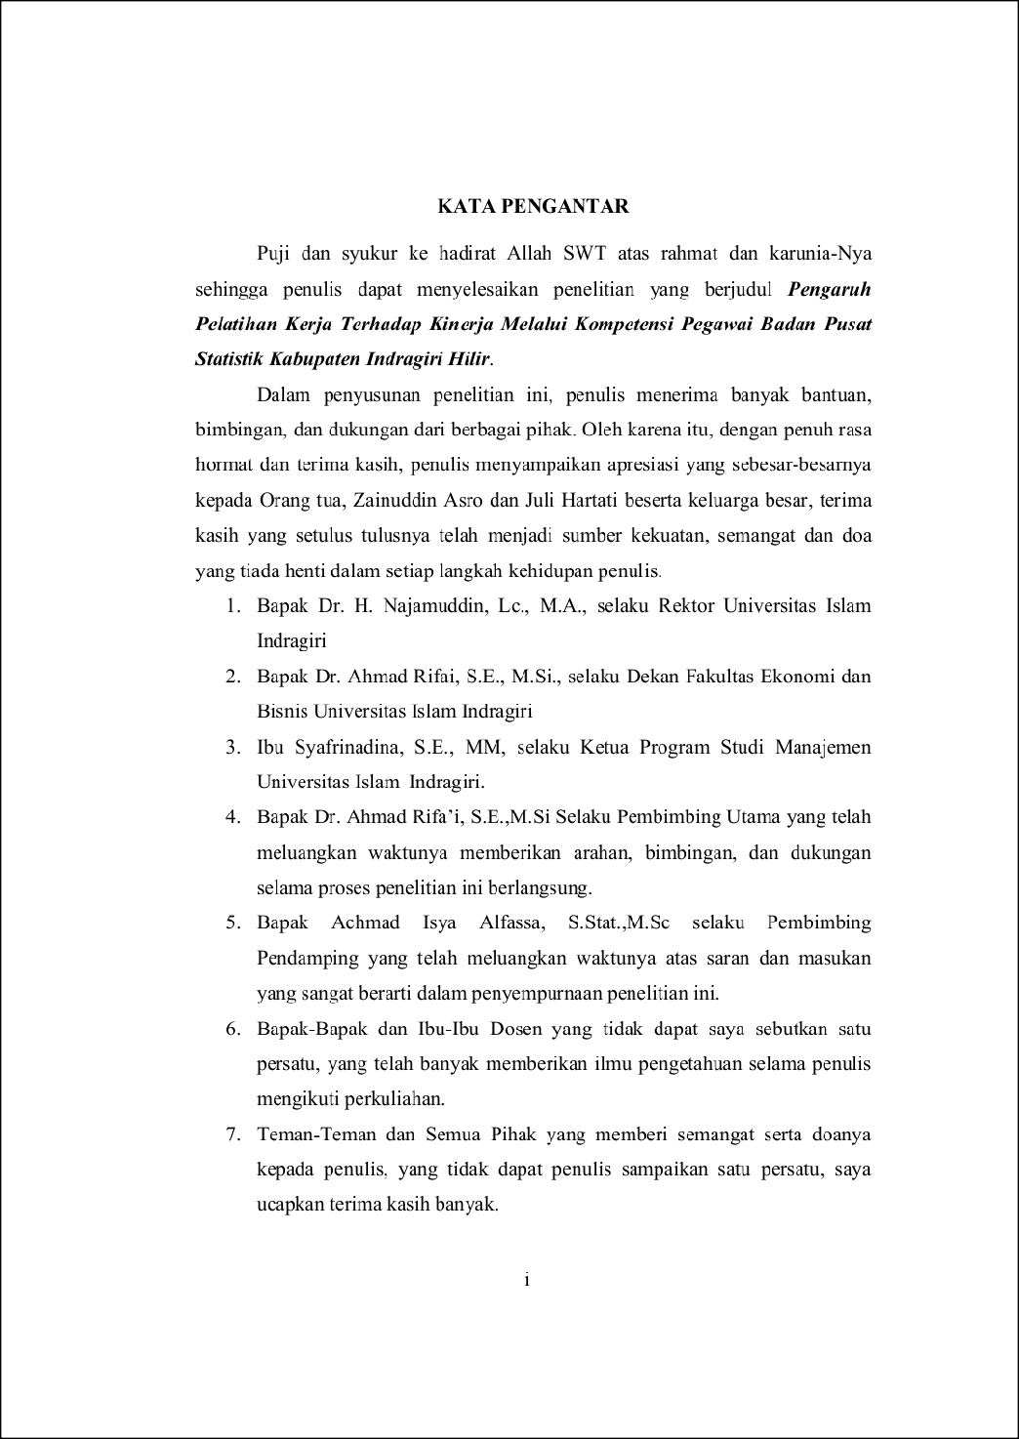
58
64
1
1
40
1
76
4
98
1

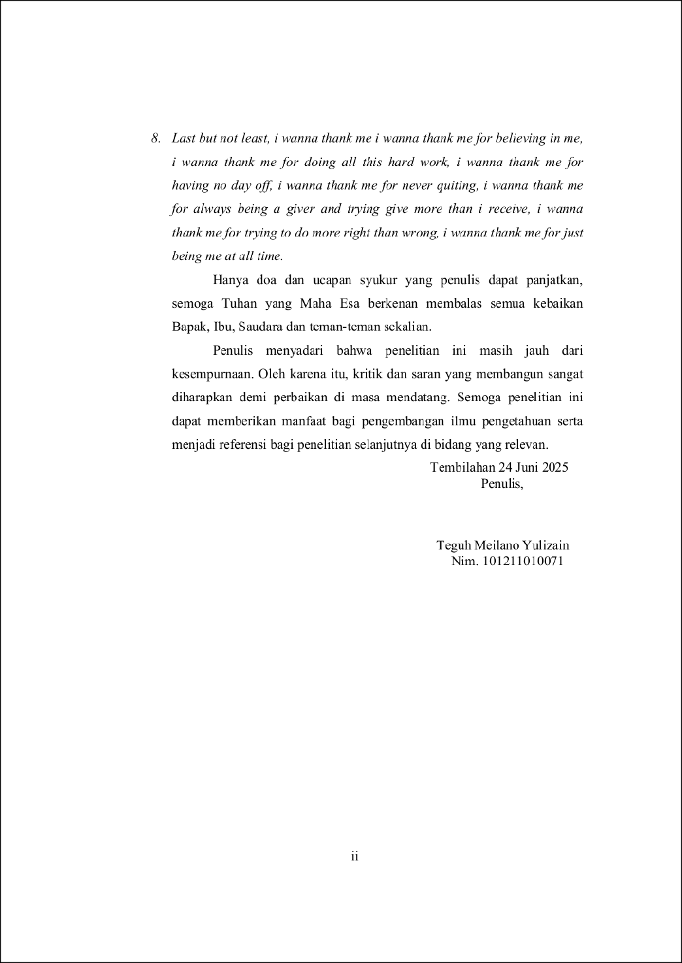
13
1

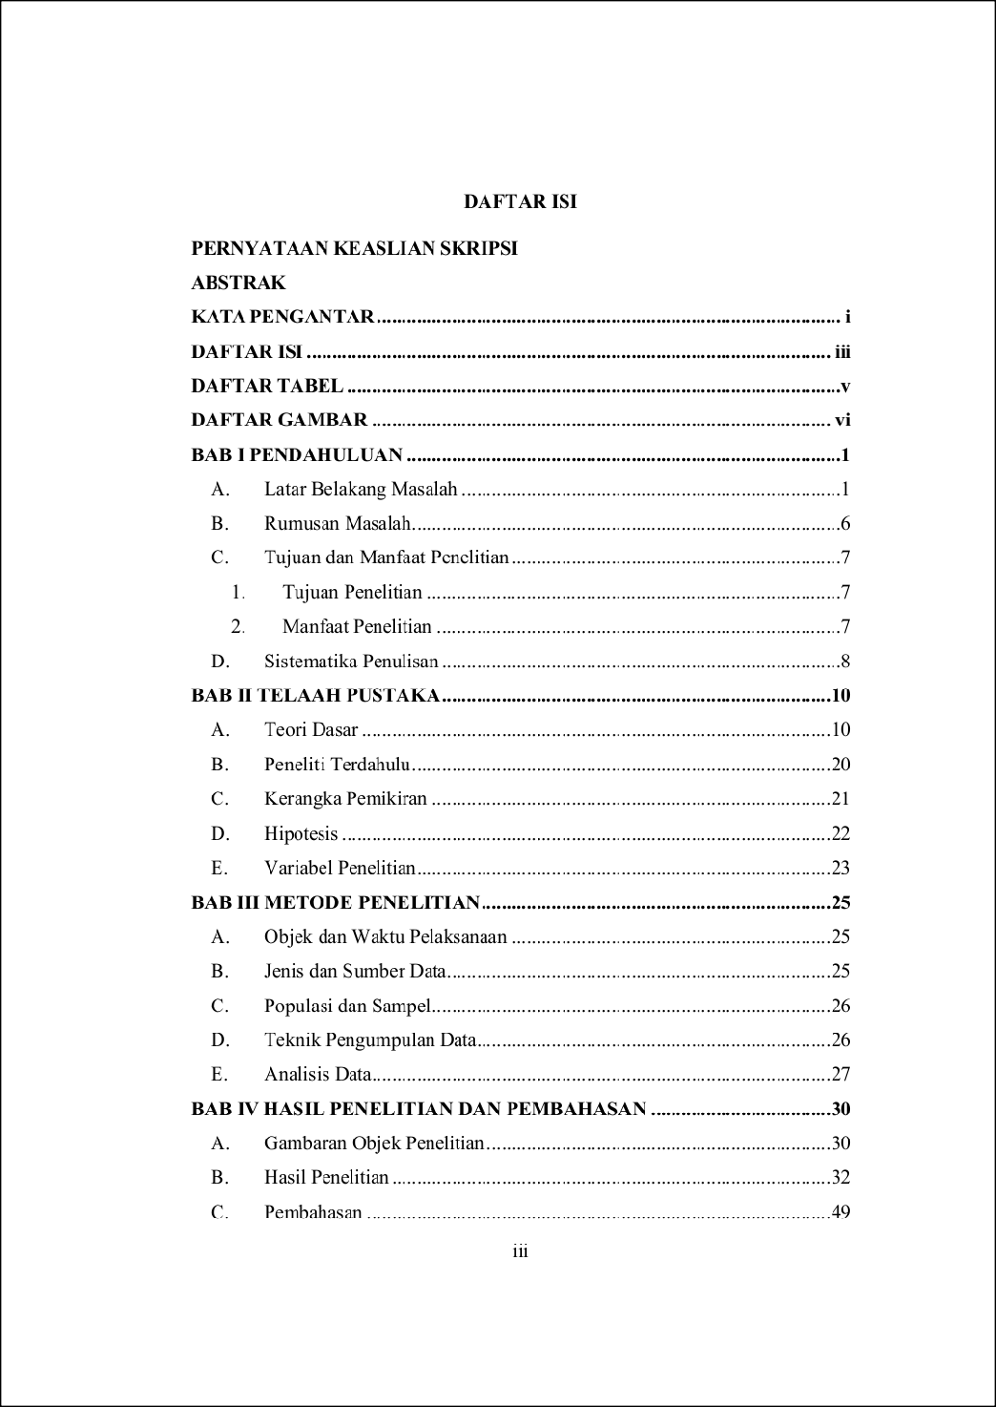
1
1



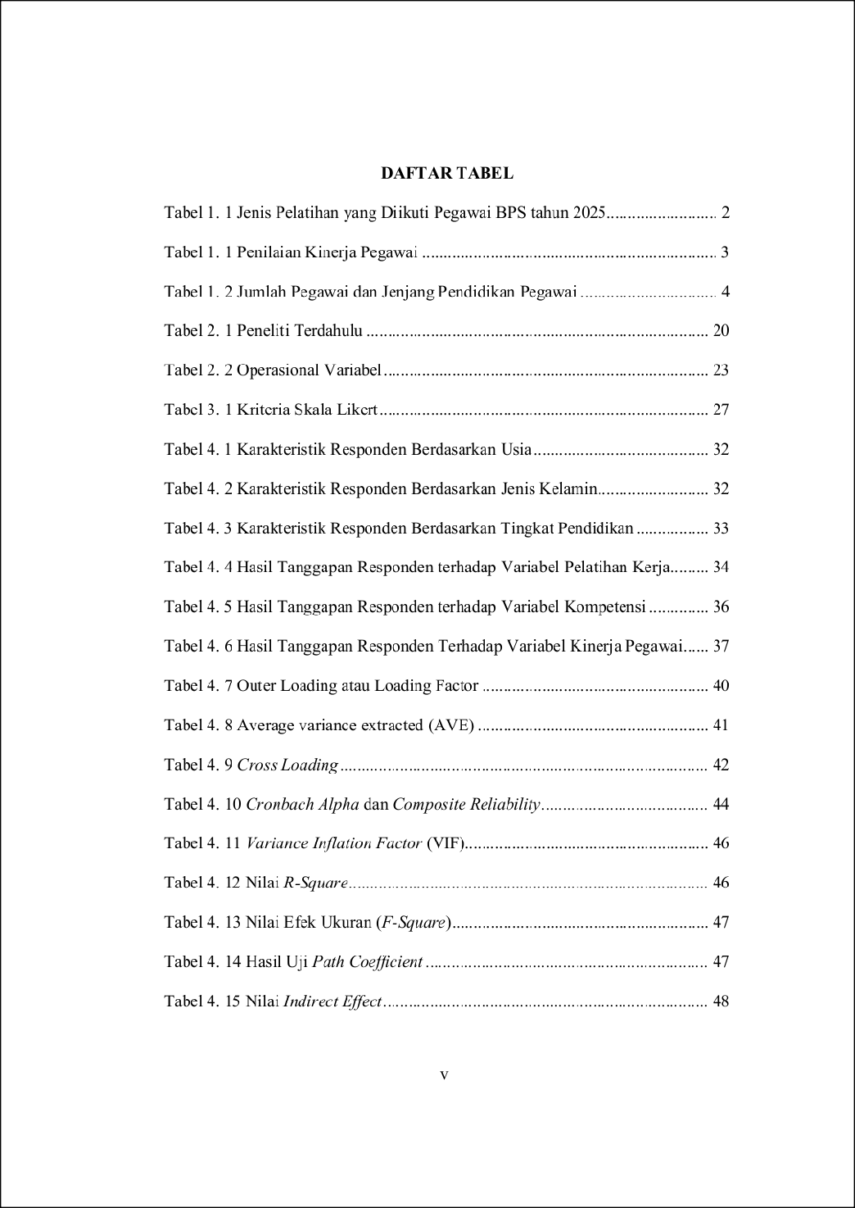
33
23
30
20
1



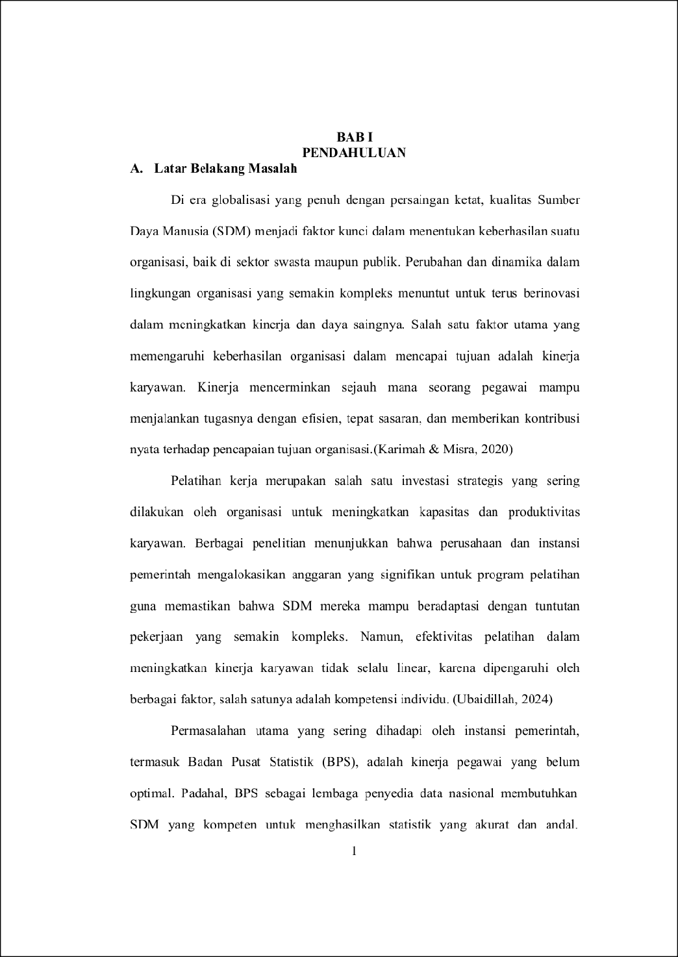
93
144
9
103
103
68
156

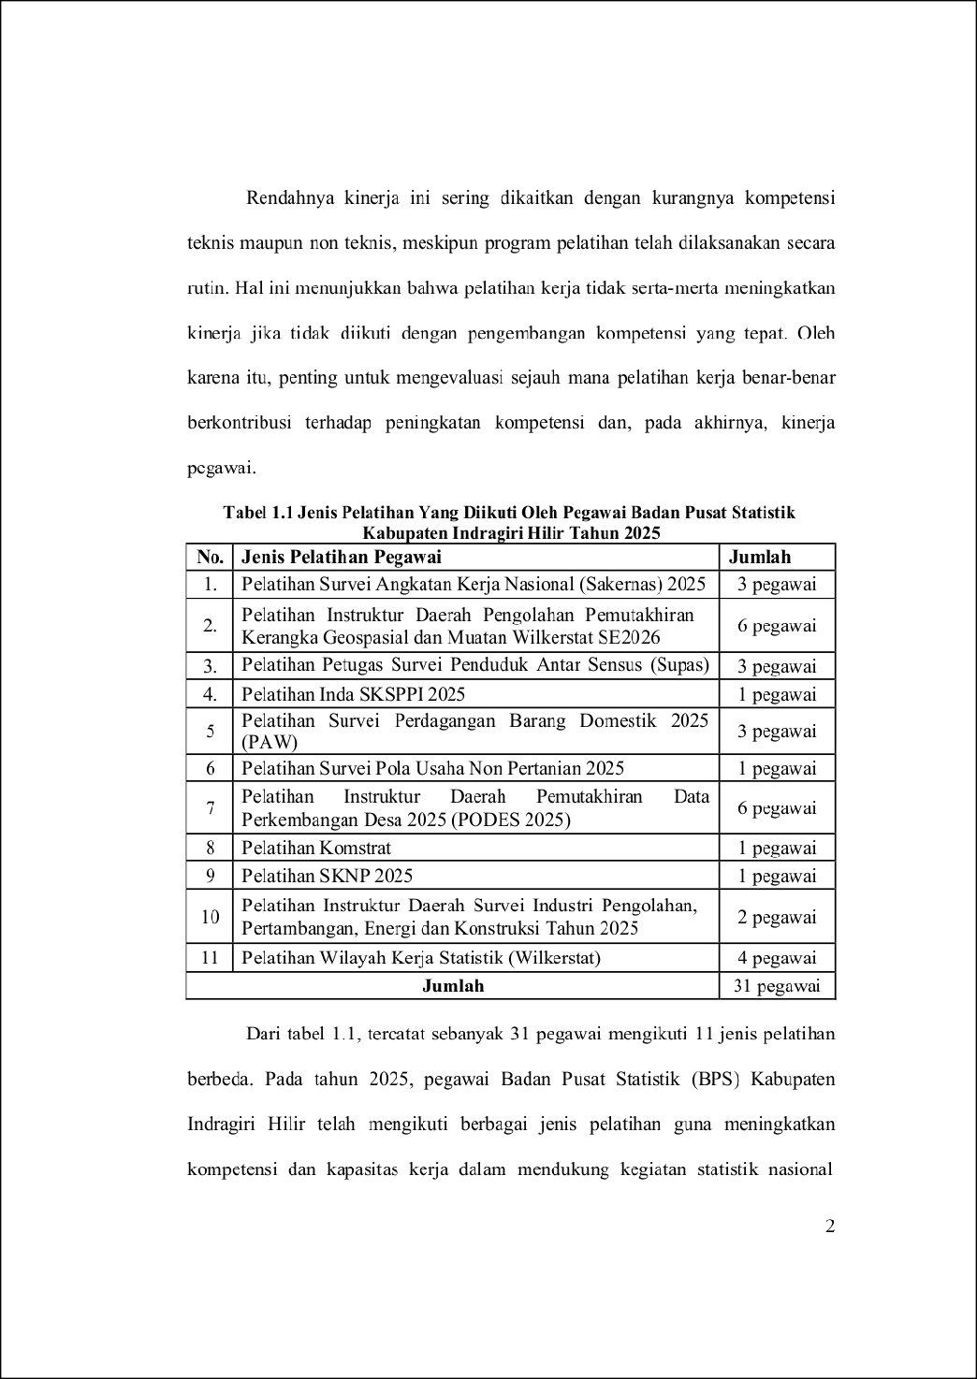
37
135
3
3

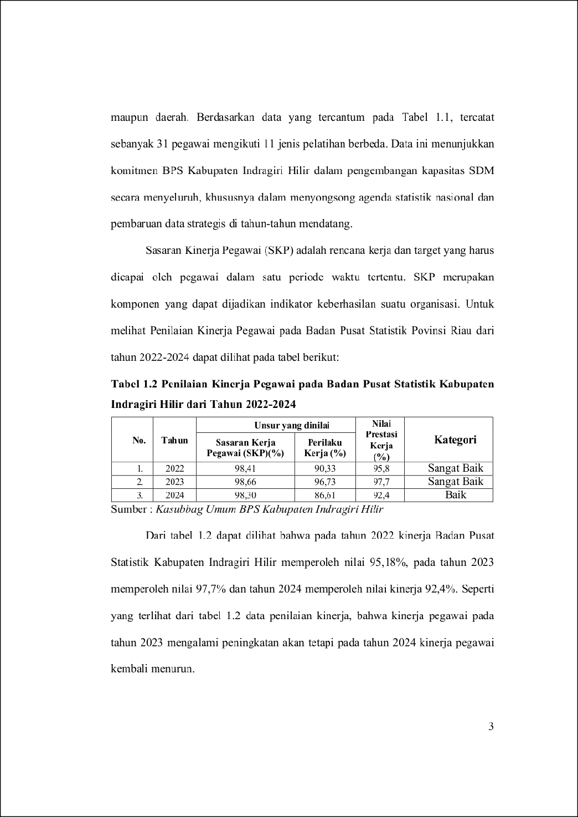
91
3
3
3

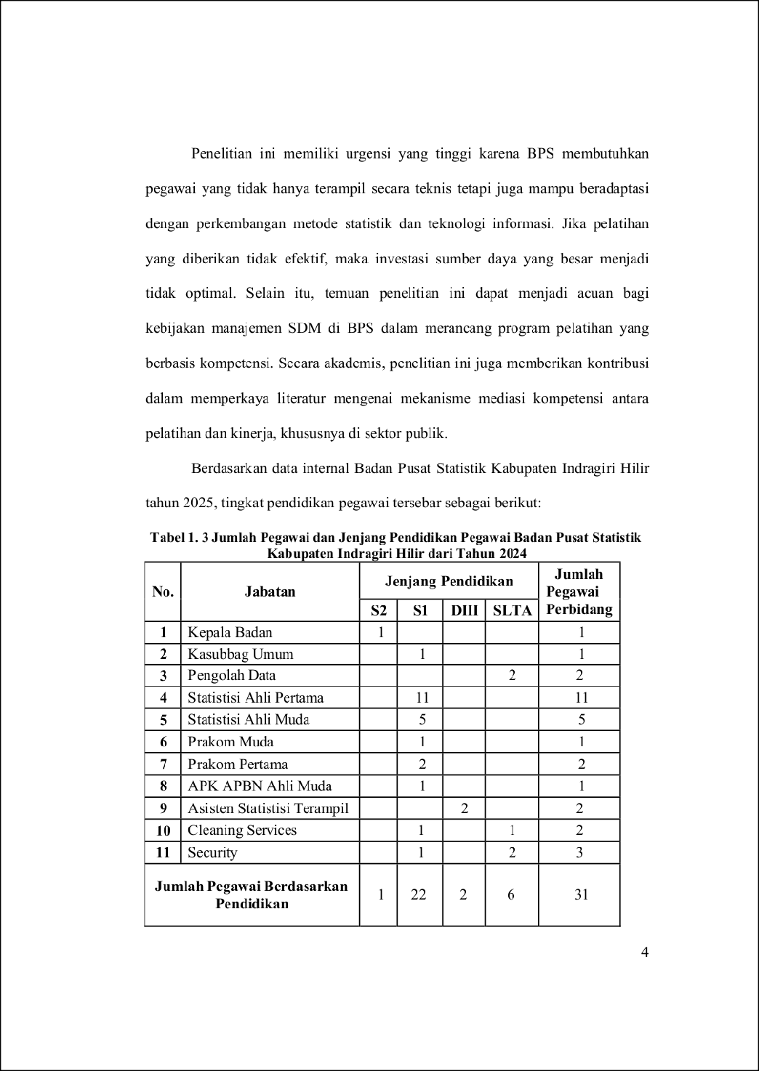
149
37
1

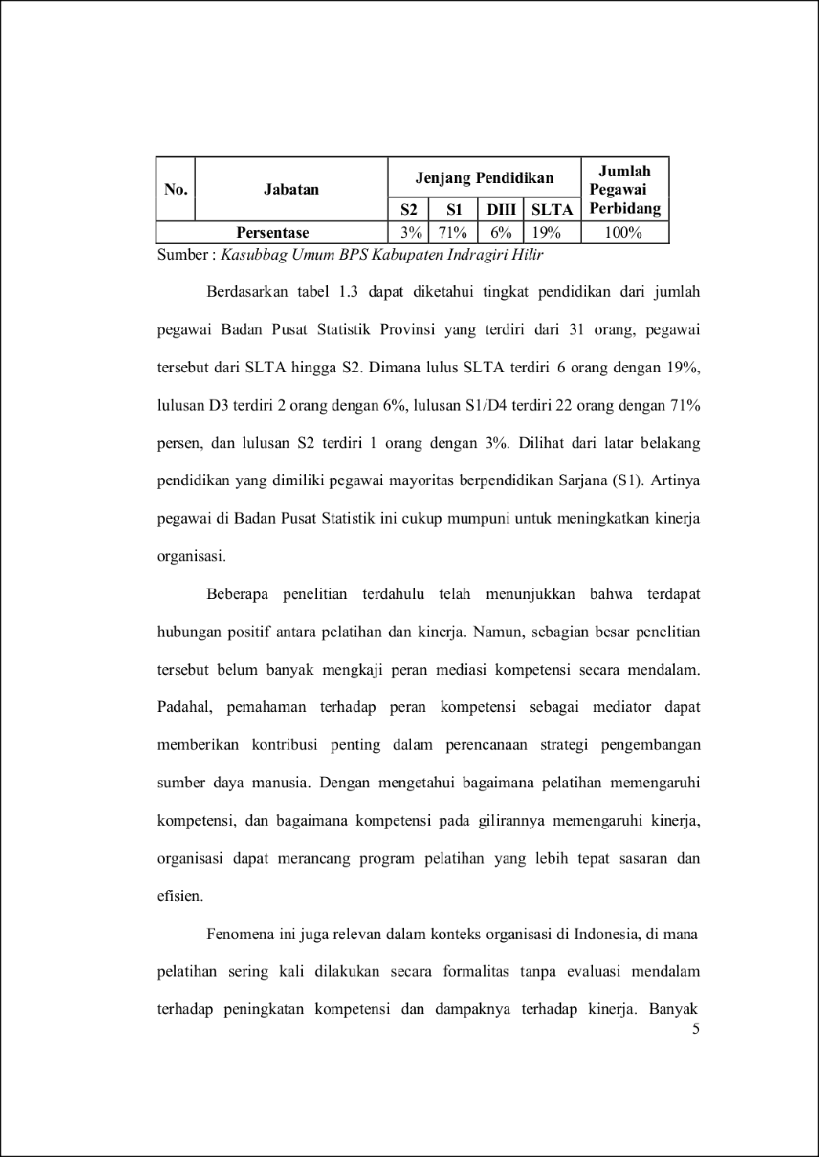
3
3
115
47

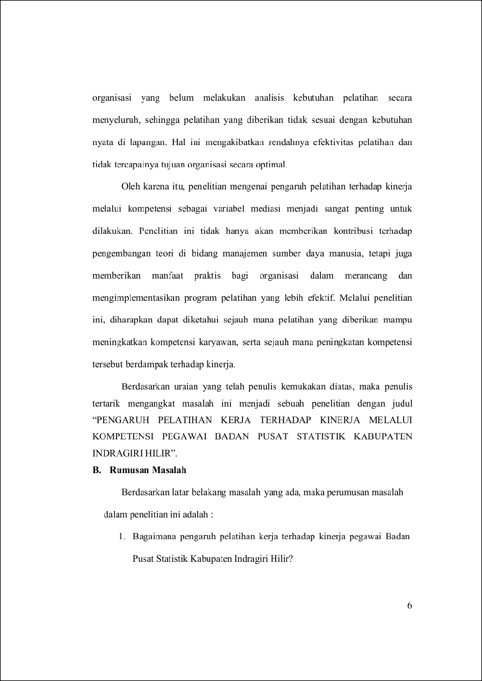
122
7
31
129
136
3
44

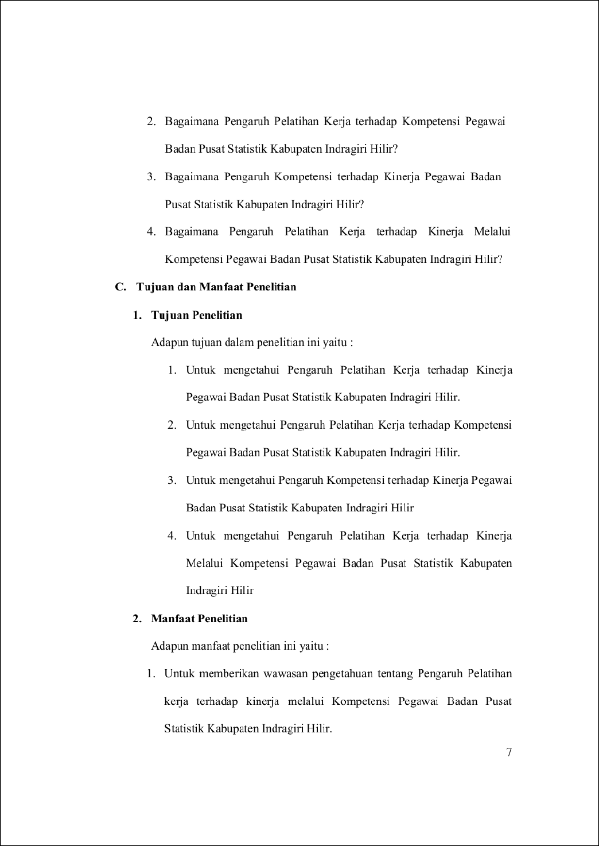
21
117
26
22
3
3

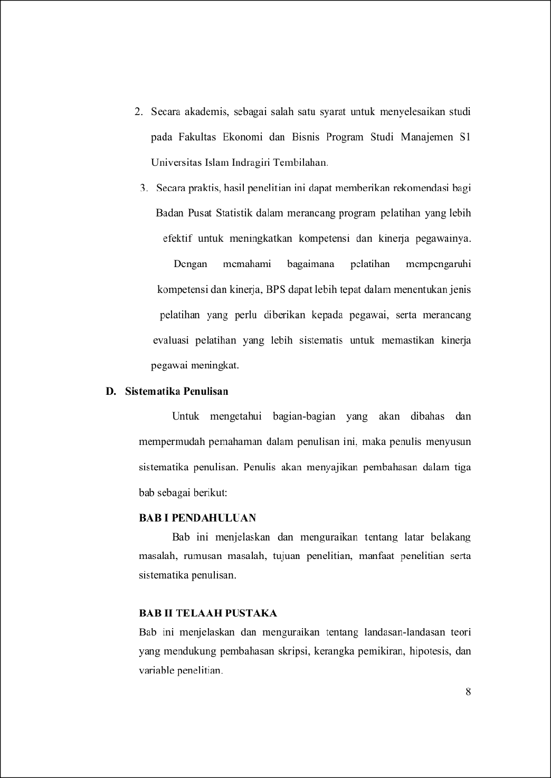
3
40
1

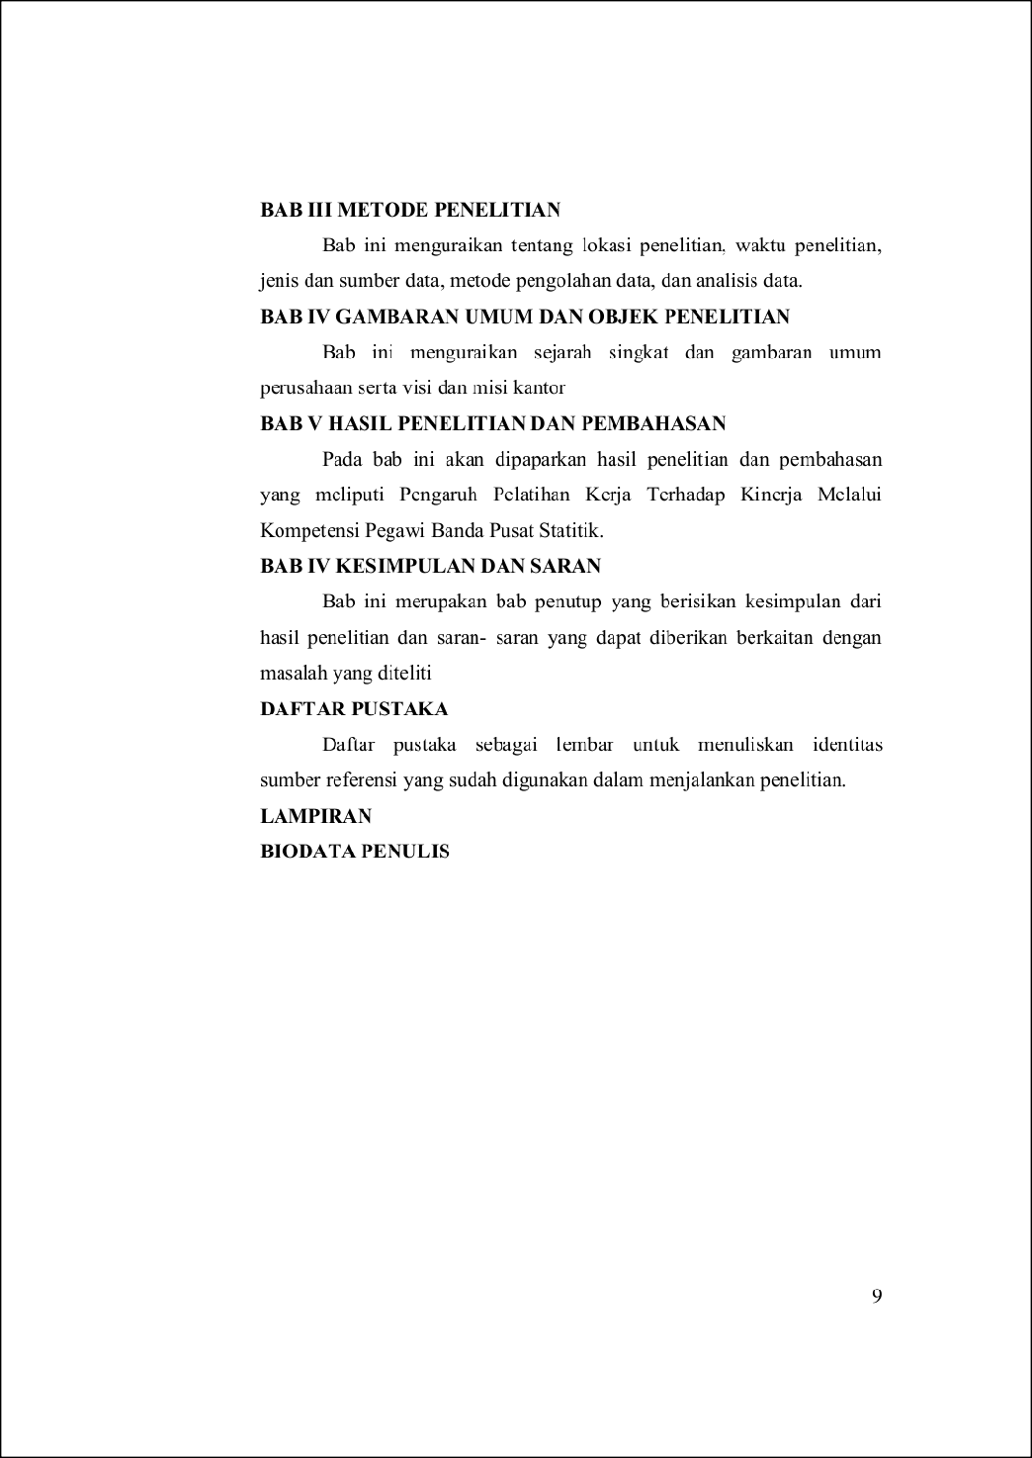
1

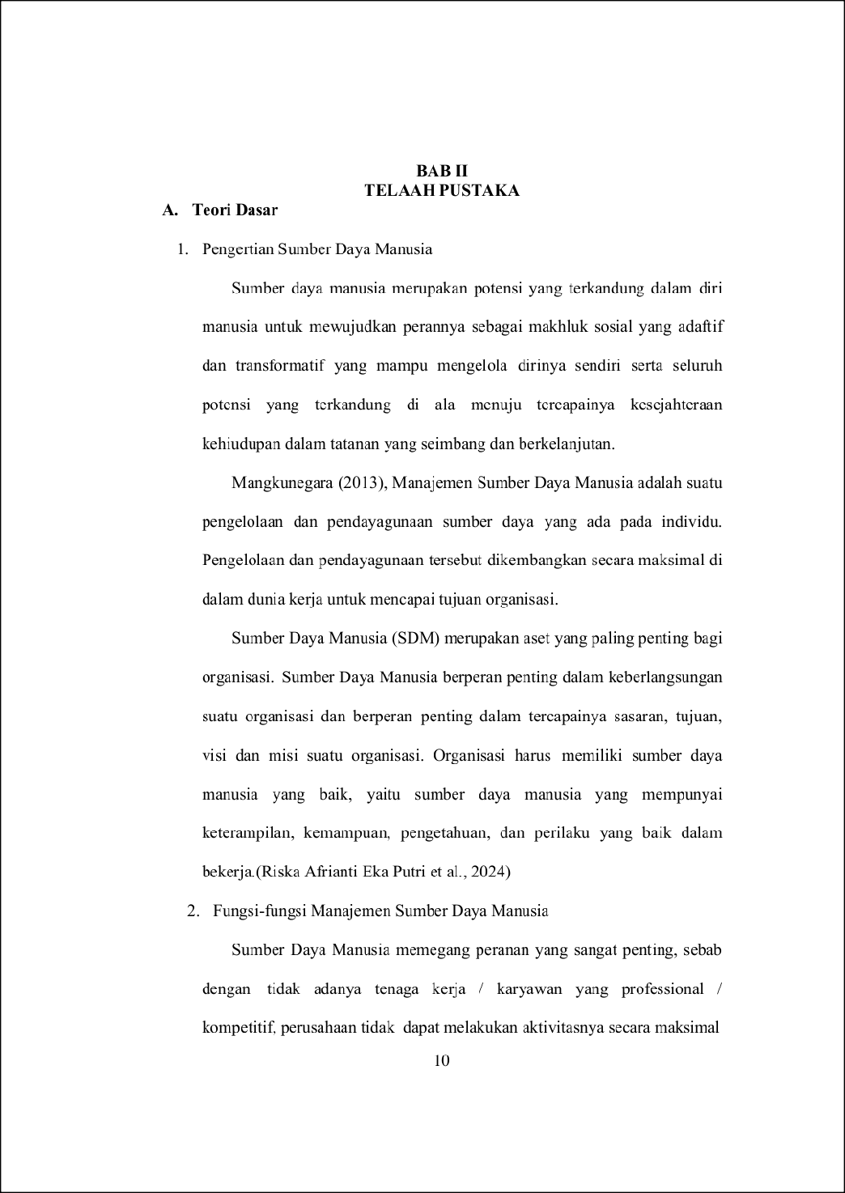
1
7
6
14
18

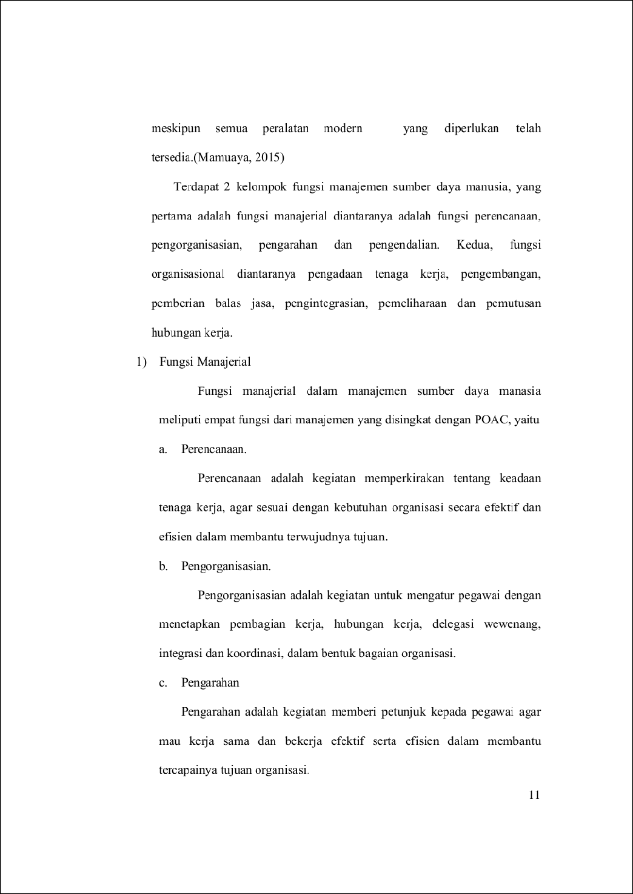
35
17
12

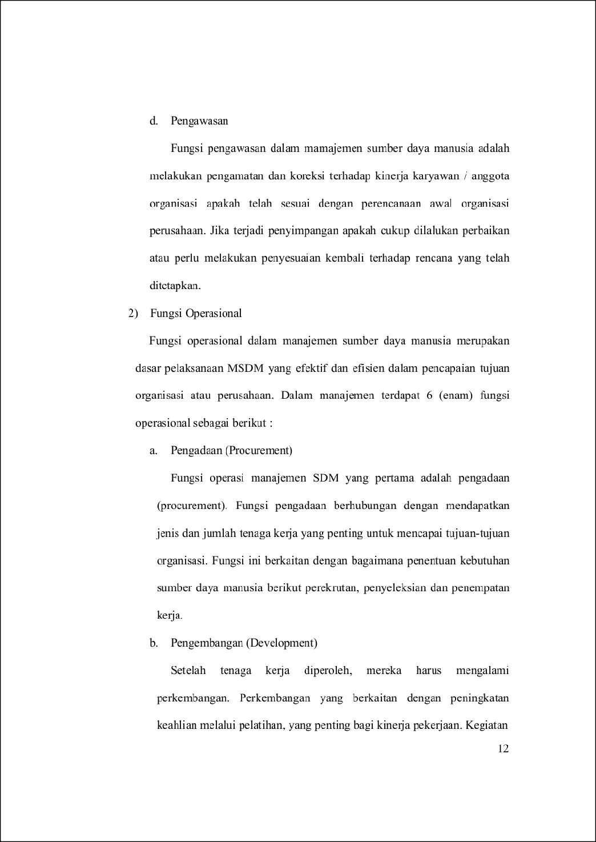
17
97
6

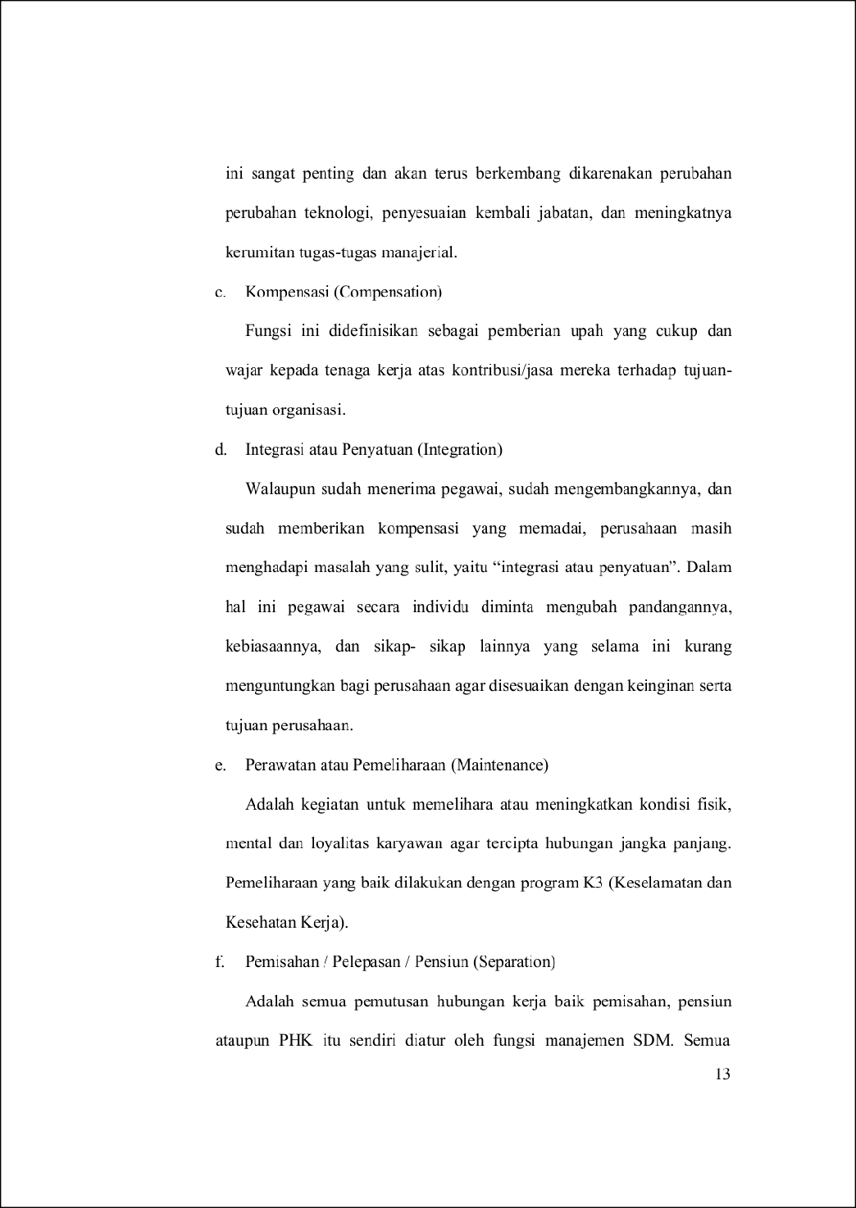
60

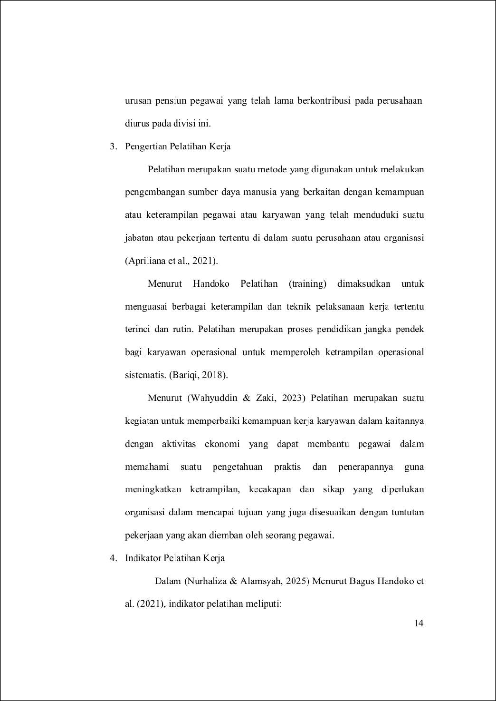
15
54
28

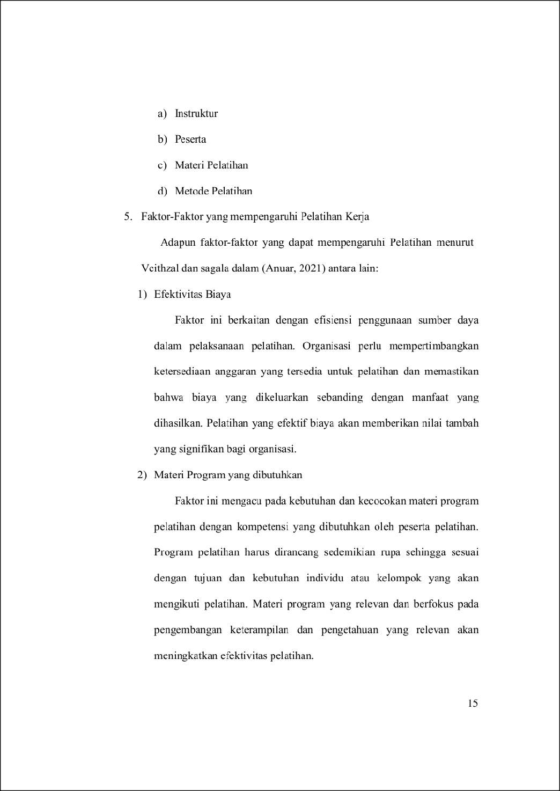
3
68
138
77

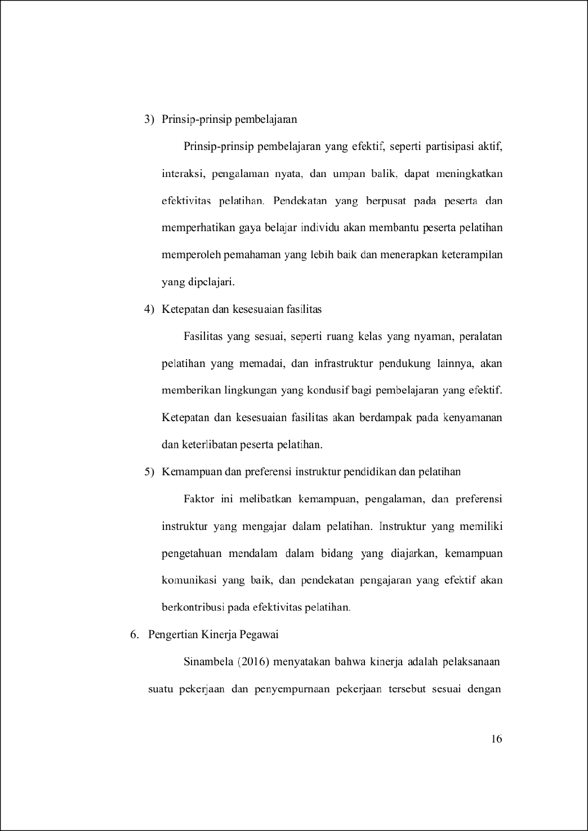
98
10
16

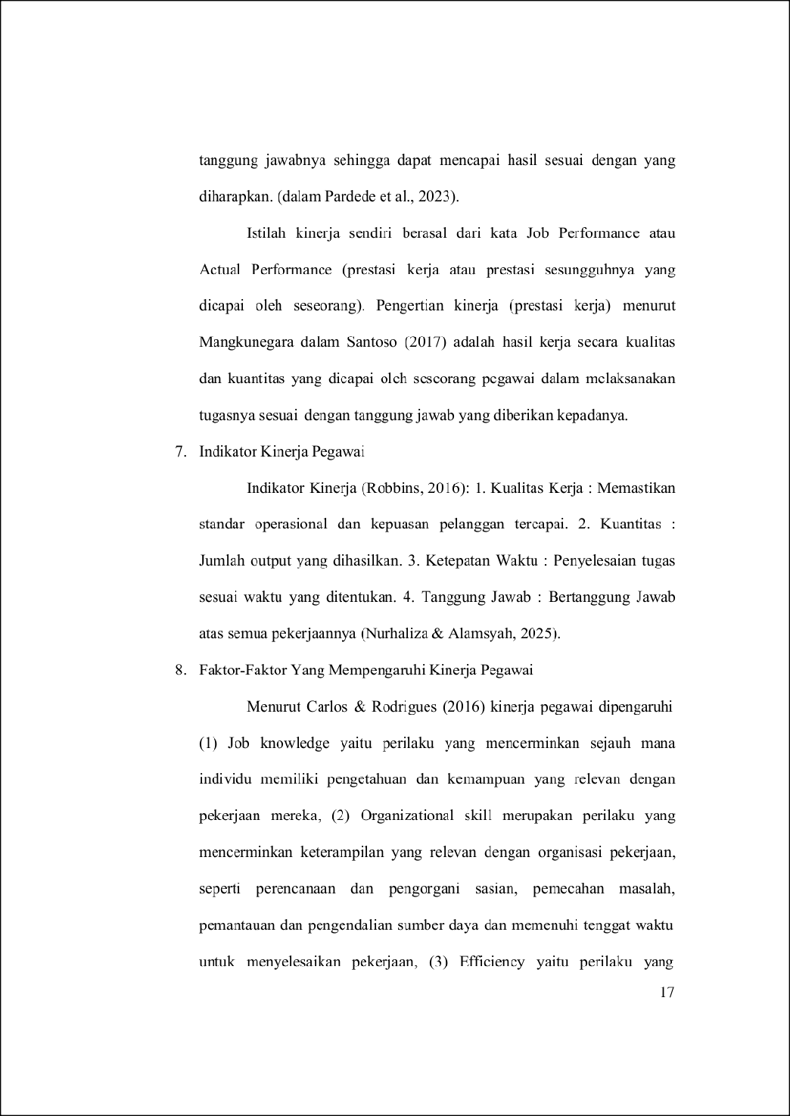
34
8

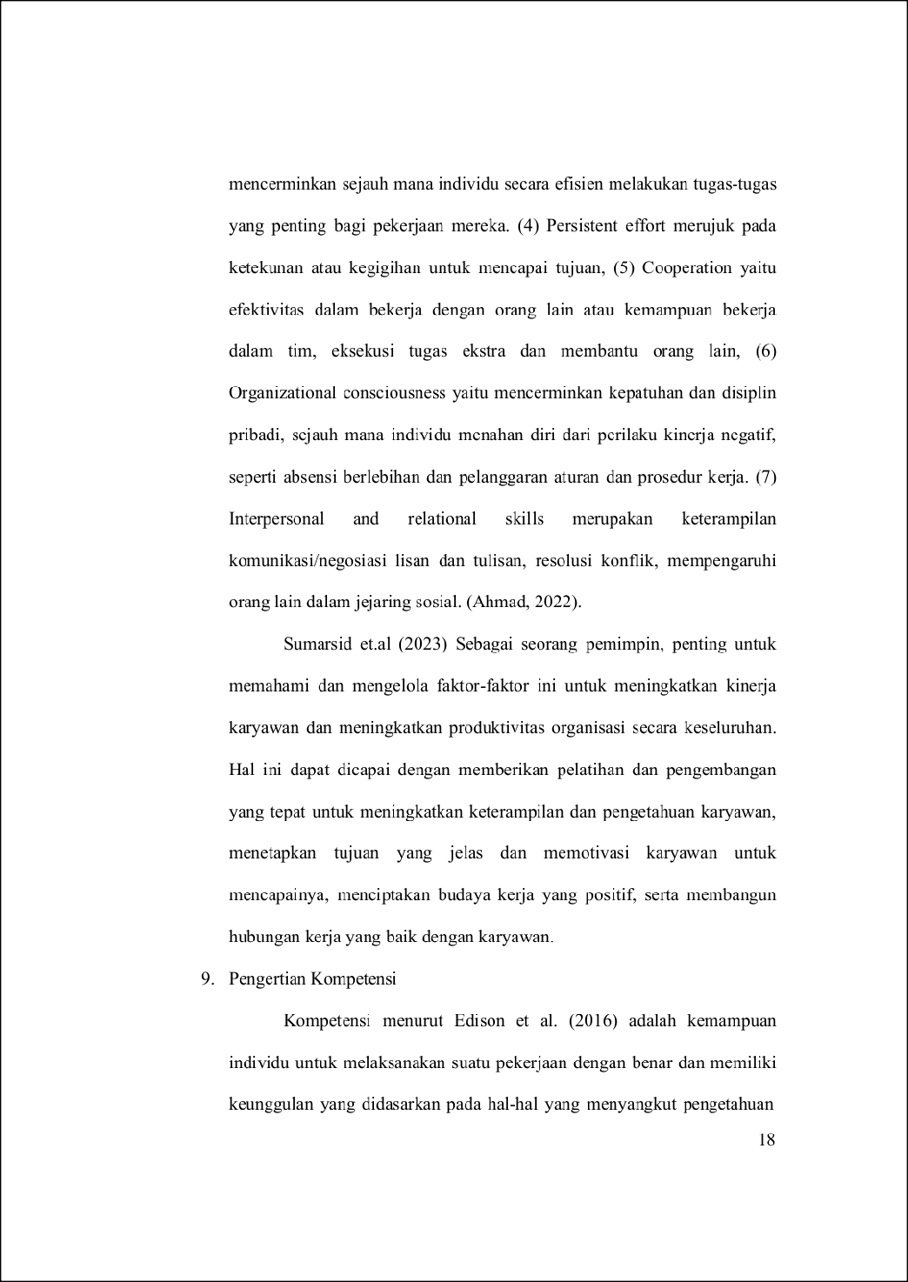
70
70
70
9
43

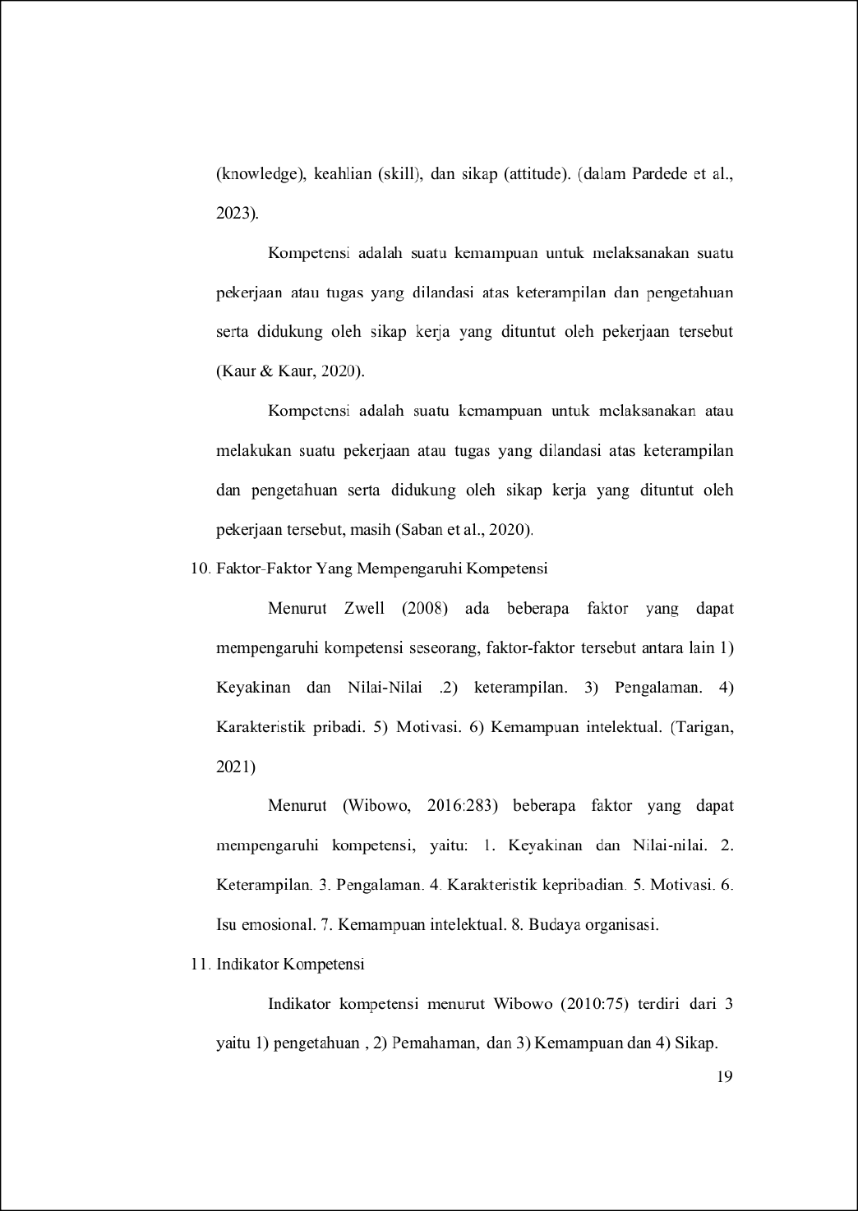
22
49
11

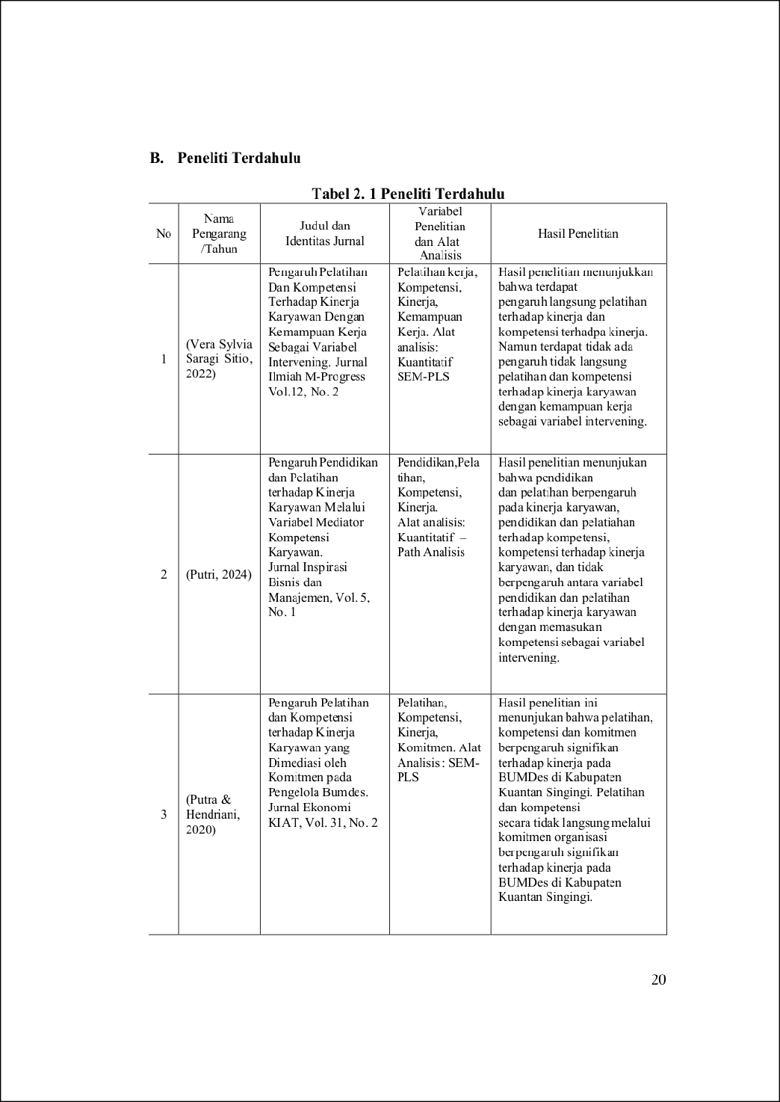
1
5
5
27
27
36
65
130
5

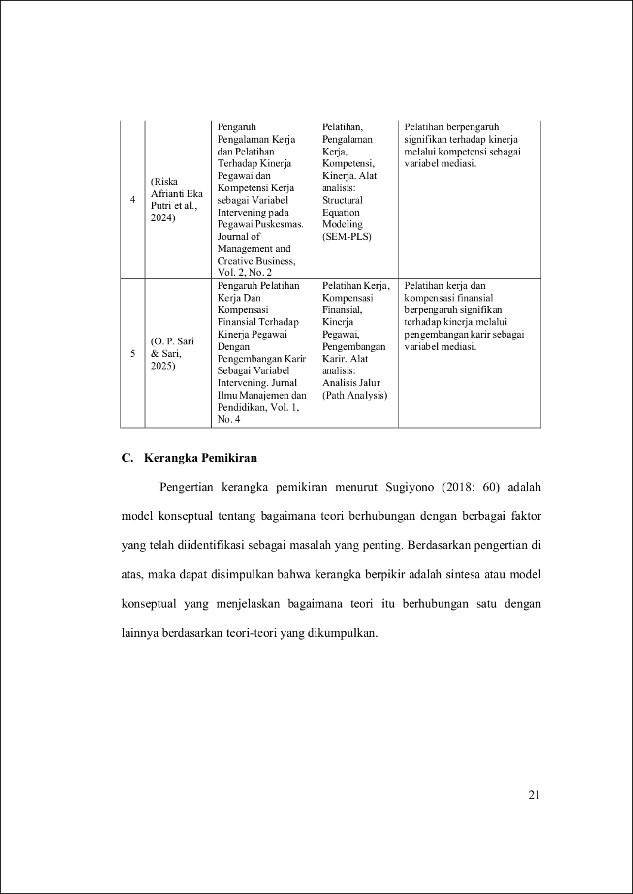
13
14
48
48
24
48
14

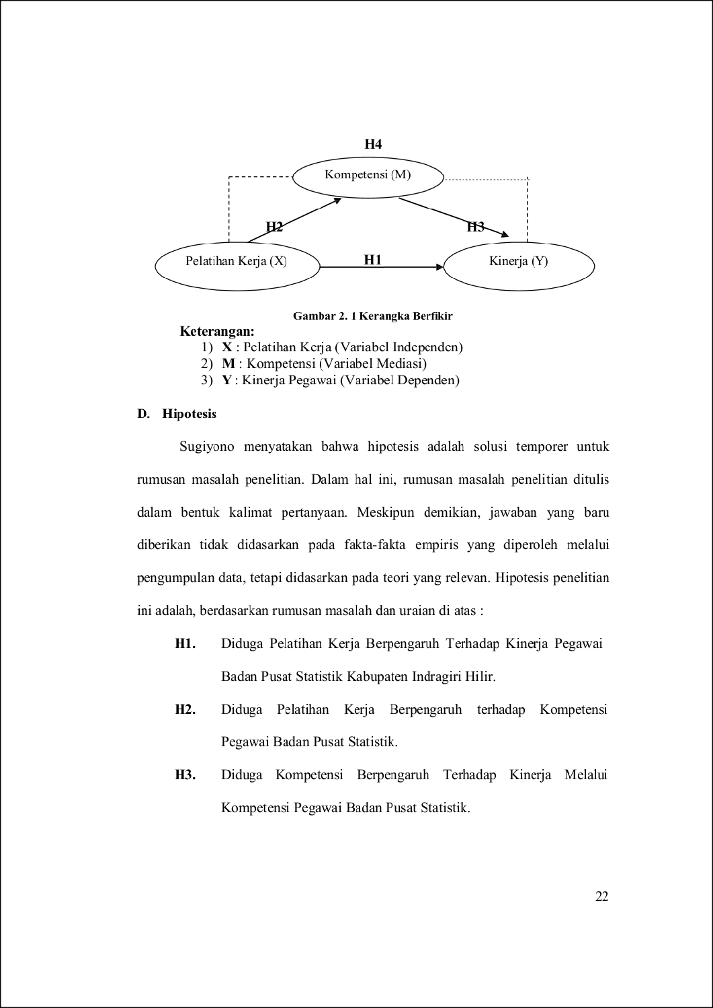
74
55
56
26

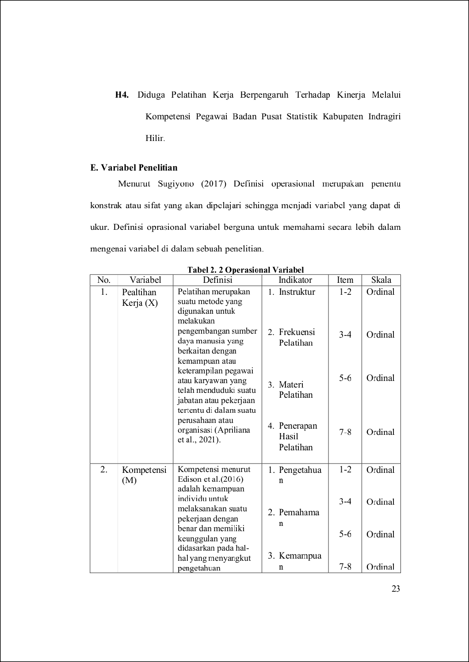
56
46
3
15
131
16

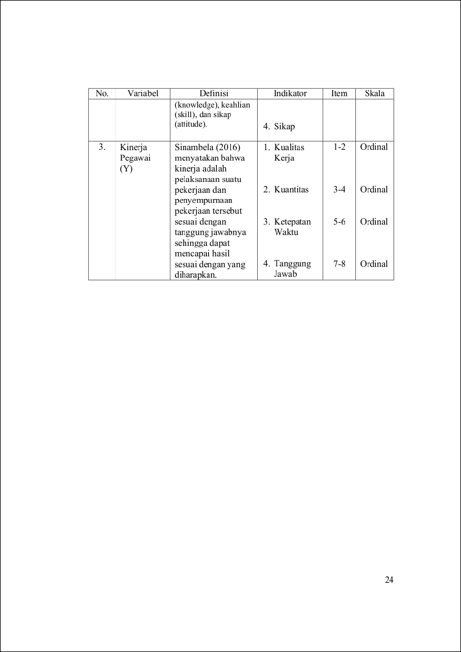
16
89

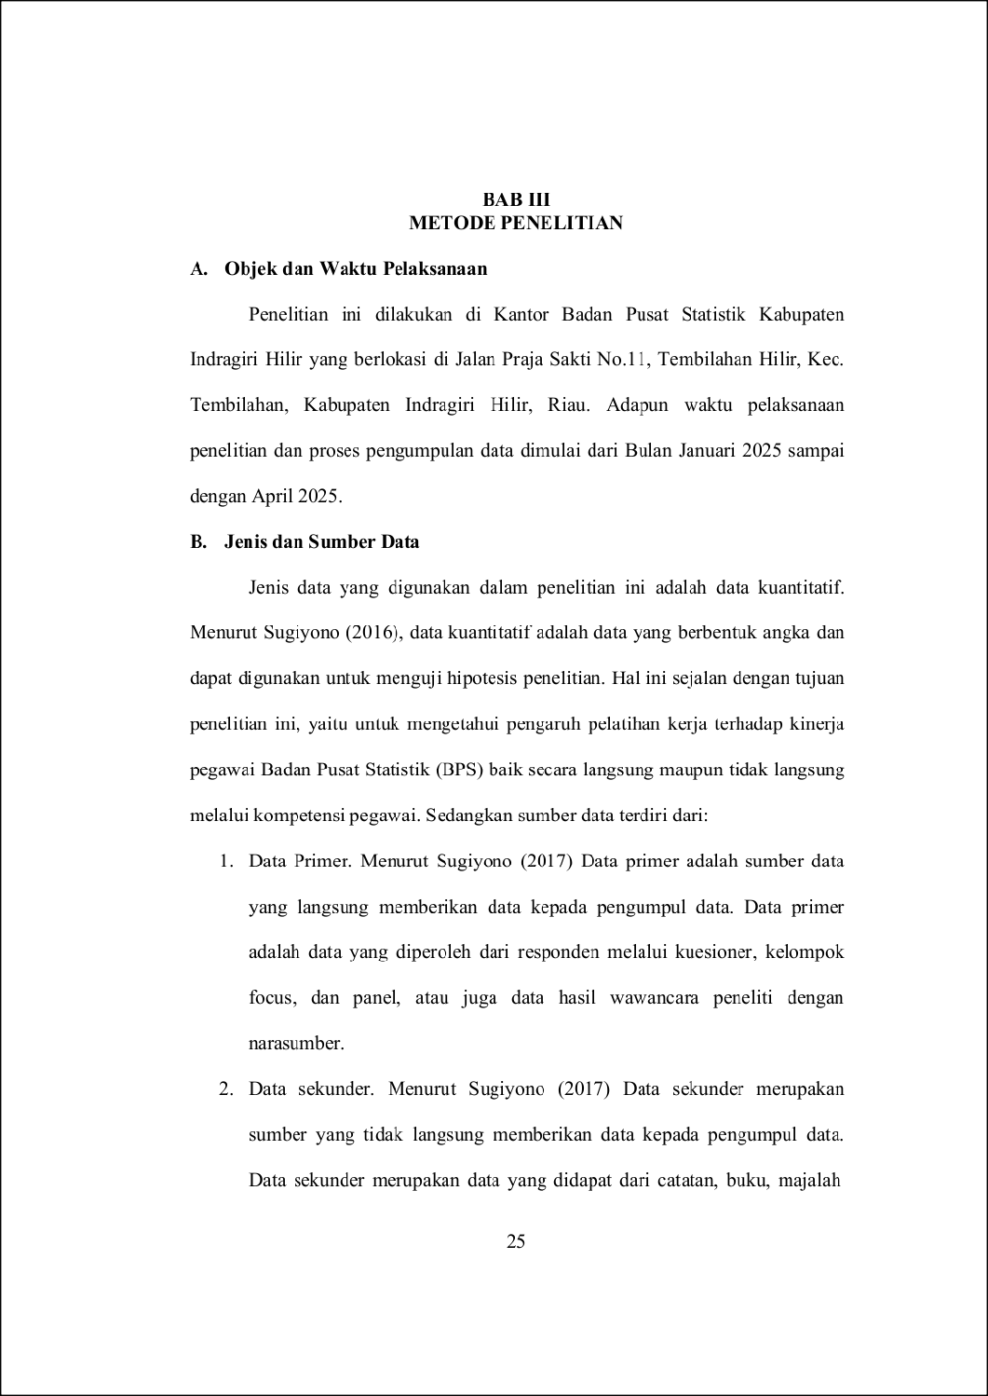
47
3
132
3
82
21
59
107

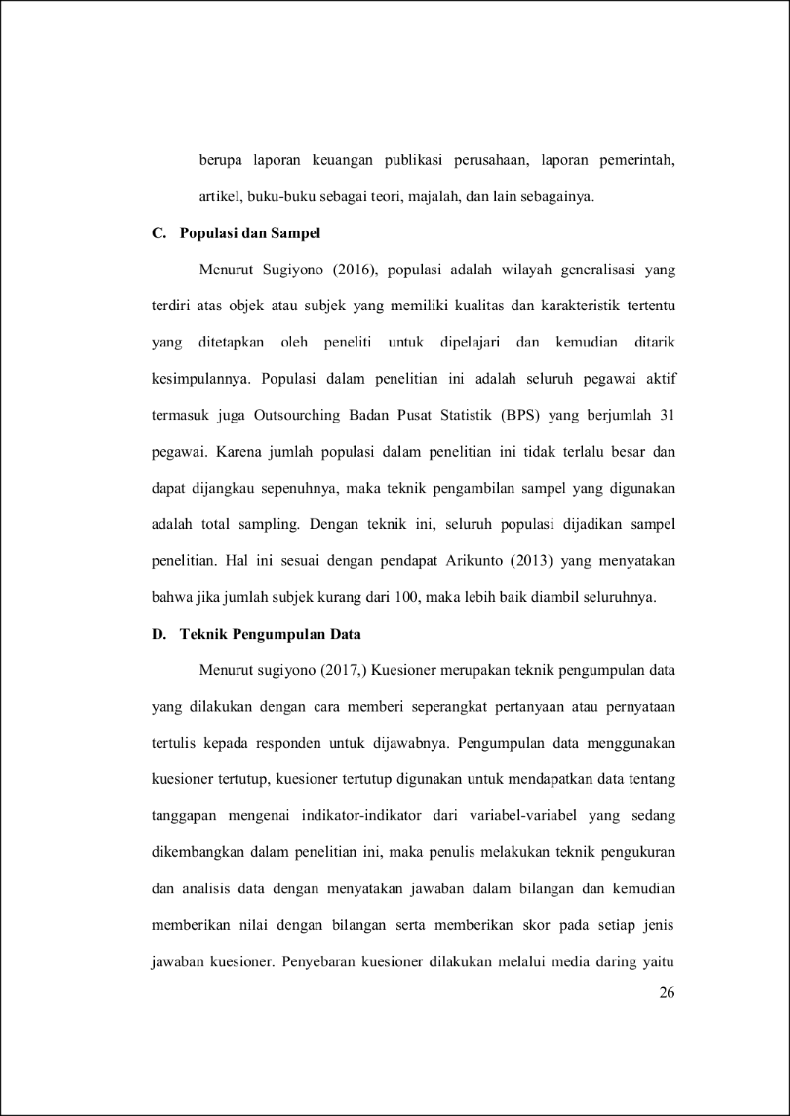
119
72
114
9
19

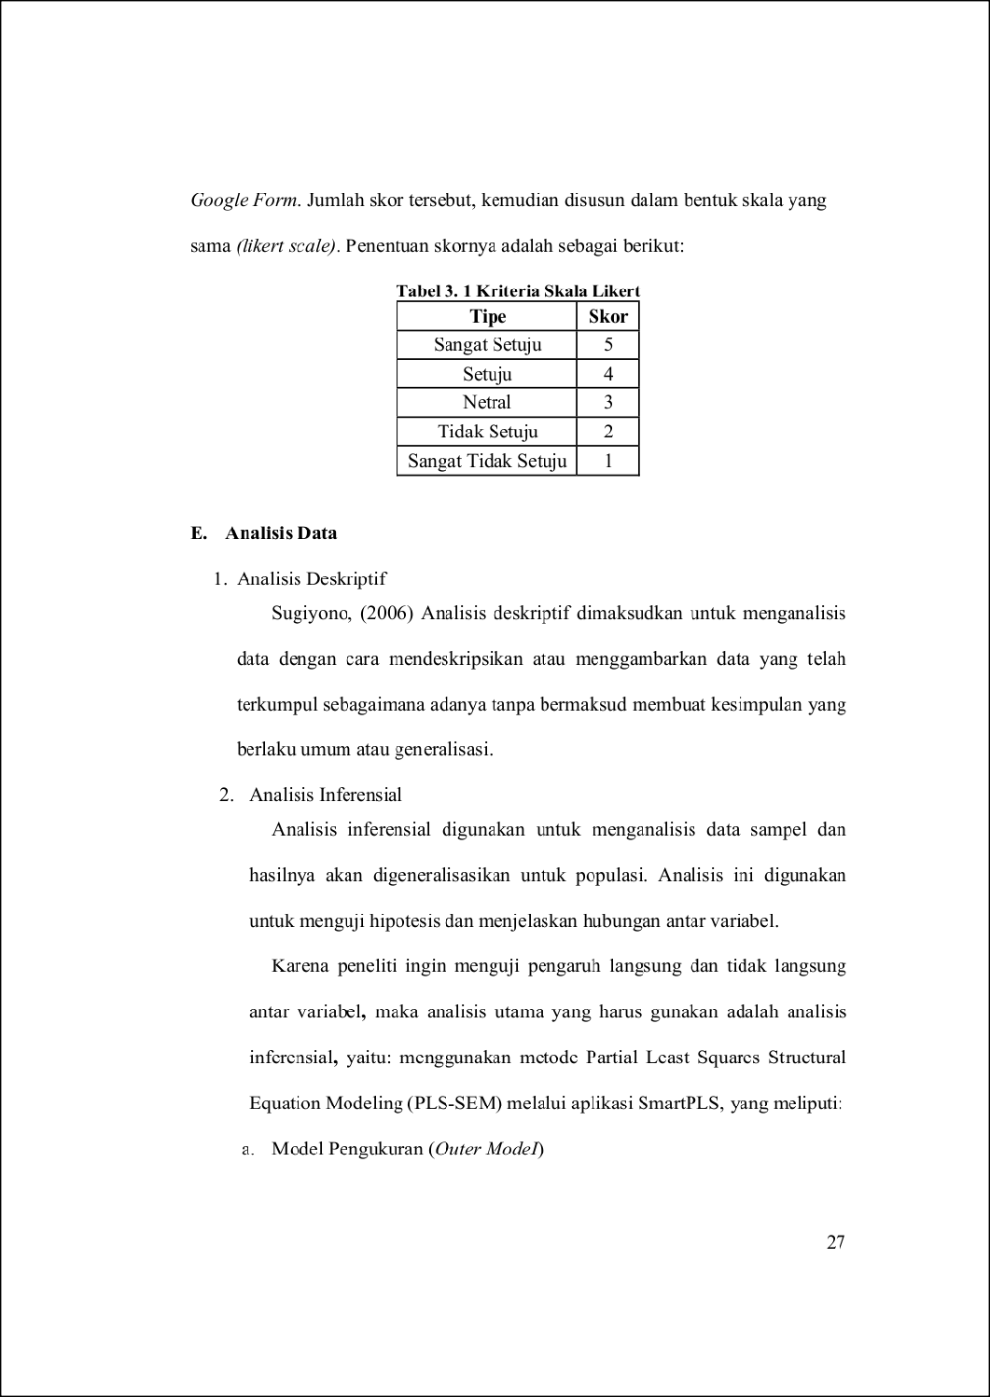
19
71
7
99
127
79
62

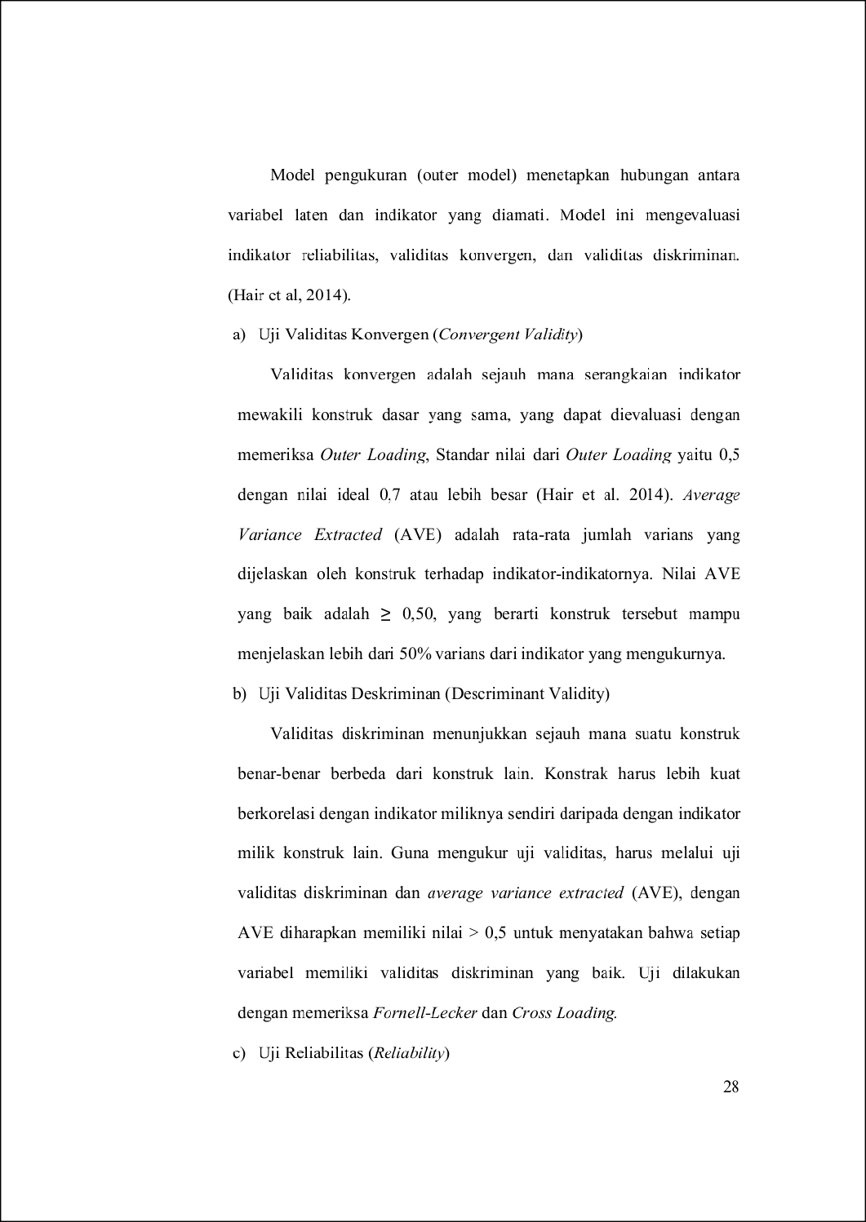
9
45
23
38

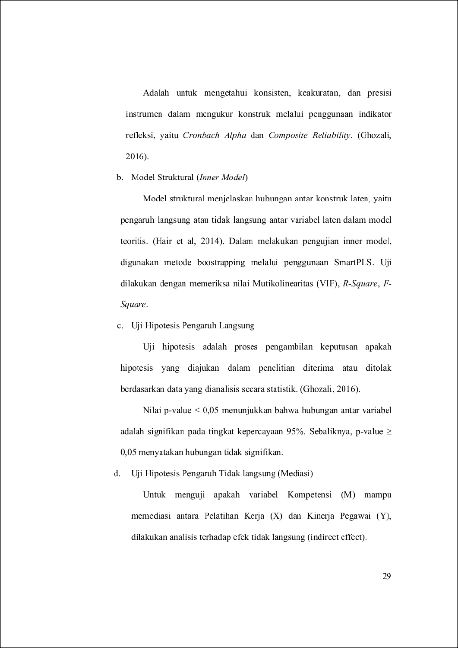
139
9
164
83
41
66
80
7

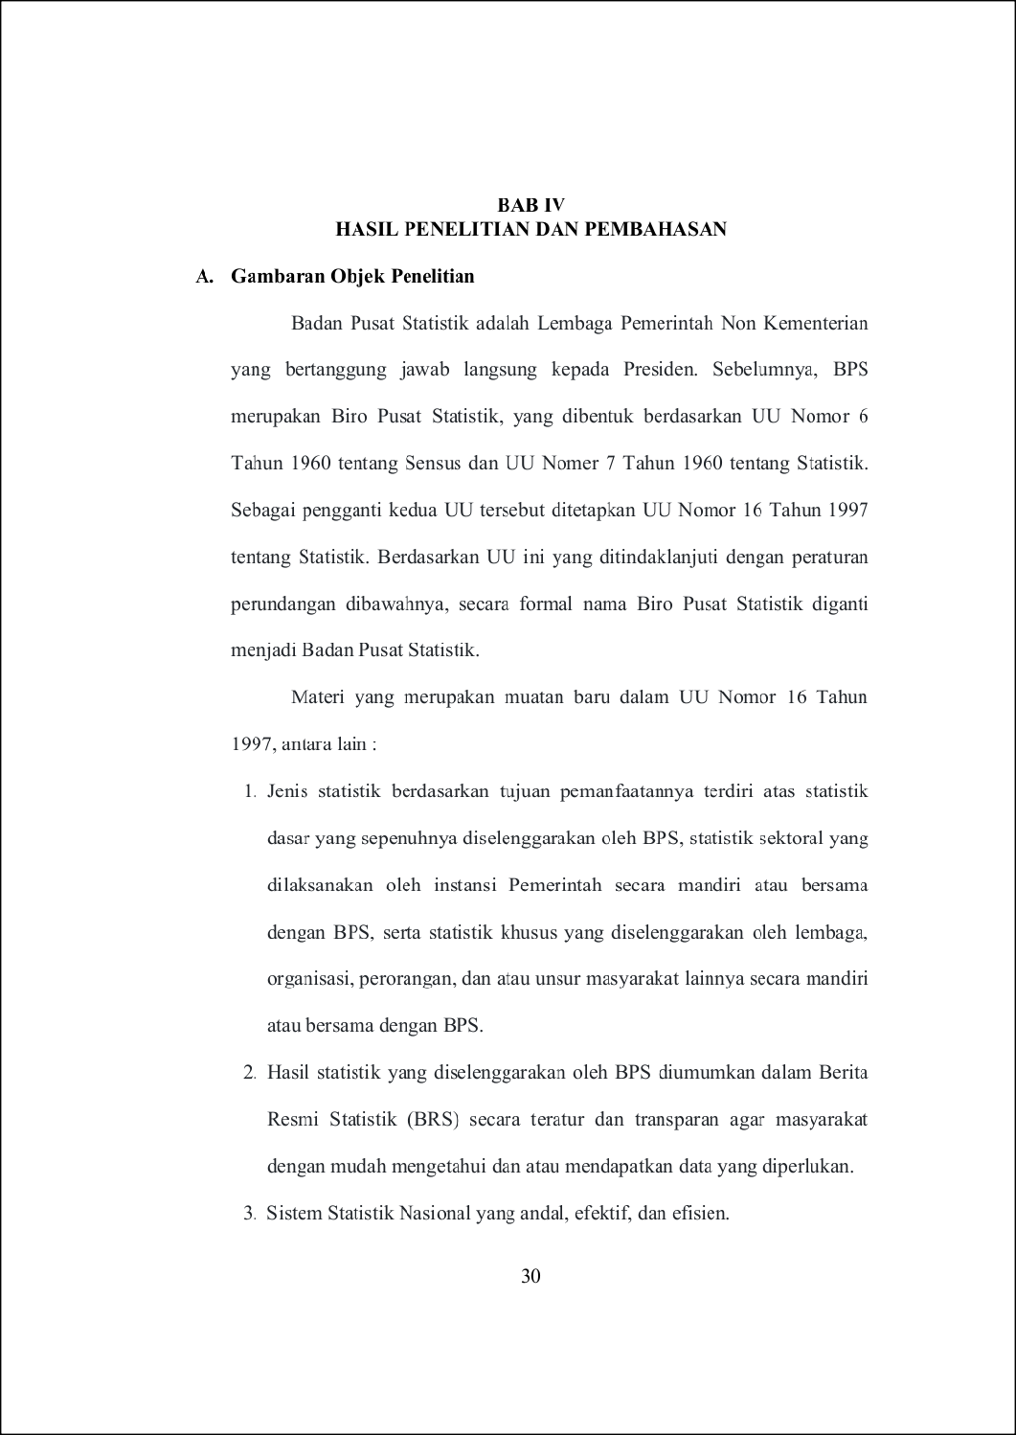
2

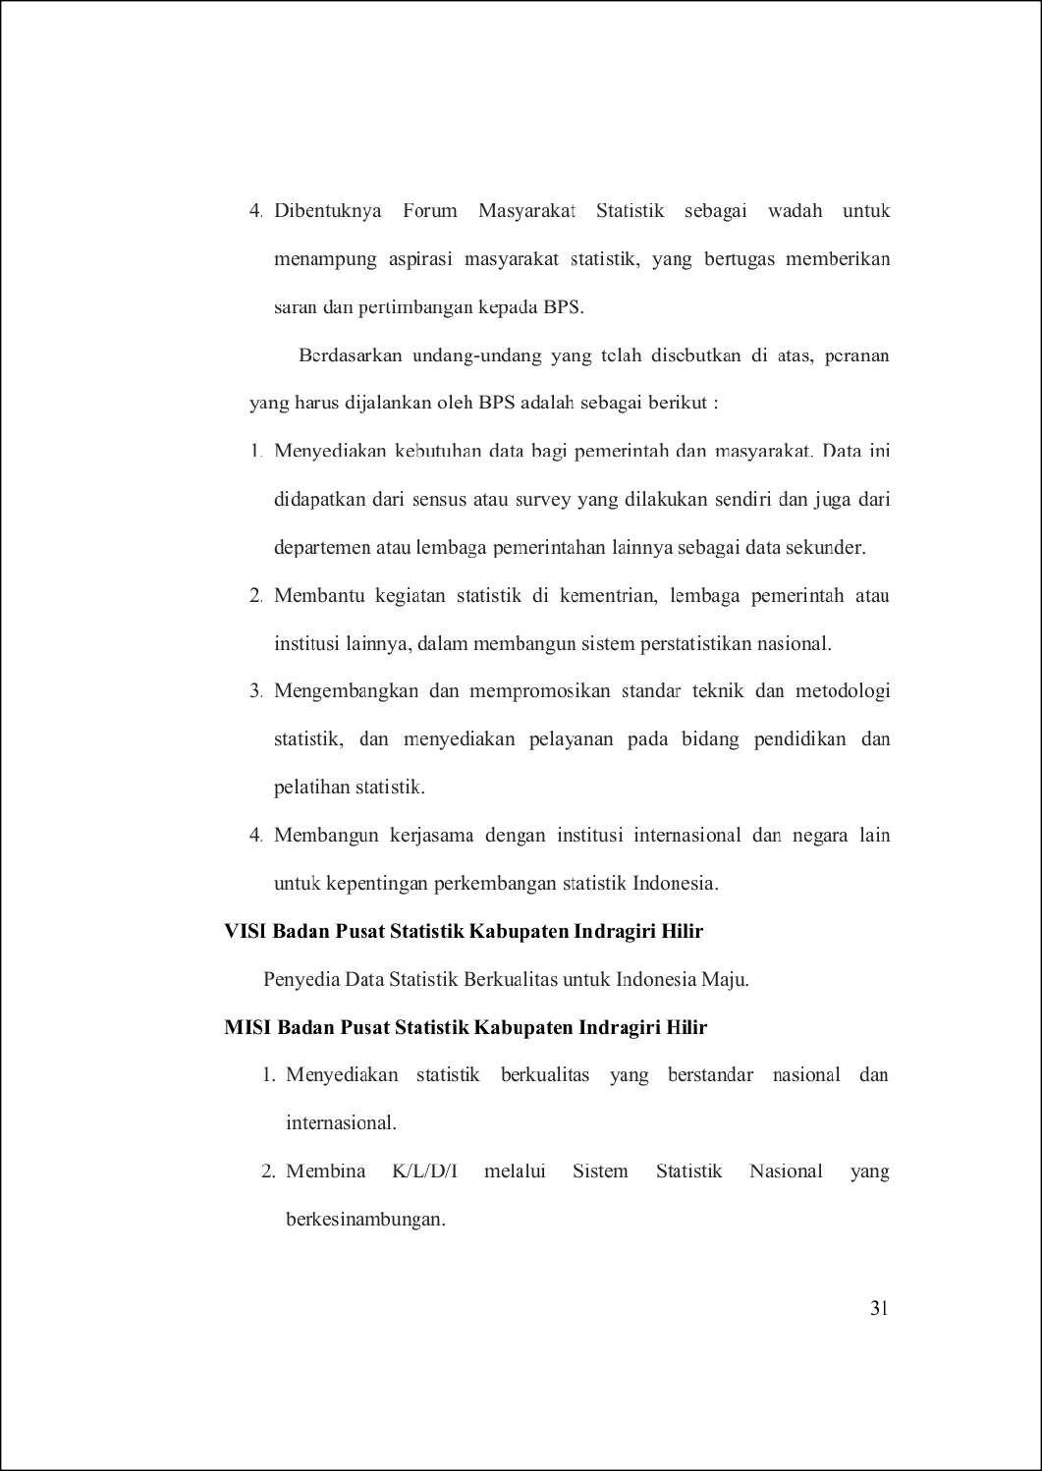
29

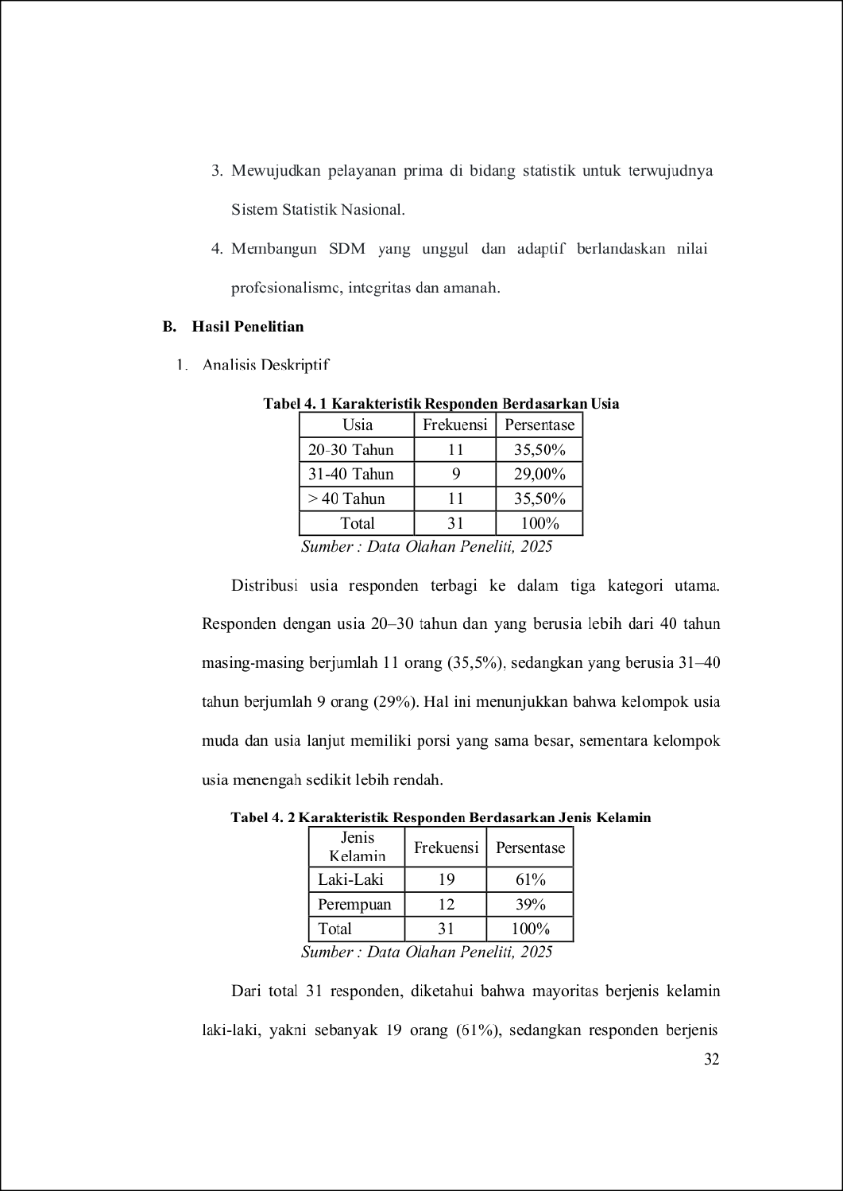
101
133
150
9

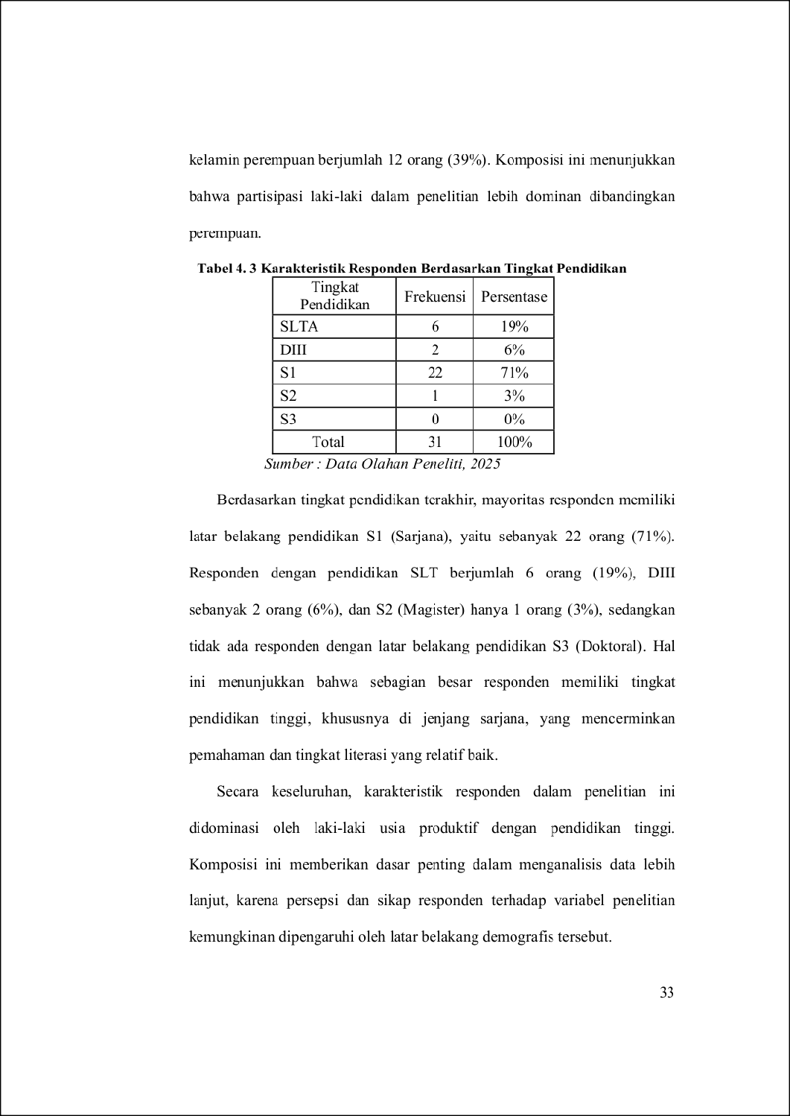
12
75
67
47
116
124

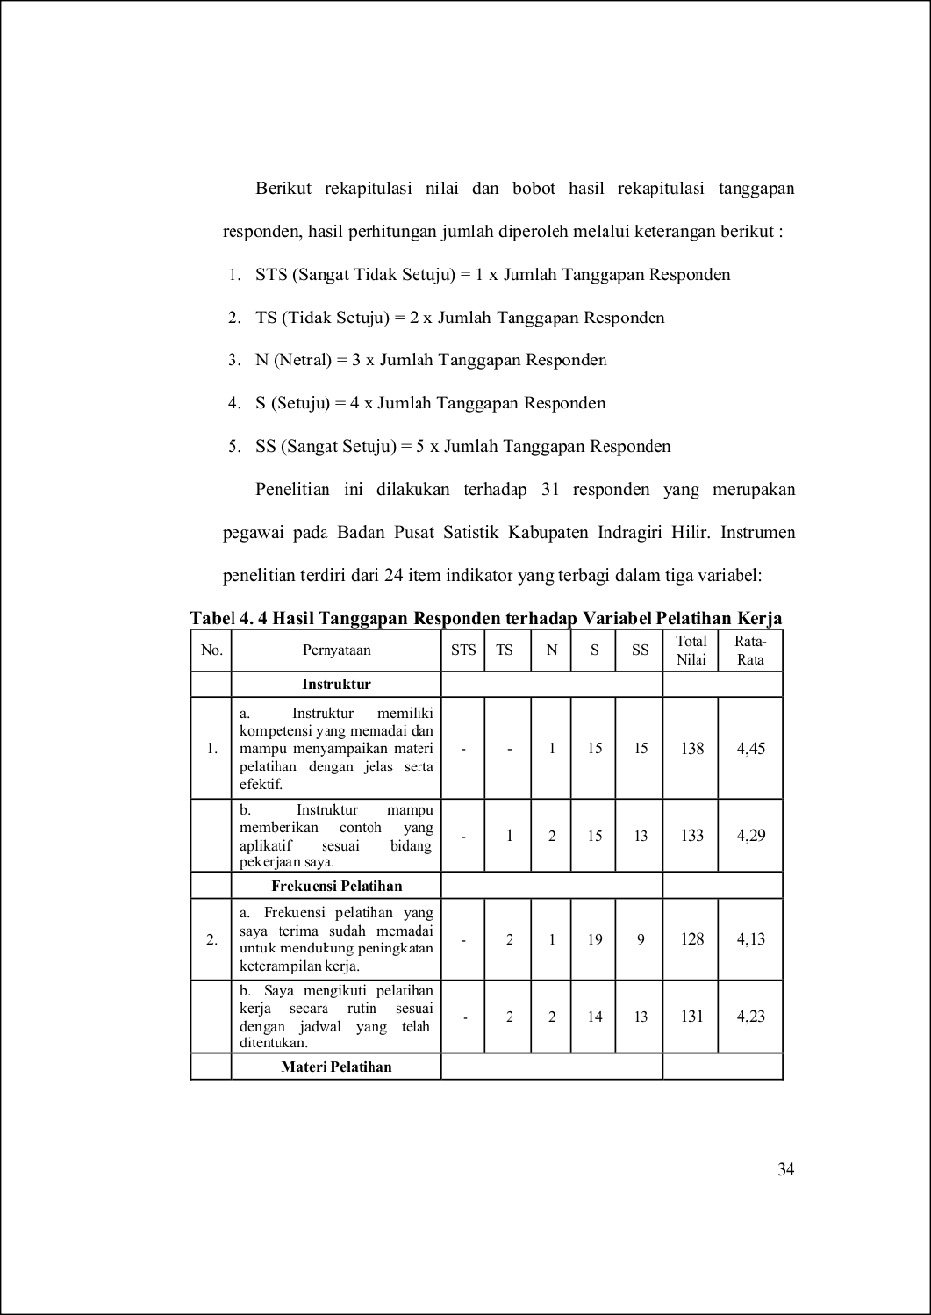
61
56
25
85

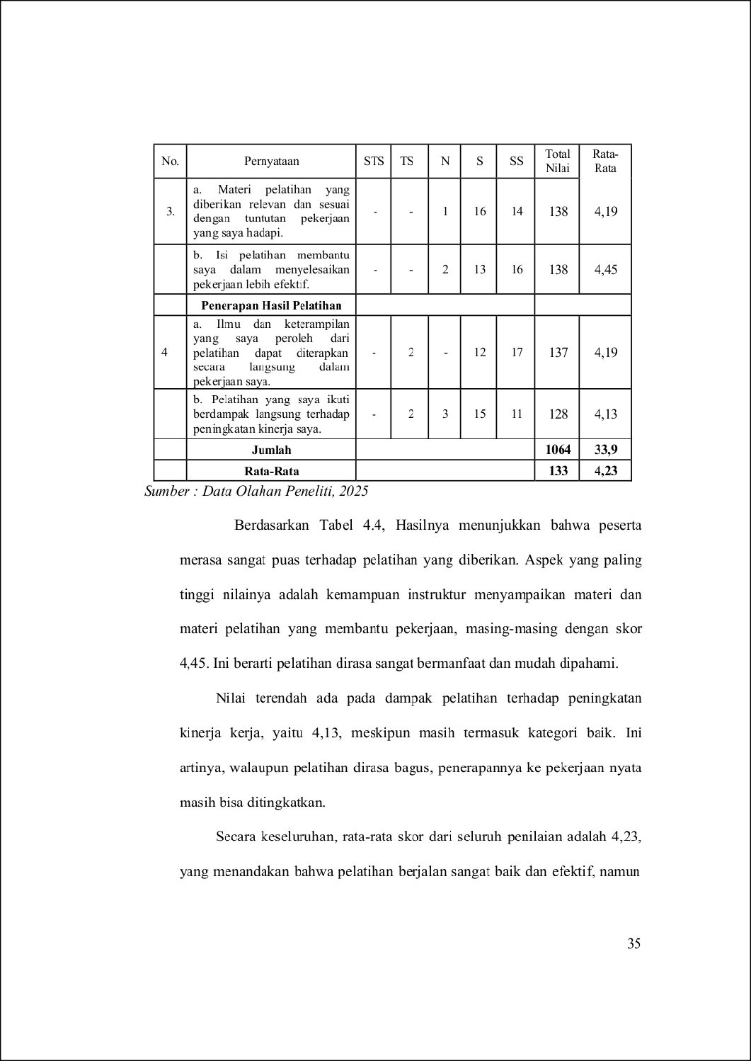
31
66

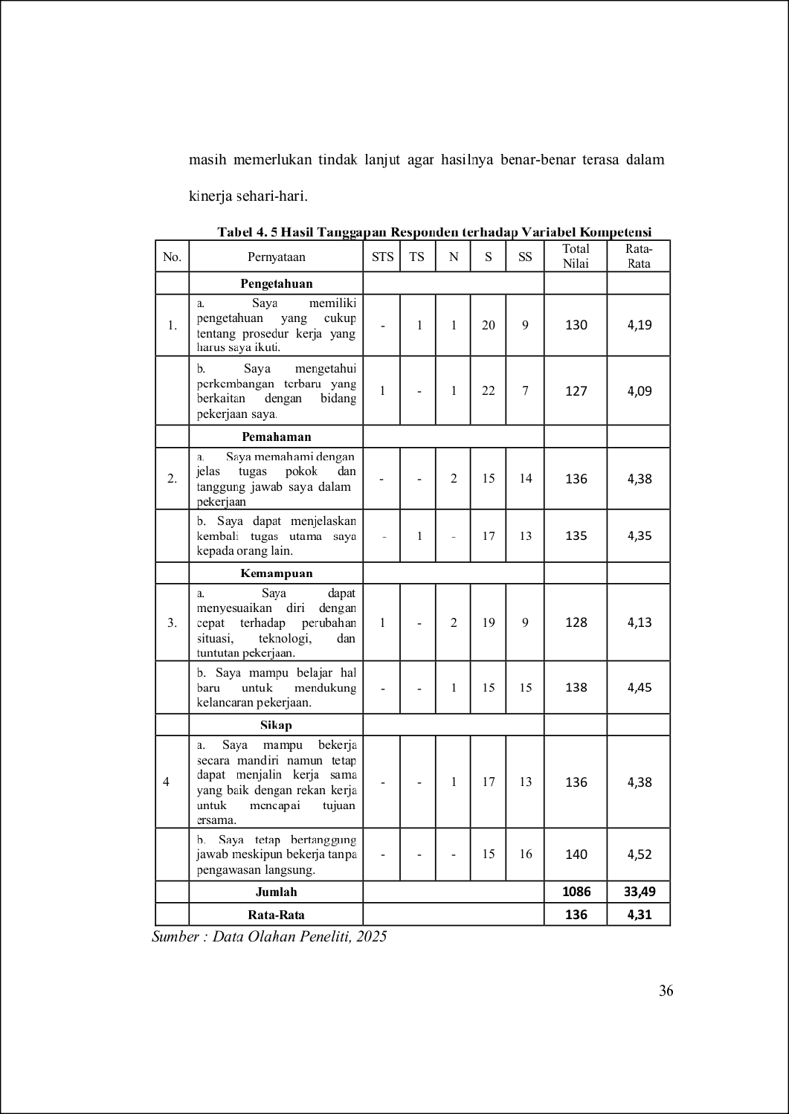
25
148
40

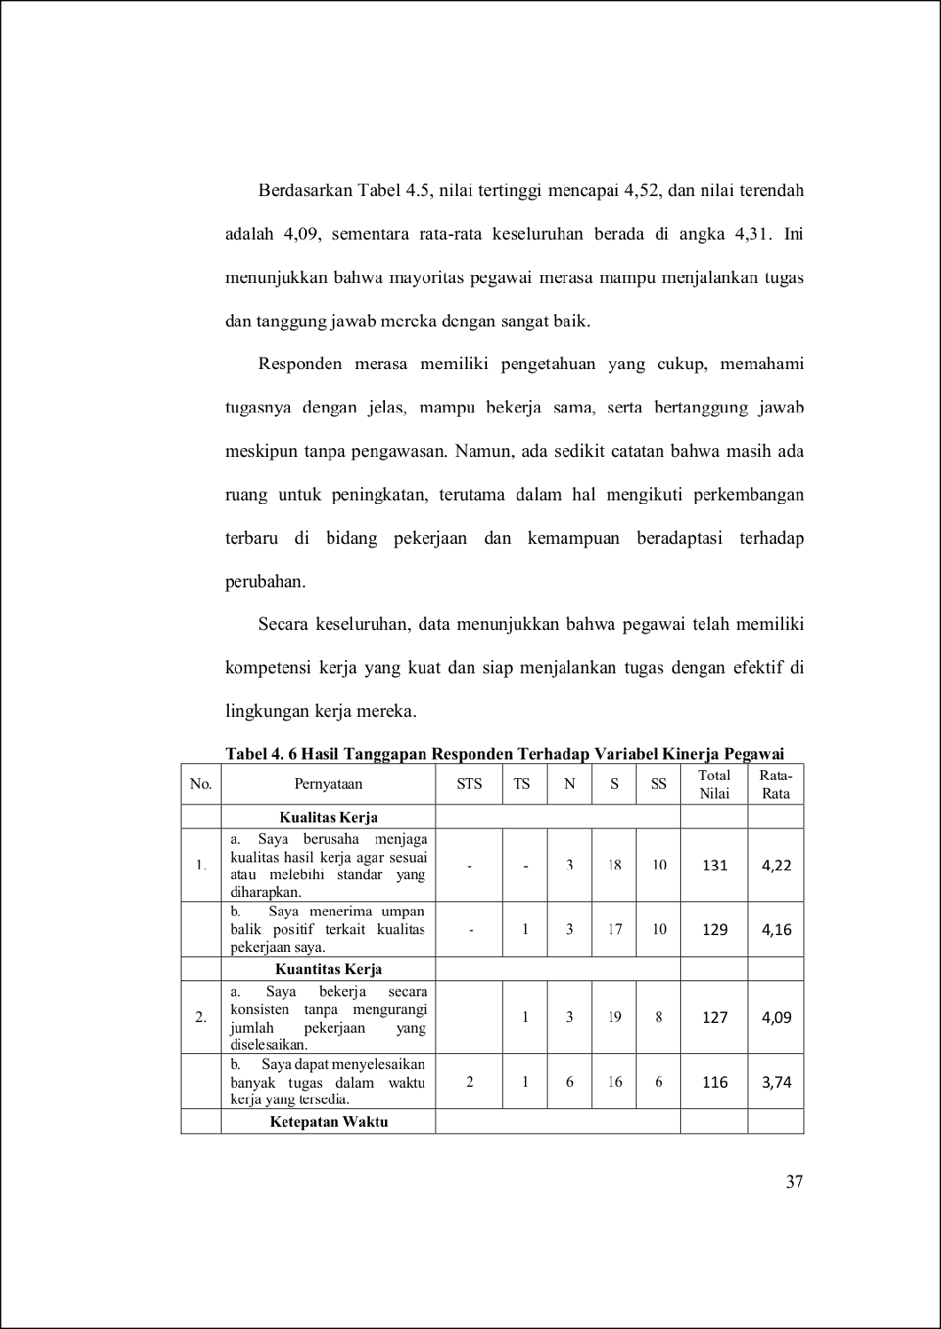
10
50
25

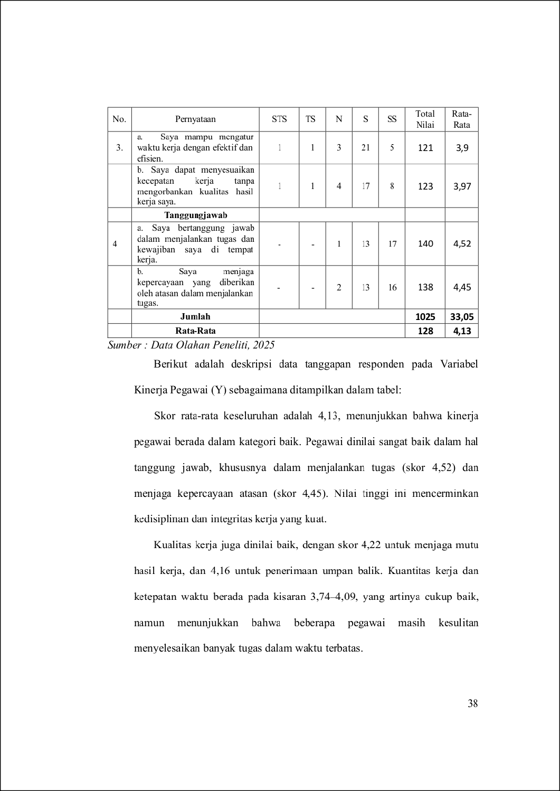
50
152
143

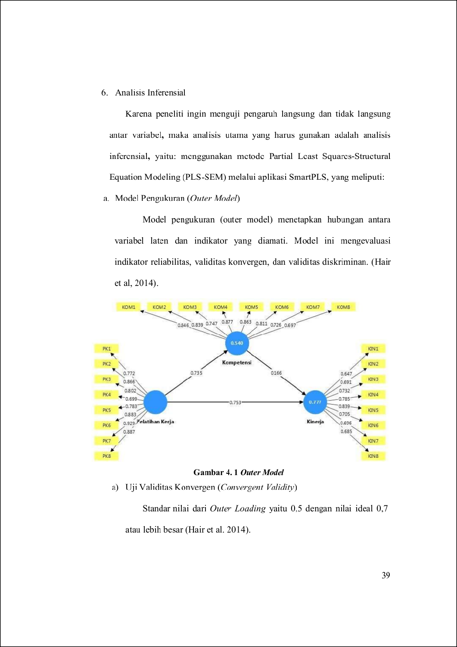
79
62
9
77
154
45

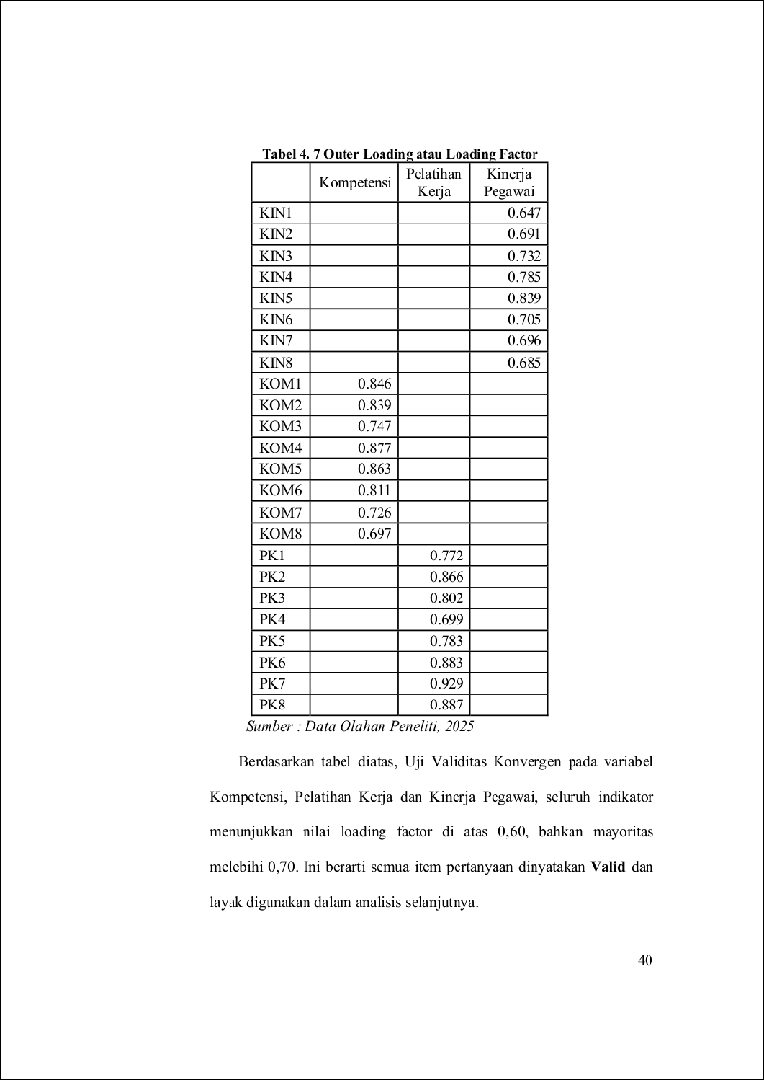
63
87
51
162
147

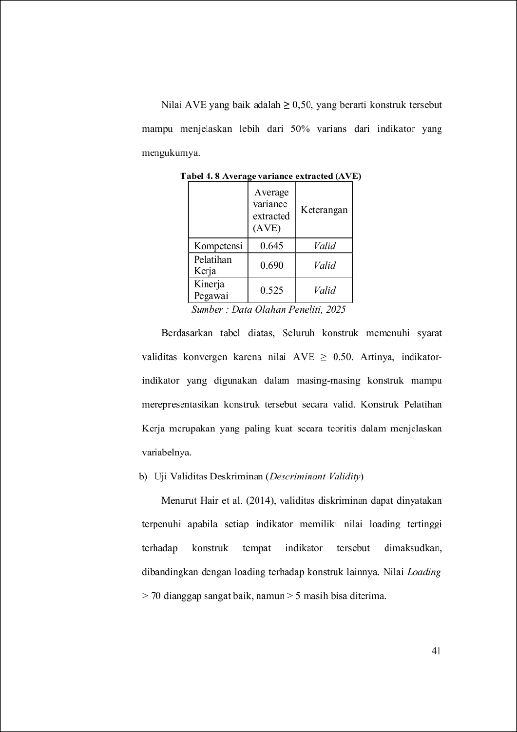
4
20
81
51
118
104
104

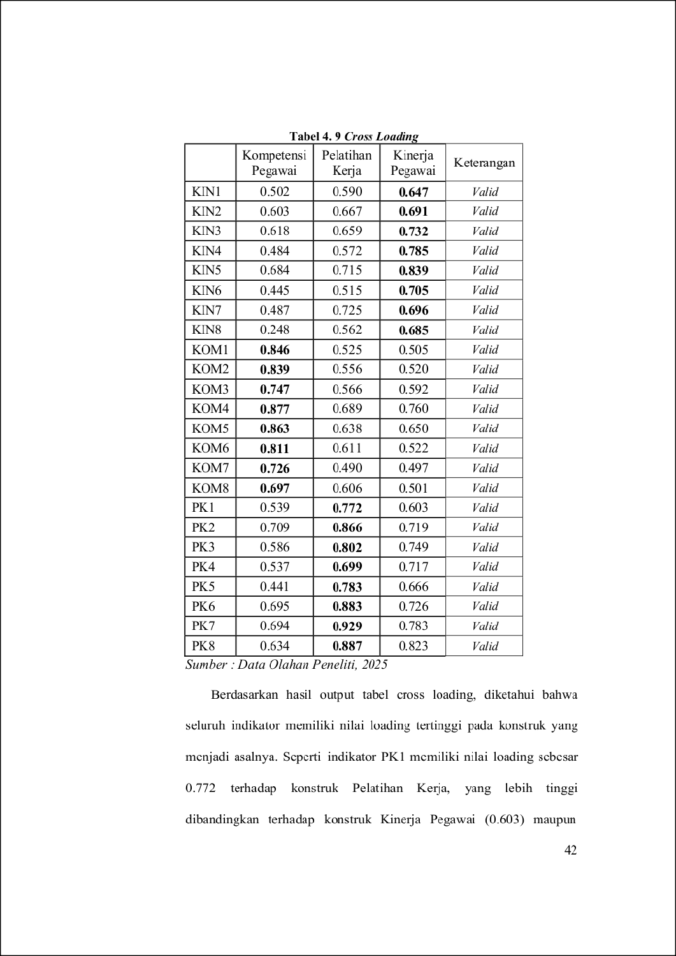
4
4
51
39
50

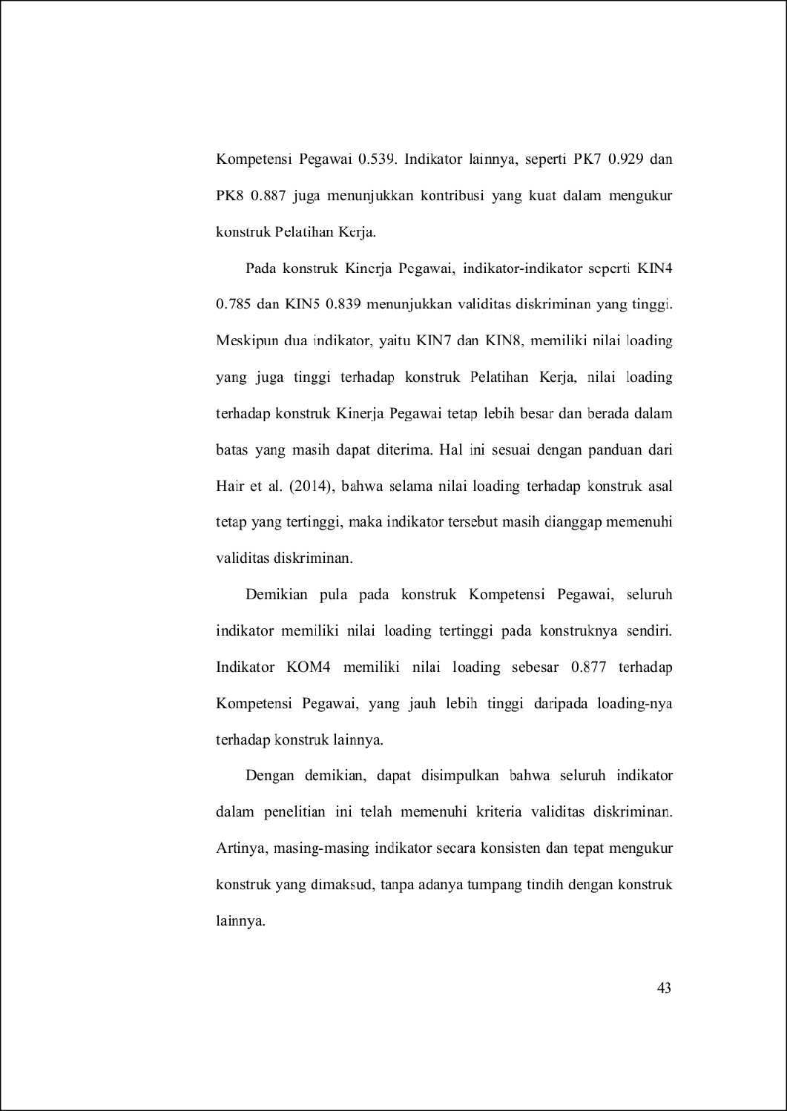
140
161
106
106
4
163

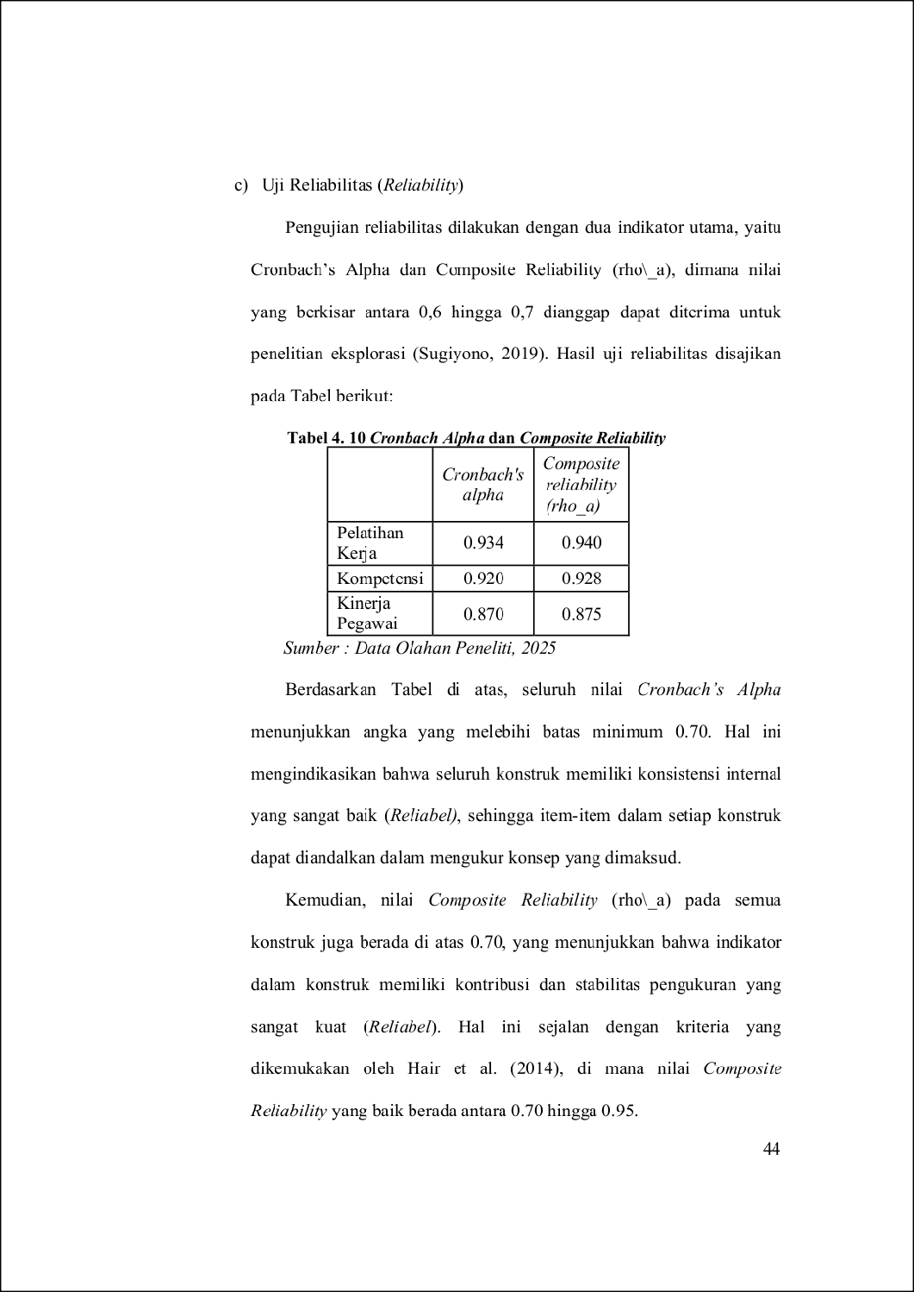
105
41
134
73
126
39
32
37
38

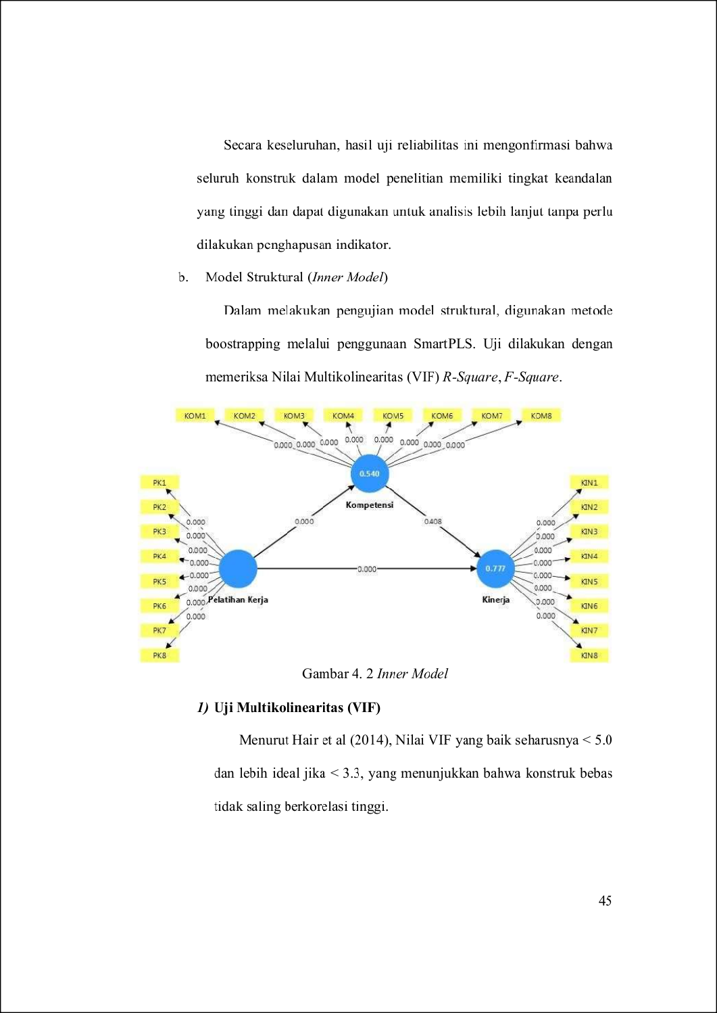
39
83

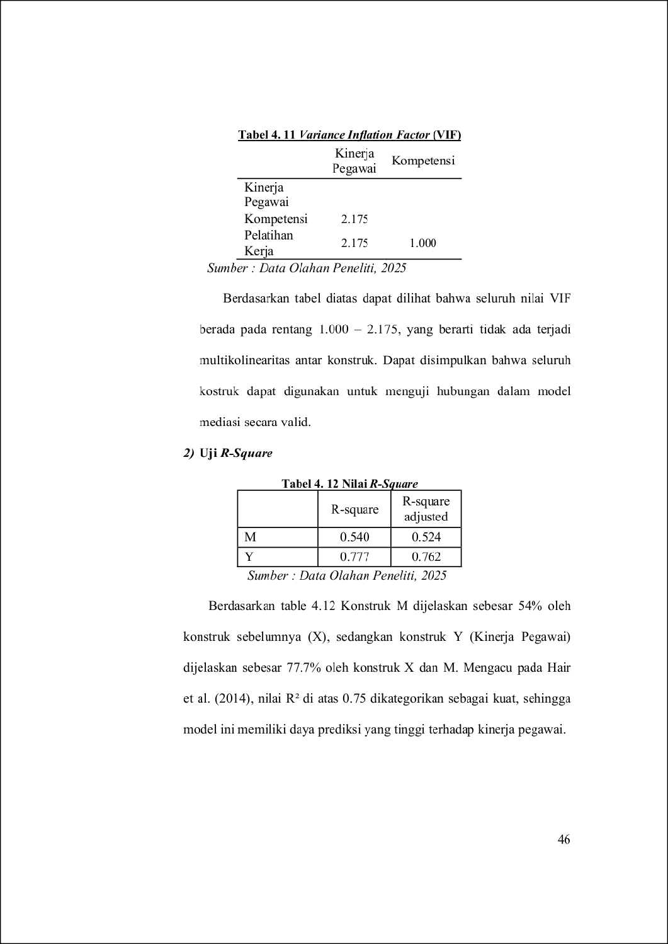
21
21
94

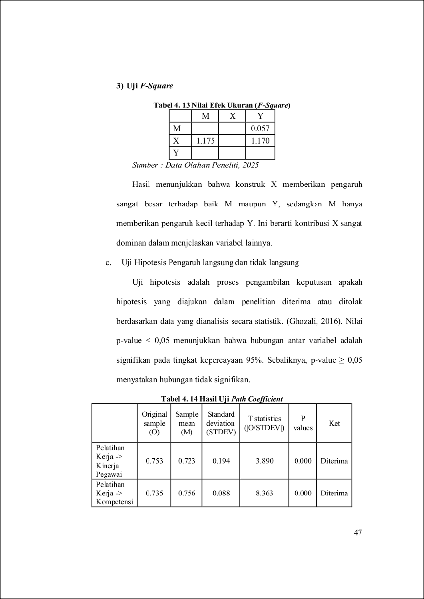
51
41
80
53

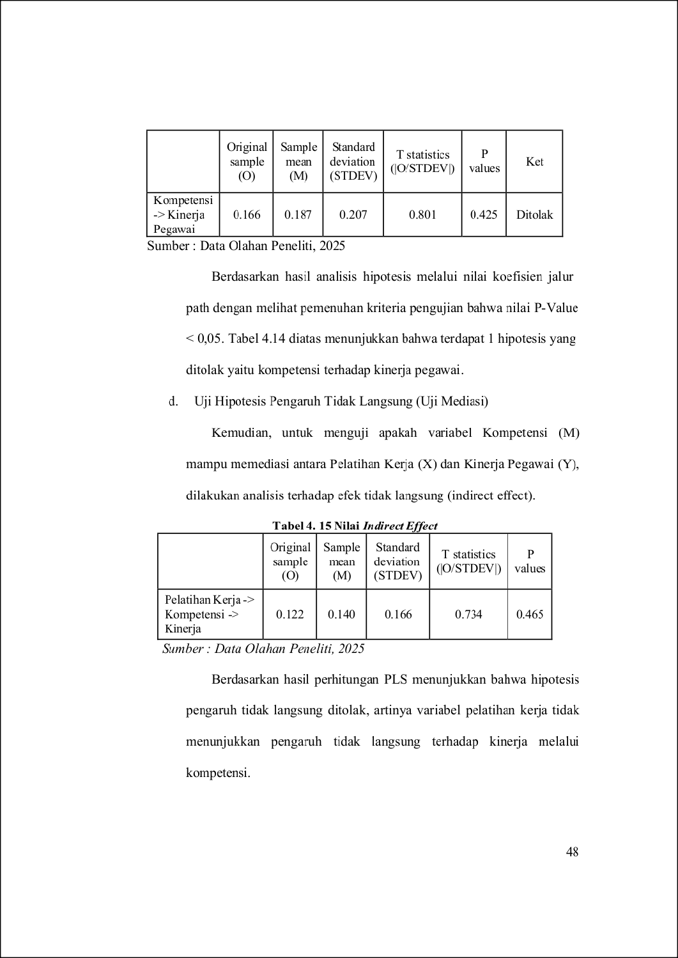
69
5
5
5
9
5
5

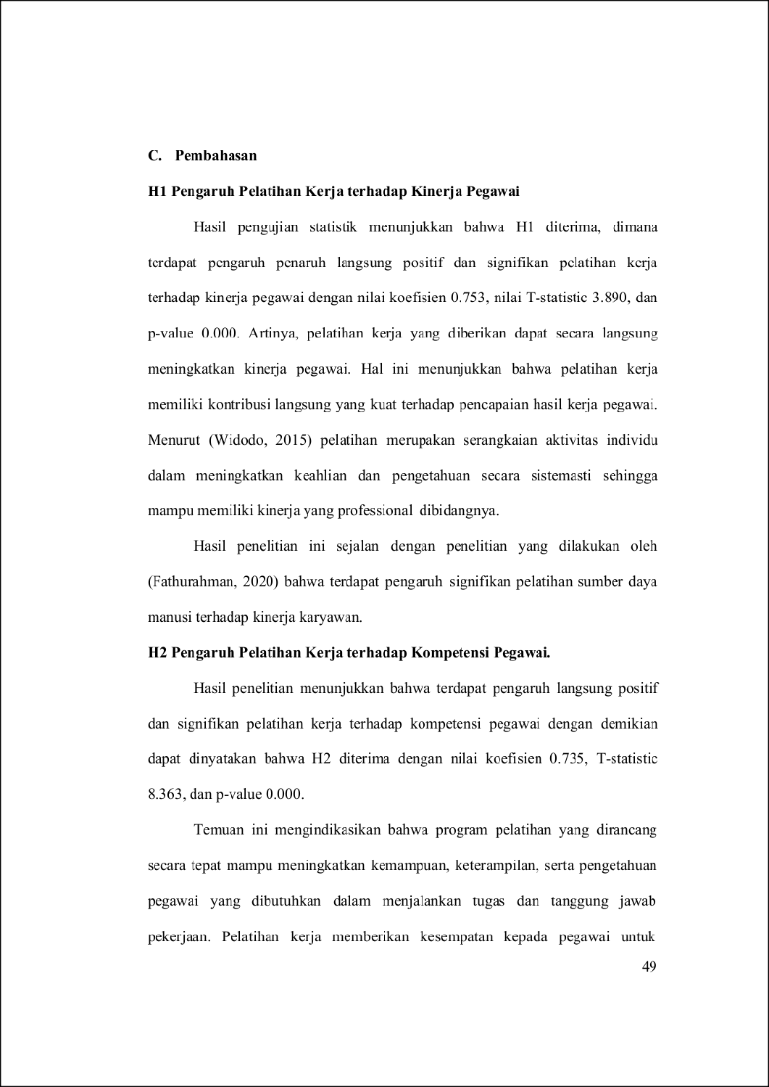
125
78
5
5
111

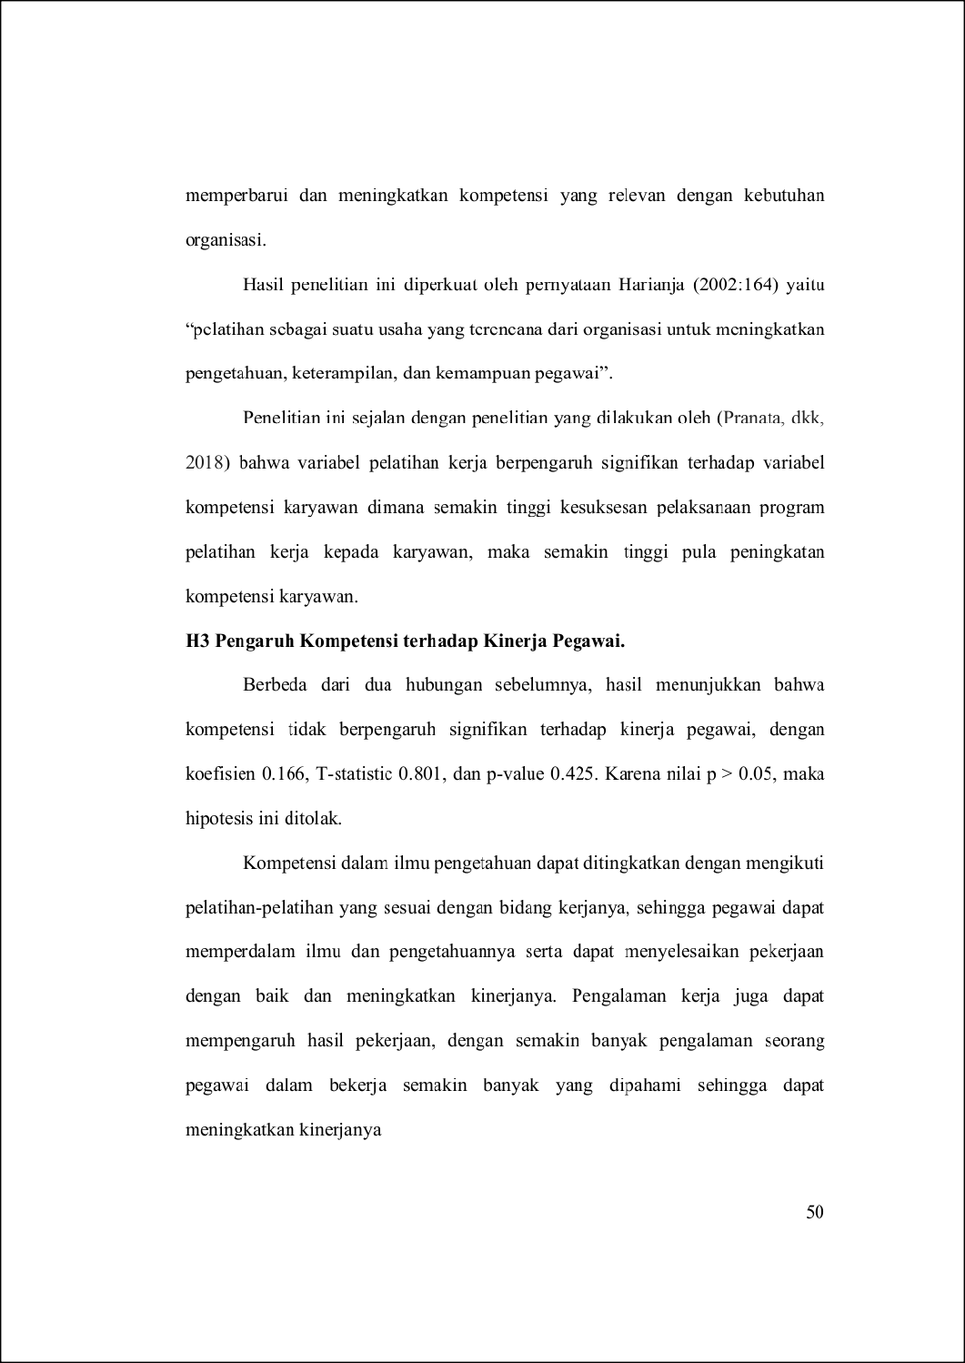
7
121
7
88
10

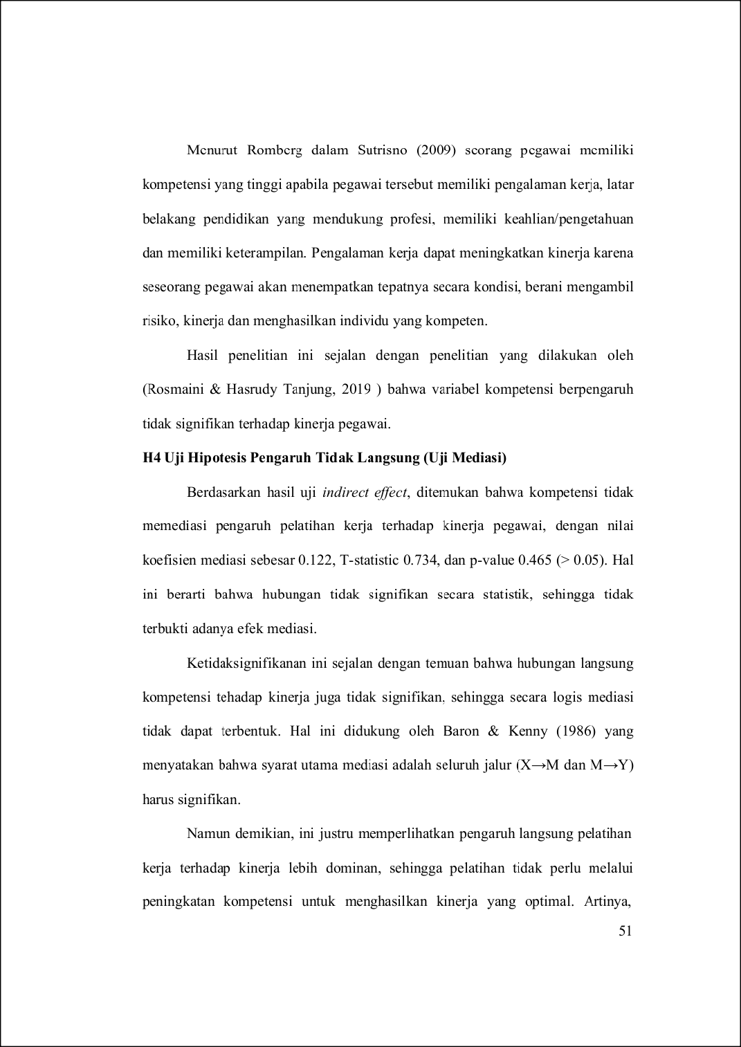
151
159
84

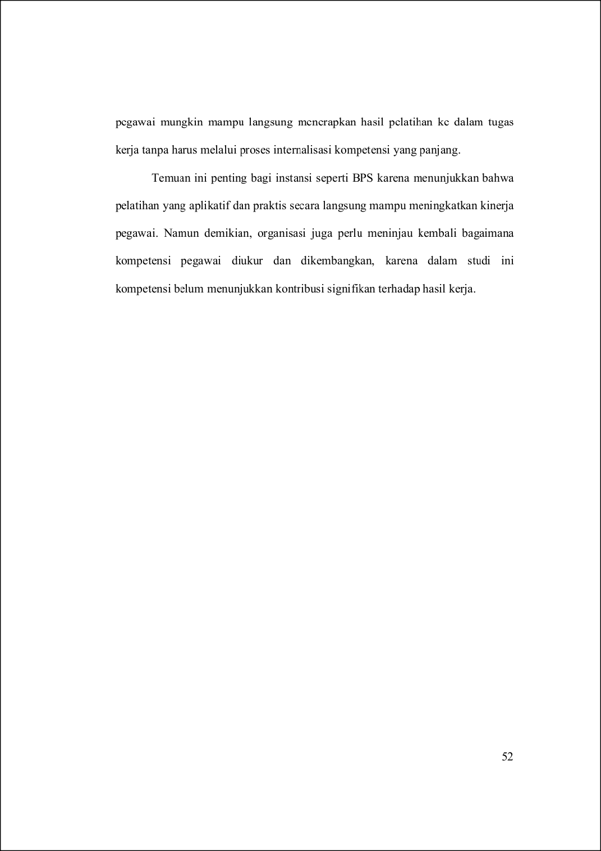

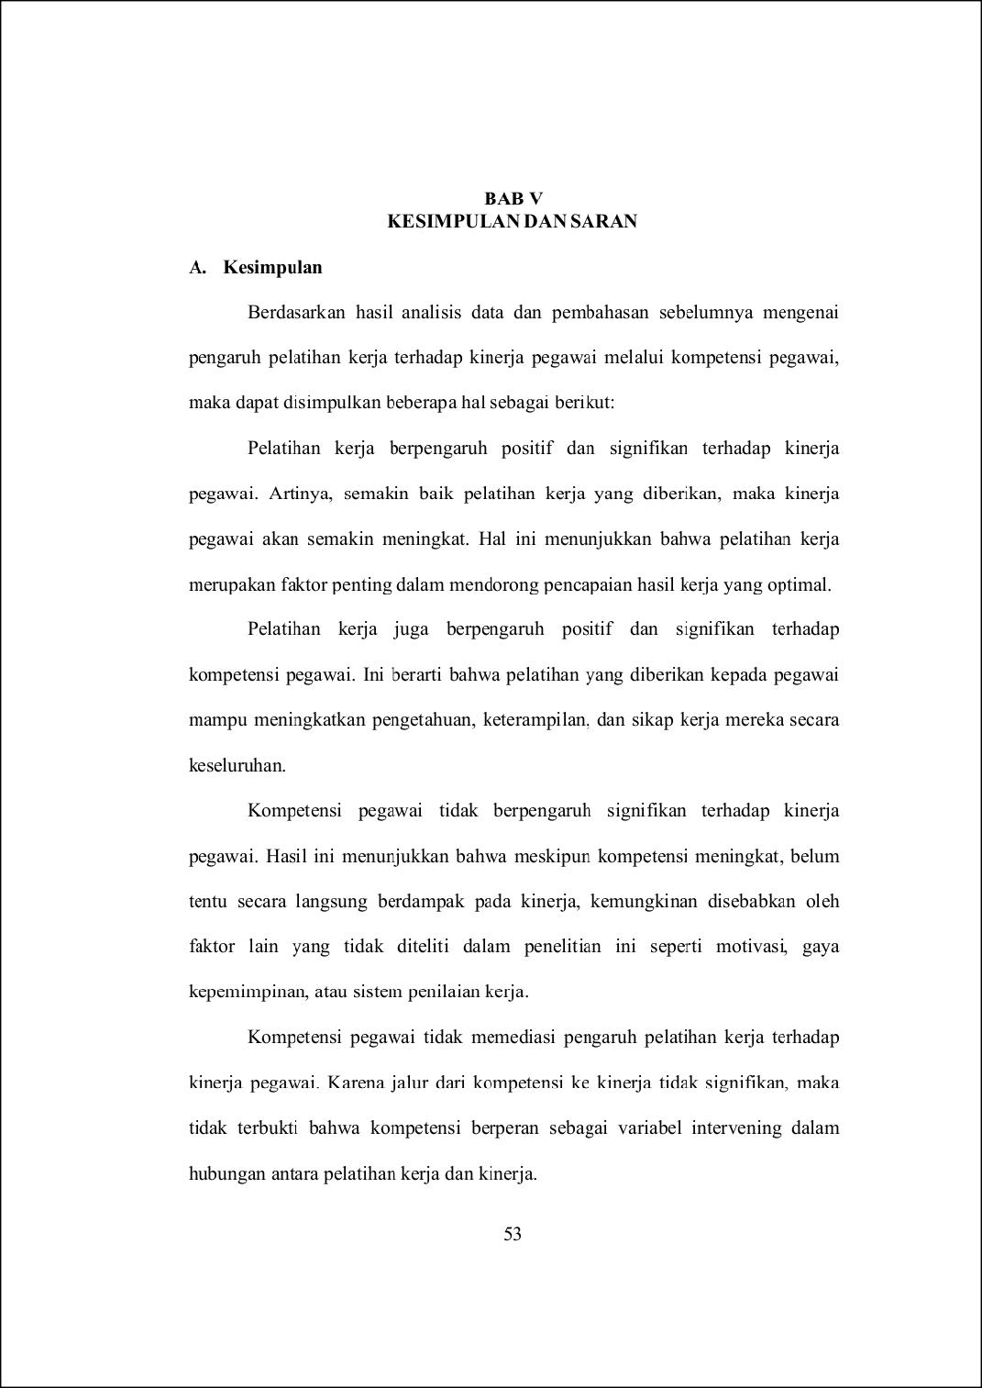
33
57
7
95
7
82
108
7

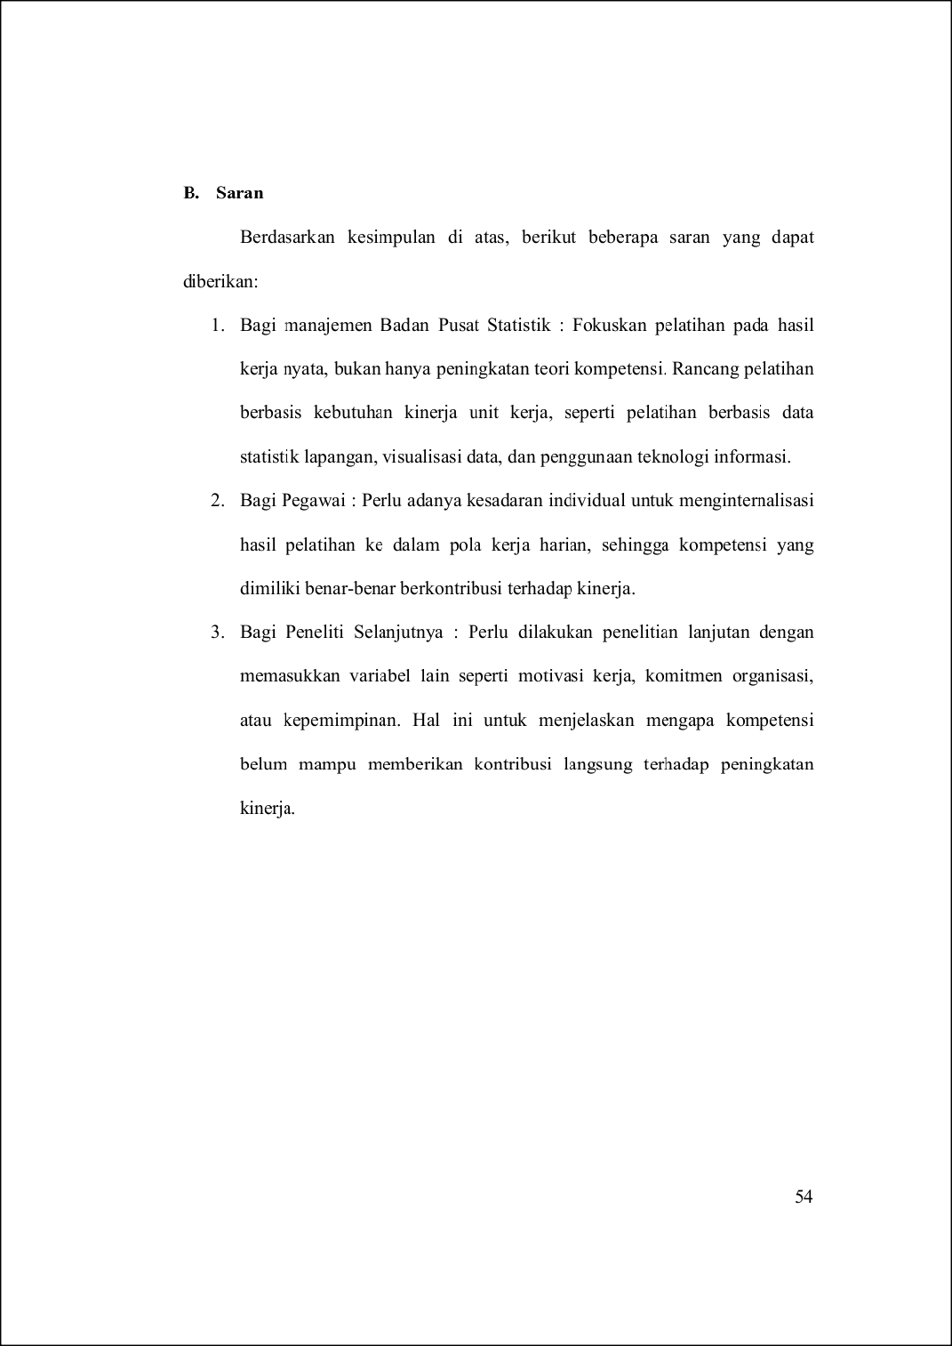
109
110

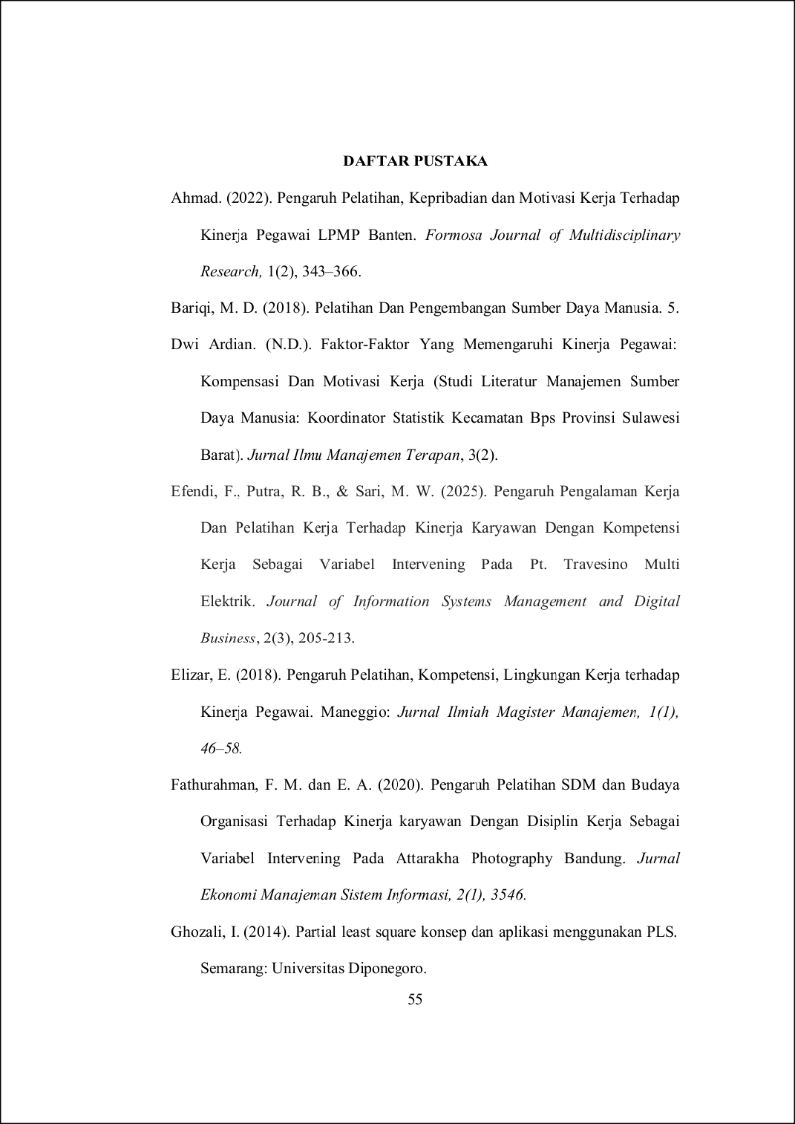

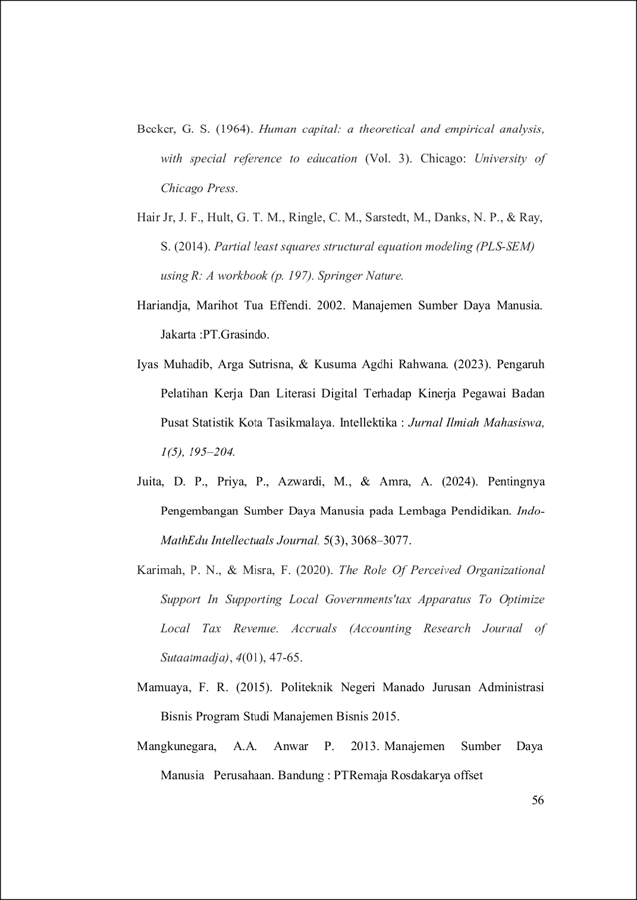

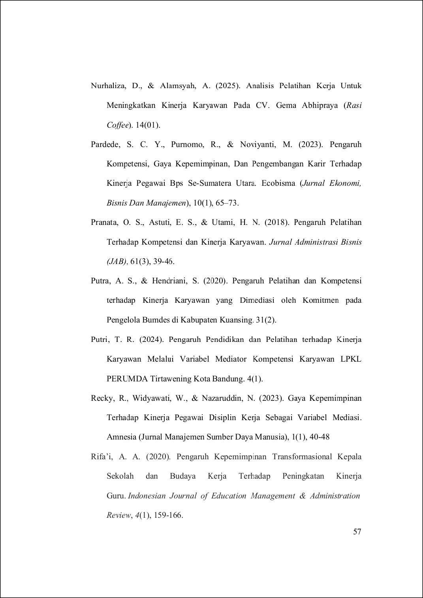

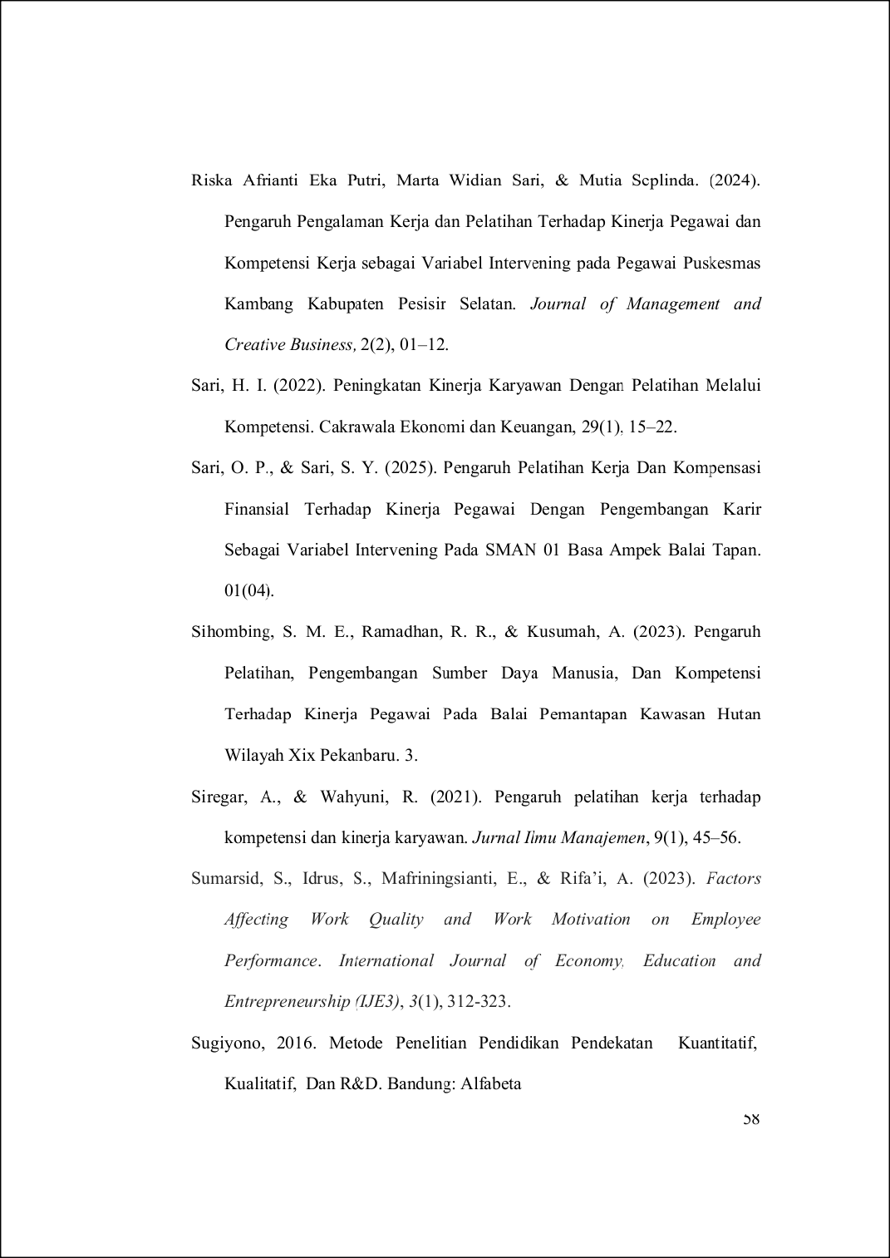

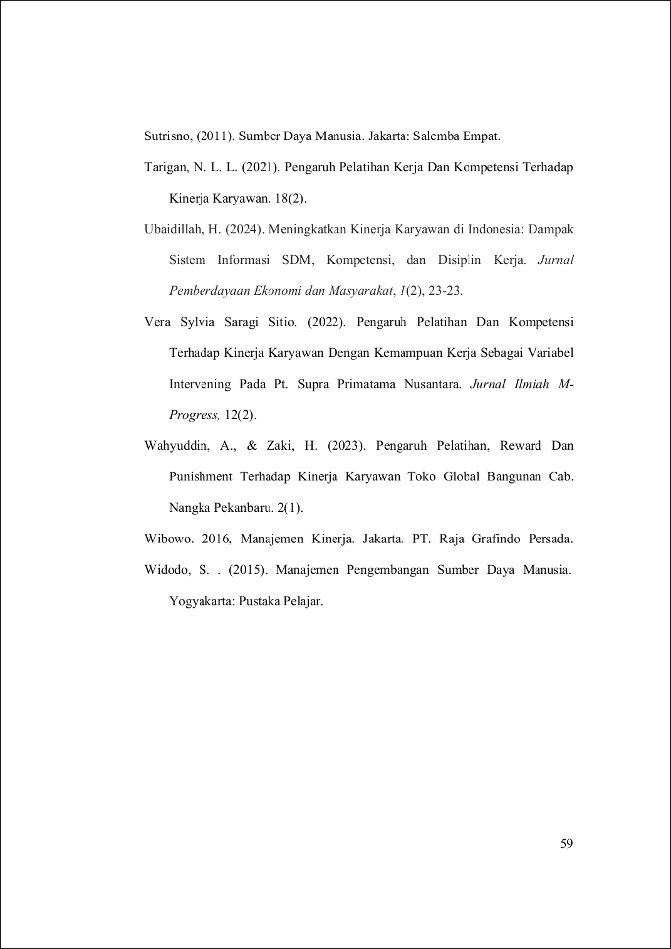

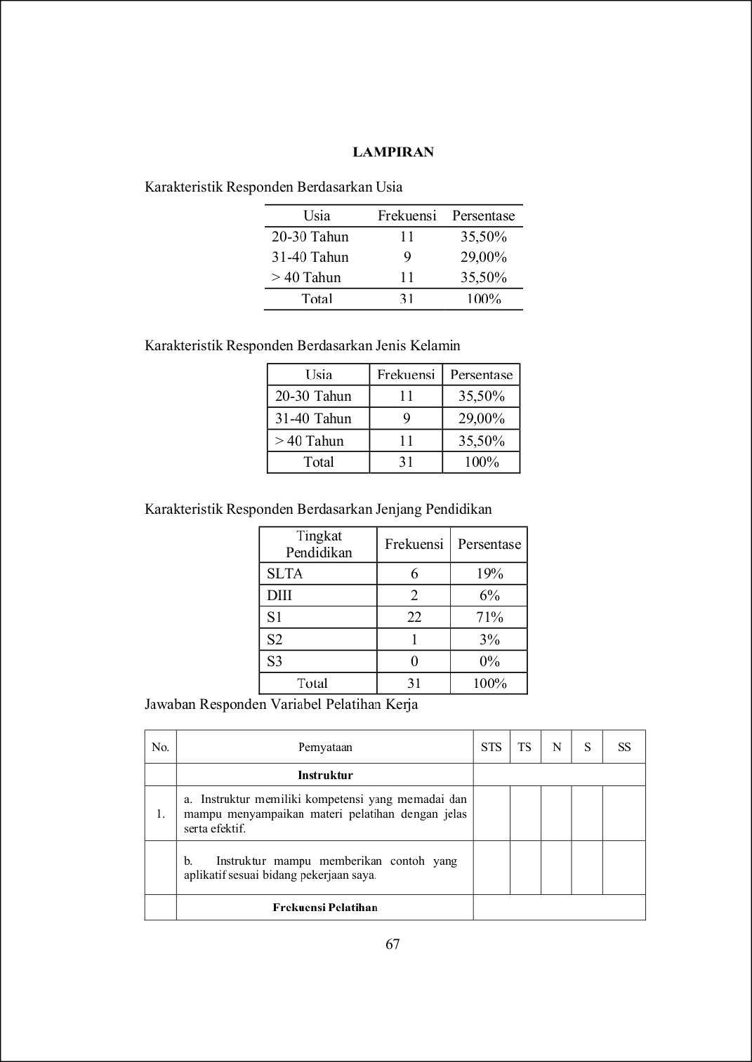
31
7
12
75
90

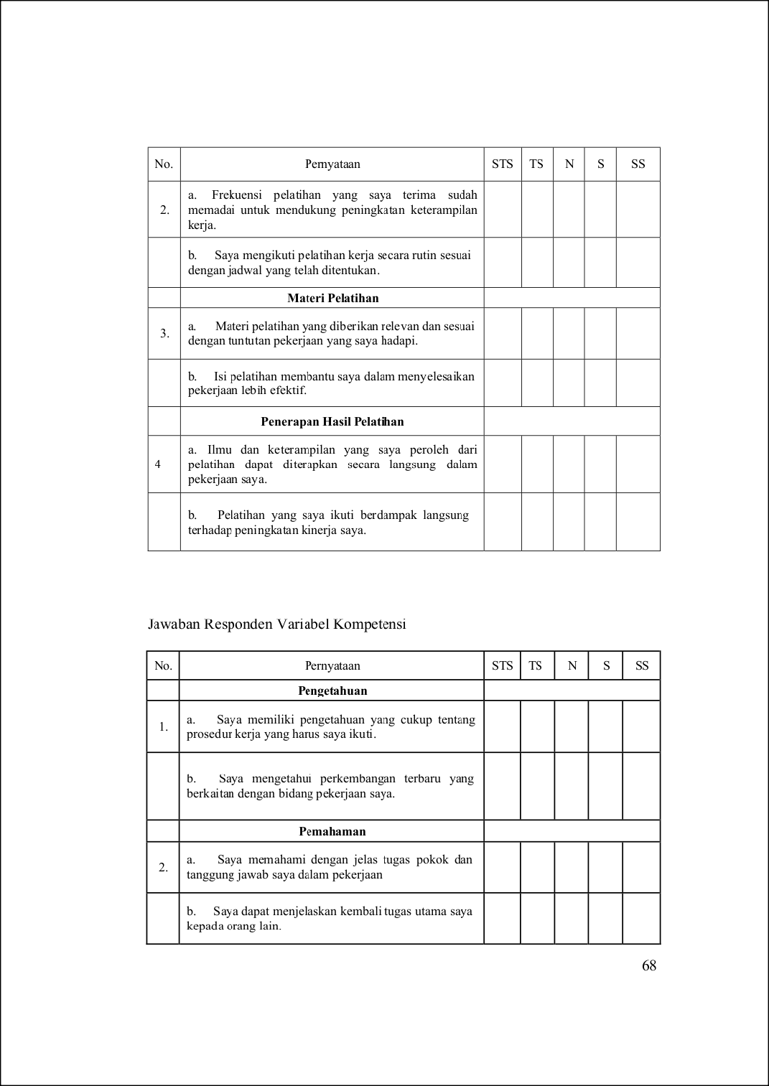
155
85
10
102

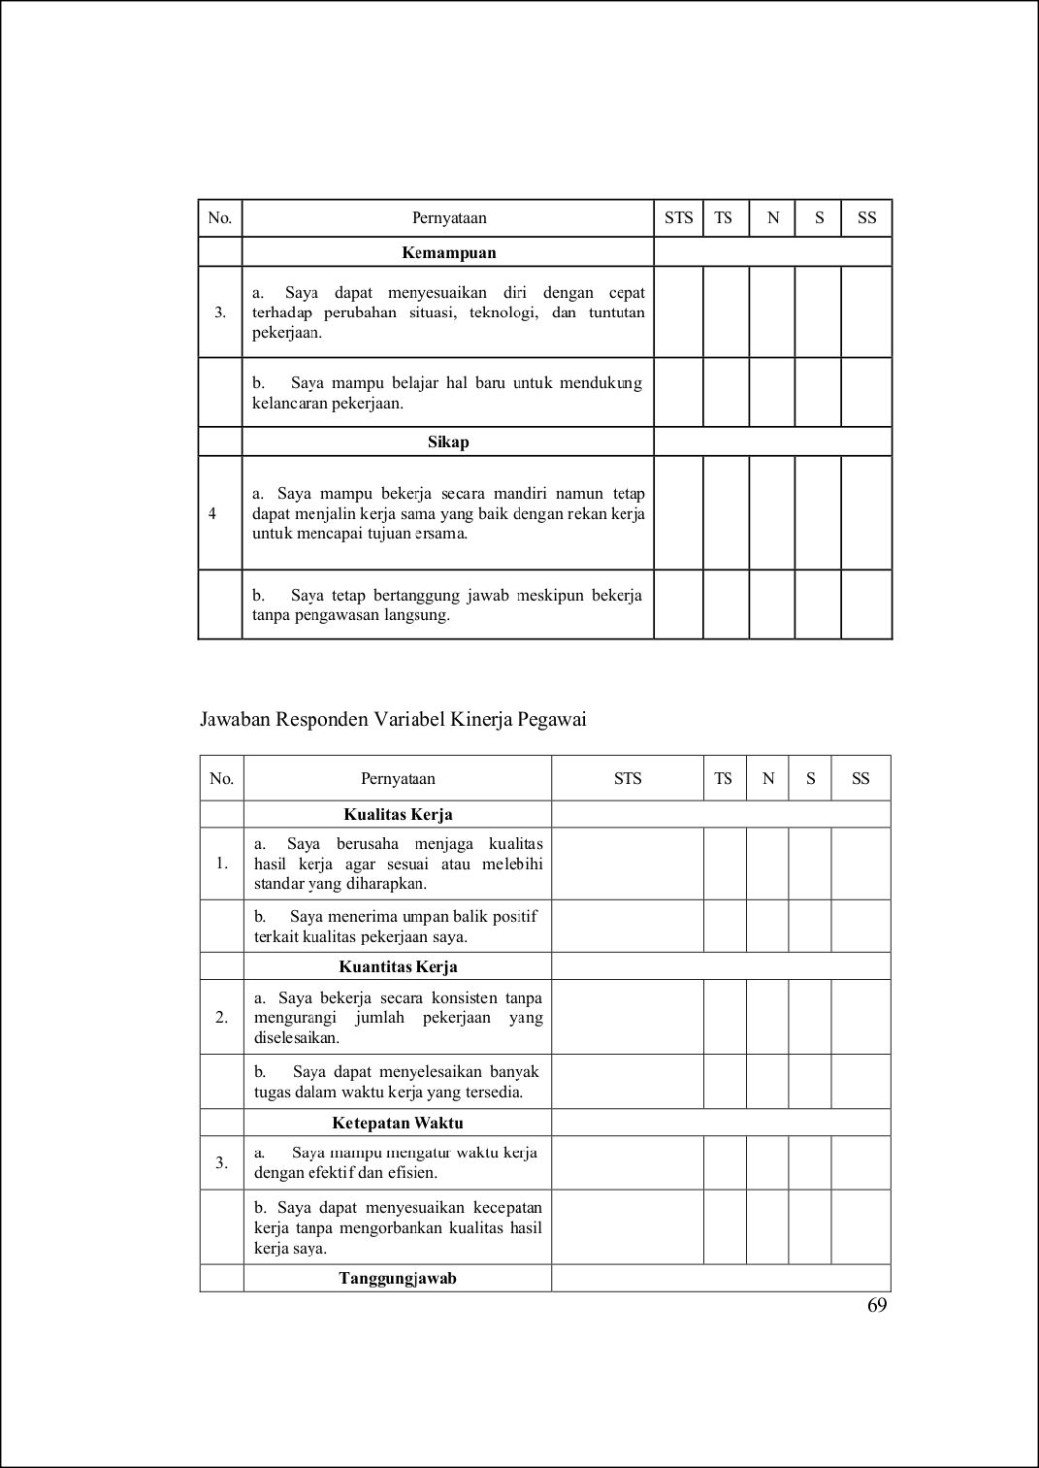
76
40
33

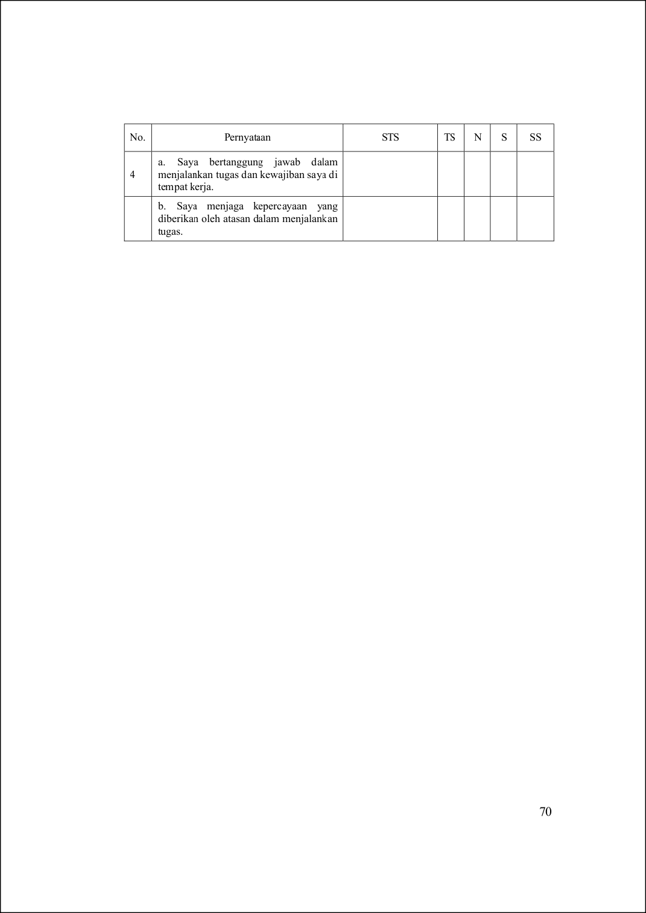
137

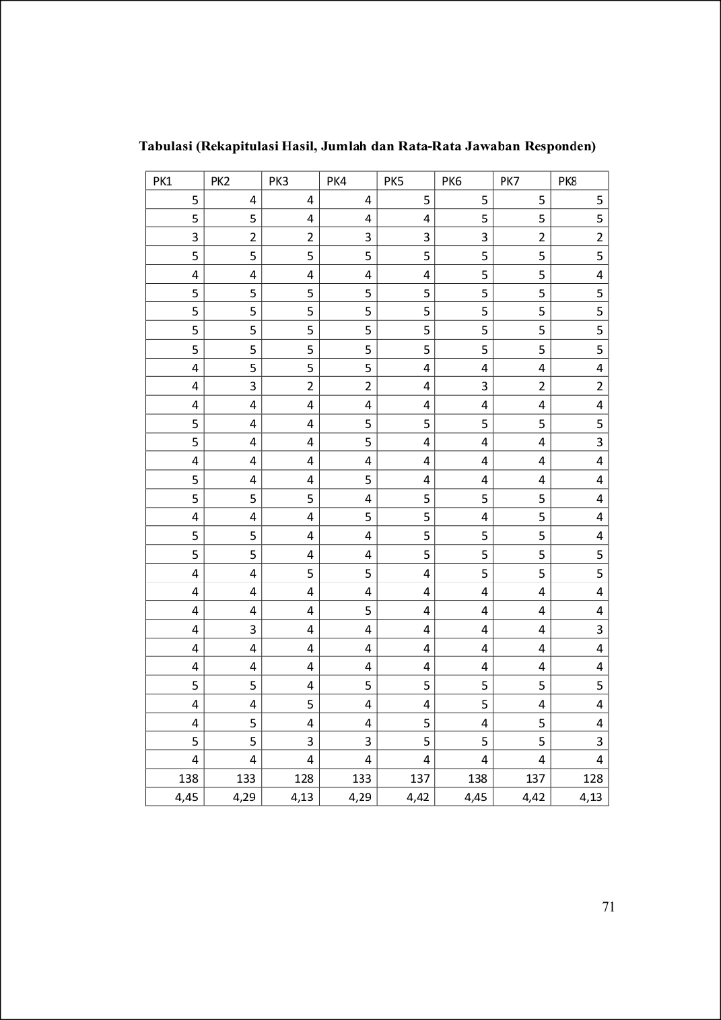
120

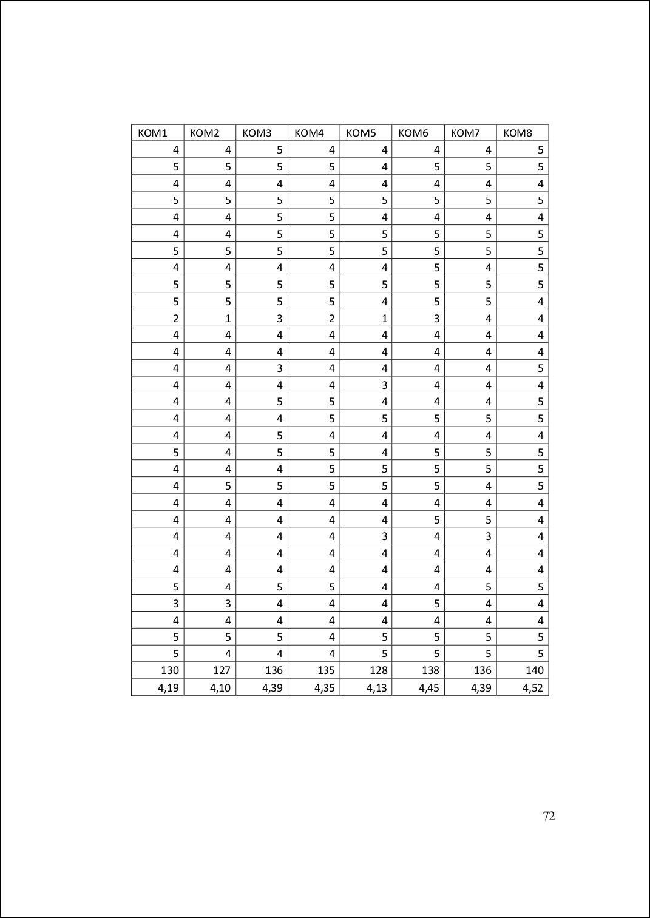
157

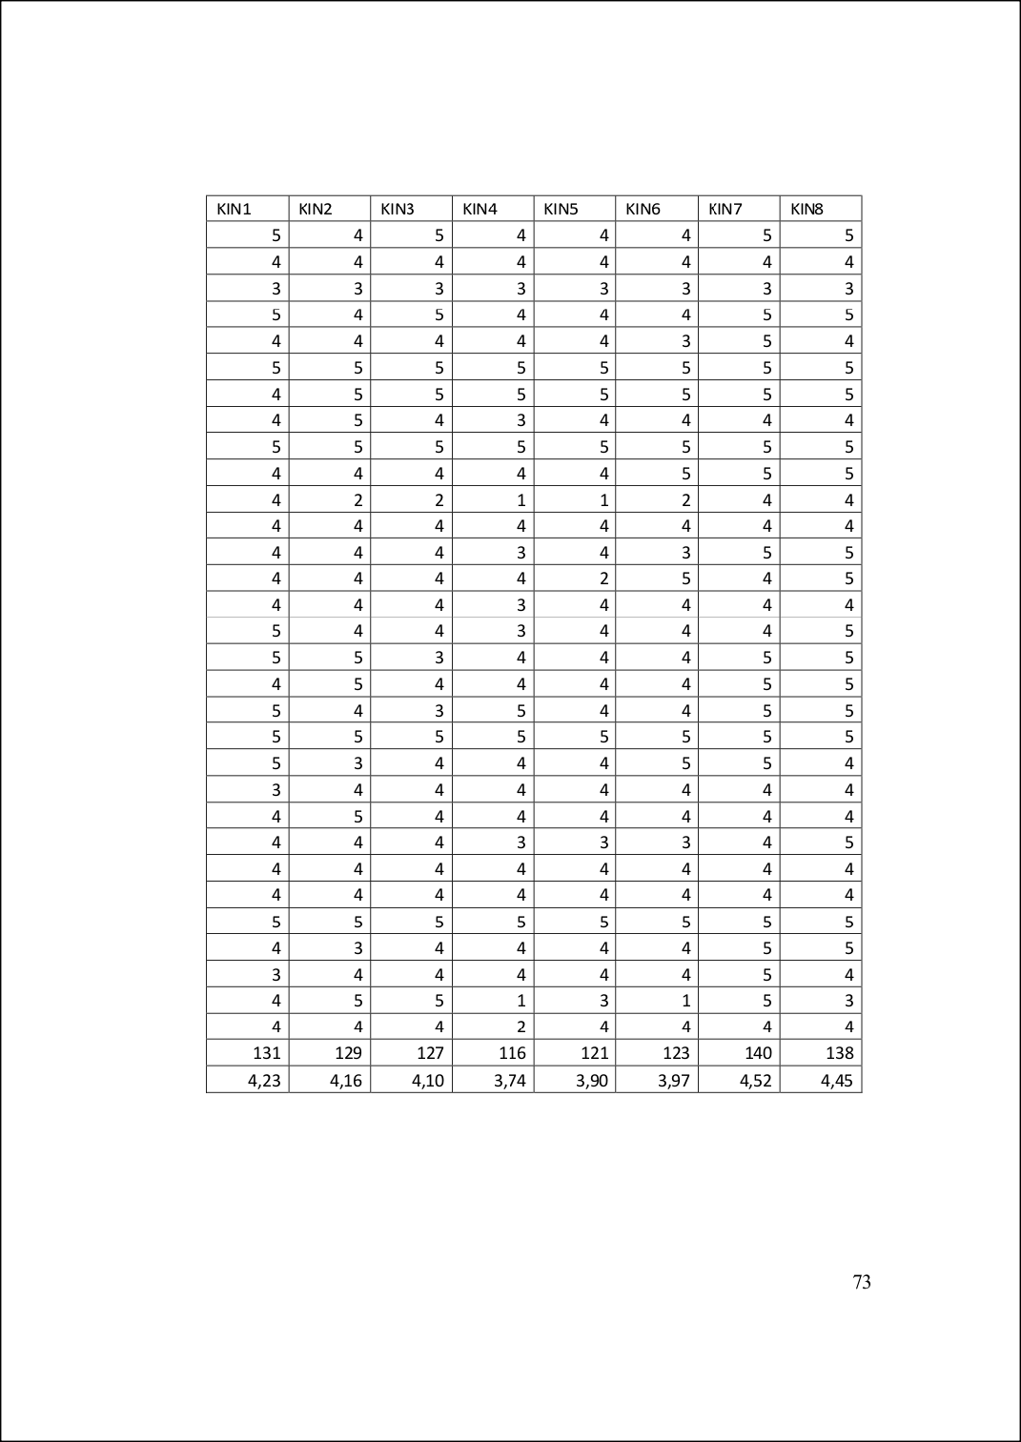
145

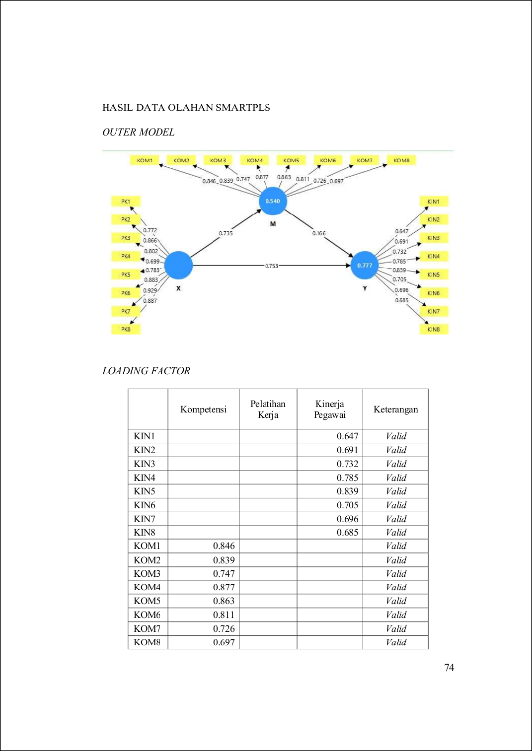
42

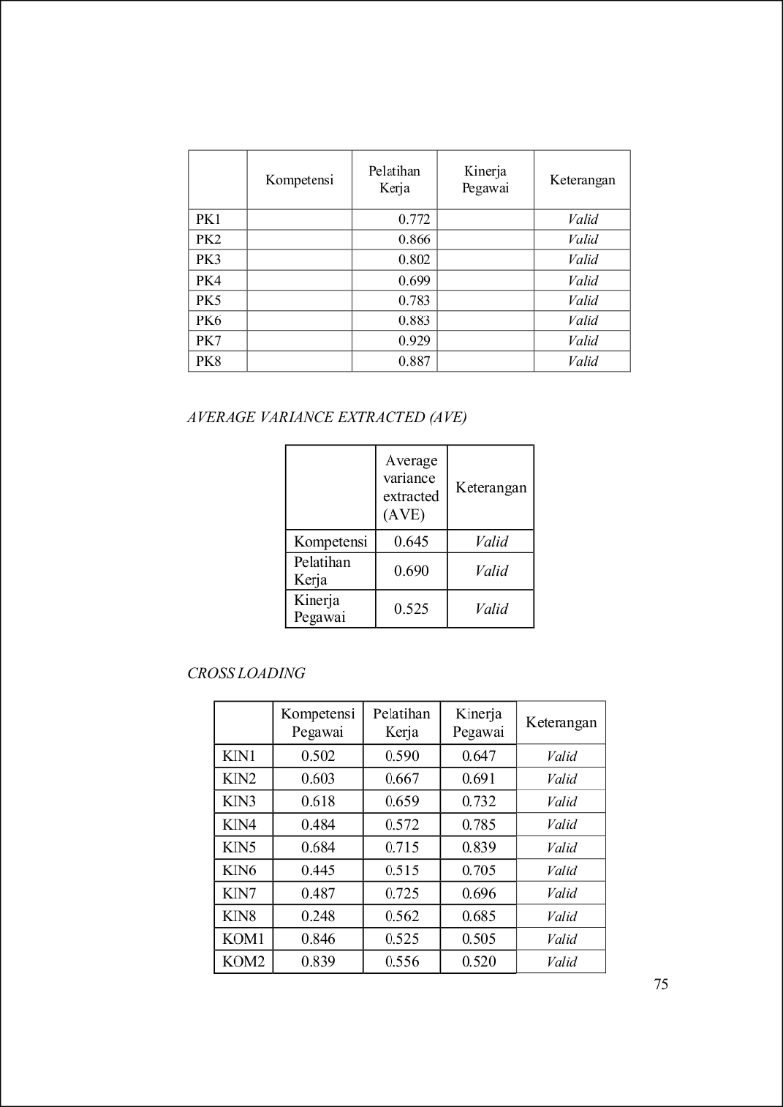
4
20
4

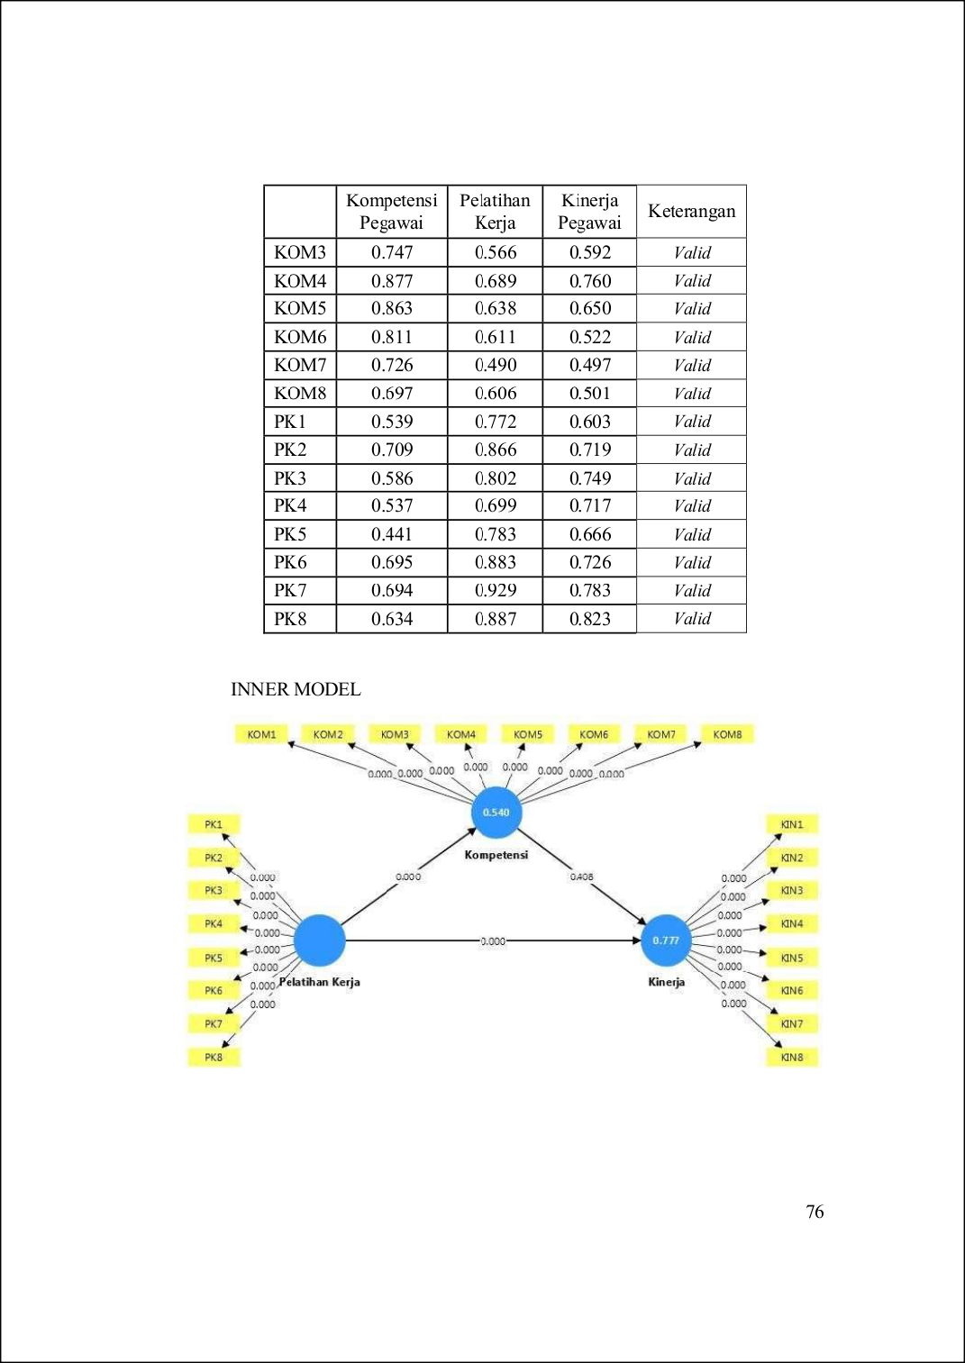

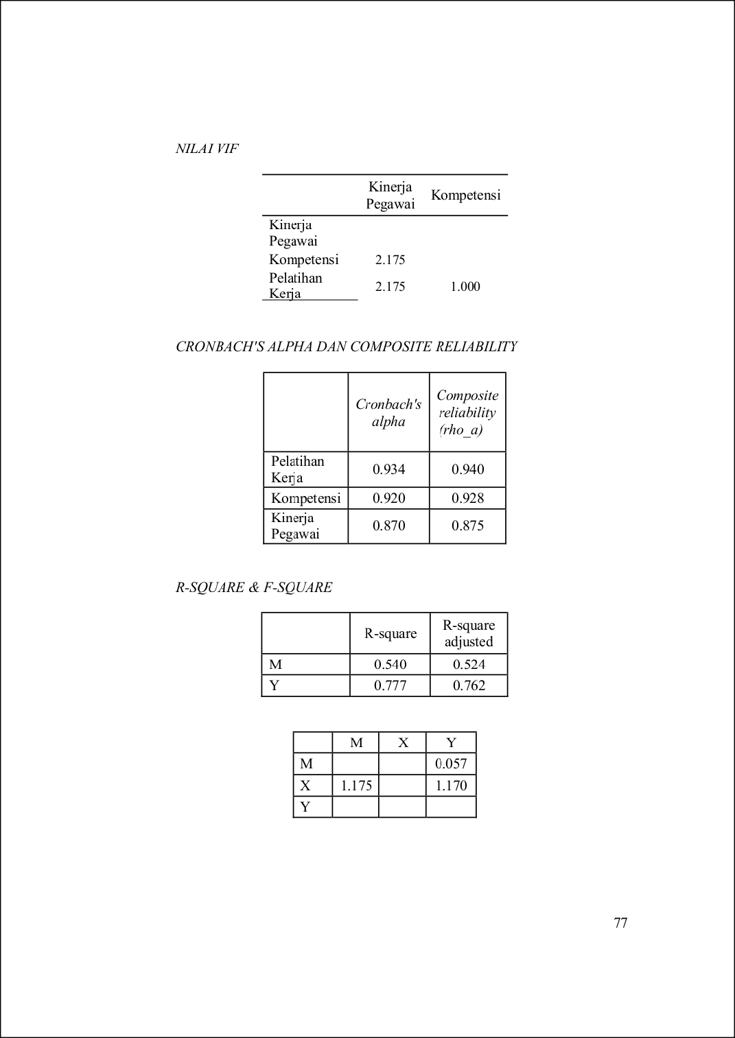
4
63

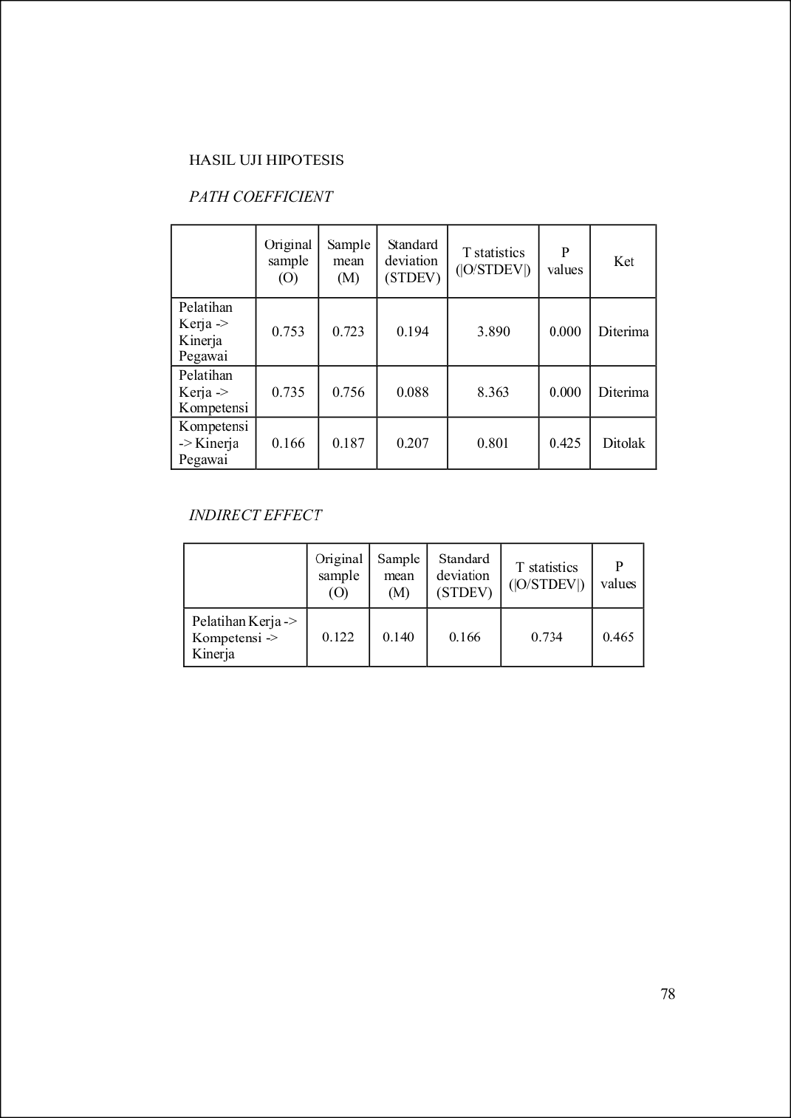
18
9

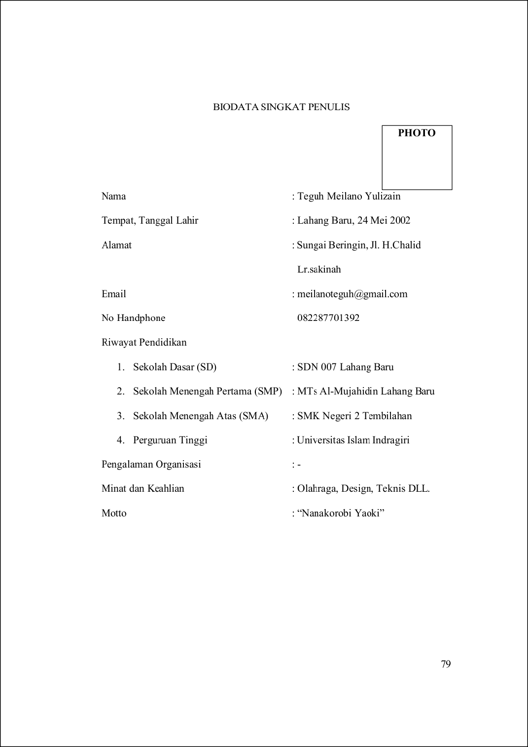

REVISISKRIPSI202579OKE.docx

ORIGINALITYREPORT
50

%
SIMILARITYINDEX
45%
INTERNETSOURCES
23%
PUBLICATIONS
35%
STUDENTPAPERS

PRIMARYSOURCES

1

2

3

4

5

6

7

8

9

10

11

12
repository.unisi.ac.id
InternetSource %
6

www.publication.idsolutions.co.id
2
InternetSource %

repository.uin-suska.ac.id
2
InternetSource %

SubmittedtoUniversitasNegeriJakarta
2
StudentPaper %

journal.universitassuryadarma.ac.id
2
InternetSource %

repository.unhas.ac.id
2
InternetSource %

repository.ub.ac.id
1
InternetSource %

media.neliti.com
1
InternetSource %

etheses.uin-malang.ac.id
1
InternetSource %

repository.umsu.ac.id
1
InternetSource %

ekobis.stieriau-akbar.ac.id
1
InternetSource %

repository-feb.unpak.ac.id
1
InternetSource %

13

14

15

16

17

18

19

20

21

22

23

24

25

26
www.repository.stiegici.ac.id
InternetSource

jurnaluniv45sby.ac.id
InternetSource

ejurnal.umri.ac.id
InternetSource

jurnal.ulb.ac.id
InternetSource

SubmittedtoUniversitasNasional
StudentPaper

SubmittedtoUniversitasRespatiIndonesia
StudentPaper

SubmittedtoSTKIPSumateraBarat
StudentPaper

SubmittedtoSultanAgungIslamicUniversity
StudentPaper

SubmittedtoUniversitasIslamRiau
StudentPaper

SubmittedtoUniversitasMuriaKudus
StudentPaper

SubmittedtoUniversitasTerbuka
StudentPaper

repository.stipjakarta.ac.id
InternetSource

SubmittedtoUniversitasIslamNegeriRaden Fatah
StudentPaper
SubmittedtoUINJambi
StudentPaper
1%
1%
1%
1%
1%
1%
1%
1%
<1%
<1%
<1%
<1%
<1%
<1%

27

28

29

30

31

32

33

34

35

36

37

38

39

40
proceedings.unisba.ac.id
InternetSource

journal.pancabudi.ac.id
InternetSource

bangkabaratkab.bps.go.id
InternetSource

jurnal.pancabudi.ac.id
InternetSource

SubmittedtoLPPM
StudentPaper

SubmittedtoUniversitasIslamIndonesia
StudentPaper

repository.uinjkt.ac.id
InternetSource

etd.uinsyahada.ac.id
InternetSource

repository.uinsu.ac.id
InternetSource

journal.uir.ac.id
InternetSource

journal.yrpipku.com
InternetSource

journal.ipm2kpe.or.id
InternetSource

repository.fe.unj.ac.id
InternetSource

digilibadmin.unismuh.ac.id
InternetSource

kc.umn.ac.id
<1%
<1%
<1%
<1%
<1%
<1%
<1%
<1%
<1%
<1%
<1%
<1%
<1%
<1%

41

42

43

44

45

46

47

48

49

50

51
InternetSource

vdocuments.pub
InternetSource

SubmittedtoForumPerpustakaanPerguruan TinggiIndonesiaJawaTimur
StudentPaper
SubmittedtoLLDiktiIXTurnitinConsortium
StudentPaper

LinggaYuliana,NurliyaApriyana,Muhammad AdamFadillah."AnalisisBrandSignaturedan BrandLogoTerhadapBrandPerformance", WidyaCipta:JurnalSekretaridanManajemen, 2023
Publication

SubmittedtoUniversitasMuhammadiyah Buton
StudentPaper
www.scribd.com
InternetSource

jurnal.kopusindo.com
InternetSource

jurnal.stieieu.ac.id
InternetSource

123dok.com
InternetSource

FiqriHadiIslami,LailanTawilaBerampu,Abd. RasyidSyamsuri."PengaruhCyberloafingdan BudayaKerjaterhadapKinerjaKaryawan denganSelfControlsebagaiVariabel
<1%
<1%
<1%
<1%
<1%

<1%
<1%
<1%
<1%
<1%
<1%

52

53

54

55

56

57

58

59

60

61

62
Moderasi pada PT Besmindo Materi Sewatama",JurnalBisnisMahasiswa,2025
Publication
dosen.upi-yai.ac.id
InternetSource

RanthyPancasastiPancasasti."PENGARUH PELATIHAN,KOMPETENSI,DAN
PENGEMBANGANKARIRTERHADAPKINERJA KARYAWANPT.KRAKATAUSTEELTBK",Jurnal
ManajemendanBisnis,2022
Publication
repository.uinsi.ac.id
InternetSource

SubmittedtoFederalUniversityofTechnology
StudentPaper

www.ejournal.unisi.ac.id
InternetSource

id.123dok.com
InternetSource

repository.stieipwija.ac.id
InternetSource

www.polteq.ac.id
InternetSource

novarehulinam.blogspot.com
InternetSource

SubmittedtoUINSunanGunungDJati Bandung
StudentPaper
SubmittedtoUniversitasNegeriPadang
StudentPaper

<1%
<1%

<1%
<1%
<1%
<1%
<1%
<1%
<1%
<1%
<1%

63

64

65

66

67

68

69

70

71

72

73

74

75

76
repositori.usu.ac.id
InternetSource

repository.uigm.ac.id
InternetSource

SubmittedtoAjouUniversityGraduateSchool
StudentPaper

SubmittedtoUniversitasAndalas
StudentPaper

SubmittedtoUniversitasDiponegoro
StudentPaper

core.ac.uk
InternetSource

rcf-indonesia.org
InternetSource

repository.ubharajaya.ac.id
InternetSource

SubmittedtoUniversitasPapua
StudentPaper

SubmittedtoSyntaxCorporation
StudentPaper

SubmittedtoUniversitasKhairun
StudentPaper

eprints.umsb.ac.id
InternetSource

repositori.uin-alauddin.ac.id
InternetSource

docplayer.info
InternetSource

journal-nusantara.com
<1%
<1%
<1%
<1%
<1%
<1%
<1%
<1%
<1%
<1%
<1%
<1%
<1%
<1%

77

78

79

80

81

82

83

84

85

86
InternetSource

IHWANULIHWANUL."DampakTransformasi DigitaldanKepemimpinanTransformasional
terhadapKinerjamelaluiKompetensiPegawai padaUPTRSUDHj.PuangSabbedi KabupatenEnrekang",RIGGS:Journalof
ArtificialIntelligenceandDigitalBusiness, 2025
Publication
anzdoc.com
InternetSource

eprints.iain-surakarta.ac.id
InternetSource

j-innovative.org
InternetSource

journal.cwe.ac.id
InternetSource

NurTsalitsnaImamah,AristaPratama,Asif Faroqi."EvaluasiFaktor-FaktorPenerimaan AplikasiSeaBankMenggunakanModel UTAUT2",JURNALFASILKOM,2024
Publication
SubmittedtoUniversitasNegeriYogyakarta
StudentPaper

toko-dinasty.blogspot.com
InternetSource

FebyCintiaSahabu,MuhammadAras,Monika AnciliaArif,CarissaArabella,LaMani."The influenceofco-branding,servicequality, lifestyle,andbrandimagetocustomer's
<1%
<1%

<1%
<1%
<1%
<1%
<1%

<1%
<1%
<1%

87

88

89

90

91

92

93

94

95
loyalty:Asurveyofglobalcoffeebrandin Indonesia", Multidisciplinary Science Journal, 2025
Publication
conference.upnvj.ac.id
InternetSource

PundyDanistyarini,HeryErdi,RatihAyu Sekarini."PengaruhKompensasiDanMotivasi KerjaTerhadapKinerjaPegawaiPadaPT. PelabuhanTanjungPriok",RIGGS:Journalof
ArtificialIntelligenceandDigitalBusiness, 2025
Publication
SubmittedtoUniversitasPGRIPalembang
StudentPaper

SubmittedtoUniversitasPGRISemarang
StudentPaper

digilib.unisayogya.ac.id
InternetSource

journal.paramadina.ac.id
InternetSource

repositori.kemdikbud.go.id
InternetSource

DiniAnggreiniSantiasari,Sulistiowati Sulistiowati."PengaruhPengembanganSDM danKompensasiTerhadapKinerjaPelaku PengadaanBarang/Jasa",eCo-Buss,2025
Publication

EndangWerdiningsih."PengaruhPelatihan danRotasiterhadapKinerjaPegawaidengan KompetensisebagaiVariabelIntervening",

<1%
<1%

<1%
<1%
<1%
<1%
<1%
<1%

<1%

96

97

98

99100
101

102

103

104

105
JurnalLitbang:MediaInformasiPenelitian, PengembangandanIPTEK,2025
Publication
eprints.umm.ac.id
InternetSource

repositori.uma.ac.id
InternetSource

repository.iainpurwokerto.ac.id
InternetSource

repository.its.ac.id
InternetSource

repository.uinjambi.ac.id
InternetSource

repository.upnyk.ac.id
InternetSource

SubmittedtoUniversitasBengkulu
StudentPaper

YarmanBate’e,YamolalaZega,HeniwatiGulo, PerlindunganFaebuadodoHulu."Pengaruh Work-LifeBalanceterhadapProduktivitas
PegawaipadaKantorKPUKotaGunungsitoli", RIGGS:JournalofArtificialIntelligenceand
DigitalBusiness,2025
Publication

DewiDzakiyatulFikriyah,NuraeniNuraeni. "PengaruhKompetensiKewirausahaan,
ModalSosial,danAksesKeuanganterhadap KinerjaUMKM",RIGGS:JournalofArtificial
IntelligenceandDigitalBusiness,2025
Publication
SubmittedtoFakultas Peternakan
StudentPaper

<1%
<1%
<1%
<1%
<1%
<1%
<1%
<1%

<1%

106

107

108

109

110

111

112

113

114

115

RizmiSamsulRizal,AhluDzikri,Supriyadi Supriyadi."PengaruhJobDescriptiondan TekananKerjaTerhadapKinerjaKaryawandi PT.JalanAbadi",RIGGS:JournalofArtificial
IntelligenceandDigitalBusiness,2025
Publication
SubmittedtoUniversitasPuteraBatam
StudentPaper

gicipress.com
InternetSource

repository.iainpalopo.ac.id
InternetSource

repository.unp.ac.id
InternetSource

DevianaDeviana,HelmaMalini,Anggraini Syahputri."PeranFinancialSelf-Efficacydalam HubunganantaraPendapatan,Literasi Keuangan,danPerilakuKeuanganMahasiswa diIndonesia",eCo-Buss,2025
Publication
journal.untar.ac.id
InternetSource

repo.stis.ac.id
InternetSource

www.slideshare.net
InternetSource

bajangjournal.com
InternetSource

cyber-chmk.net
<1%
<1%

<1%
<1%
<1%
<1%
<1%

<1%
<1%
<1%
<1%

116

117

118

119

120

121

122

123

124

125
InternetSource

drakyatjelata.blogspot.com
InternetSource

ejournal2.undip.ac.id
InternetSource

journal.ikippgriptk.ac.id
InternetSource

moam.info
InternetSource

BachtiarApriyanto,FetiFatimah,Nursaidah Nursaidah."DampakPelatihanKerja, LingkunganKerja,DanKompensasiTerhadap KinerjaKaryawan",JurnalPenelitianIlmu
SosialdanEksakta,2021
Publication

KhristianKhristian,AzzisAbdulMunir,Ilzar Daud,RizkyFauzan."PengaruhPelatihandan KompetensiTerhadapKinerjaPegawaiPada PusdiklatRSUDDr.SoedarsoPontianak",eCo- Buss, 2025
Publication
SubmittedtoSriwijayaUniversity
StudentPaper

TioPrasetio."PengaruhArtificialIntelligence danLiterasiDigitalTerhadapKinerja KaryawandiBidangEkonomi",Jurnal Ecodemica:JurnalEkonomiManajemendan Bisnis, 2024
Publication
SubmittedtoUniversitasRiau
StudentPaper
<1%
<1%
<1%
<1%
<1%
<1%

<1%

<1%
<1%

<1%

126

127

128

129

130

131

132

133

134

135

136

137

138

139
ejournal.unhi.ac.id
InternetSource

ejournal3.undip.ac.id
InternetSource

journal.stiejayakarta.ac.id
InternetSource

jurnal-stiepari.ac.id
InternetSource

jurnal.ugj.ac.id
InternetSource

lib.ui.ac.id
InternetSource

repo.darmajaya.ac.id
InternetSource

repo.uinsatu.ac.id
InternetSource

repository.stptrisakti.ac.id
InternetSource

repository.unbari.ac.id
InternetSource

statistik.jakarta.go.id
InternetSource

vdocuments.net
InternetSource

widuri.raharja.info
InternetSource

SubmittedtoHawaiiPreparatoryAcademy
StudentPaper
<1%
<1%
<1%
<1%
<1%
<1%
<1%
<1%
<1%
<1%
<1%
<1%
<1%
<1%

140

141

142

143

144
NataliaParanoan,ChristinaJeane Tandirerung,AnthonParanoan."PENGARUH PEMANFAATANTEKNOLOGIINFORMASIDAN KOMPETENSI SUMBER DAYA MANUSIA TERHADAPEFEKTIVITASSISTEMINFORMASI
AKUNTANSI",JurnalAkunNabelo:Jurnal
AkuntansiNetral,Akuntabel,Objektif,2019
Publication

ReniDwiWidiyastini,YunioritaIndah Handayani,DedyWijayaKusuma."TheEffect ofTrainingandWorkEnvironmenton
PerformanceofEmployeesThrough
OrganizationalCommitmentasIntervening", RIGGS:JournalofArtificialIntelligenceand
DigitalBusiness,2025
Publication

ShaniaWahyuTuffahati,AinatulMardiyah, RaveliaAzZahraCendekiaRose,TitikInayati. "PengaruhMotivasi,StresKerja,Kepribadian danKarakteristikIndividuTerhadapKinerja- LiteratureReview",RIGGS:JournalofArtificial IntelligenceandDigitalBusiness,2025
Publication

Sumarno,Najeminur."PENGARUHKINERJA PEGAWAITERHADAPKUALITASPELAYANAN KEPADAMASYARAKATDIDESAKESSING
KECAMATANDONRI-DONRIKABUPATEN
SOPPENG",JurnalMediasosian:JurnalIlmu SosialdanAdministrasiNegara,2025
Publication

VinolaRiaIfani,MarianaPuspaDewi. "PenerapanPenghargaan,Pelatihan,dan KomunikasiInternalMeningkatkanKinerja
<1%

<1%

<1%

<1%

<1%

145

146

147

148

149

150

151

152

153

154

155

156

157
PegawaiBTPNSyariahWlingiBlitar",Al- Kharaj:JurnalEkonomi,Keuangan&Bisnis Syariah, 2025
Publication
crackest.com
InternetSource

digilib.unila.ac.id
InternetSource

docobook.com
InternetSource

e-journal.uajy.ac.id
InternetSource

journal-theo.ukdw.ac.id
InternetSource

journal.poltekkes-mks.ac.id
InternetSource

journal.tofedu.or.id
InternetSource

pt.scribd.com
InternetSource

repository.umpalopo.ac.id
InternetSource

repository.unama.ac.id
InternetSource

text-id.123dok.com
InternetSource

www.coursehero.com
InternetSource

www.dogskalendar.narod.ru
InternetSource

<1%
<1%
<1%
<1%
<1%
<1%
<1%
<1%
<1%
<1%
<1%
<1%
<1%

158

159

160

161

162
www.goodyear-indonesia.com
InternetSource

AnggaSaputra,SriRahayu,Choiriyah Choiriyah."PengaruhDisiplinKerja,
KompetensidanMotivasiTerhadapKinerja PegawaiBadanPenanggulanganBencana DaerahProvinsiSumateraSelatan",Jurnal Bisnis,Manajemen,danEkonomi,2023
Publication

DarmadiDarmadi,WyatiSaddewisasi,Indarto Indarto."PENGARUHSERVANTLEADERSHIP
DANKOMPETENSITERHADAPKINERJA
APARATURSIPIL",SustainableBusiness Journal, 2023
Publication

LinaFebriasari,AbuTalkah,RatnaDewi Mulyaningtiyas."StrategiDalam Mengimplementasikan Kebijakan Dan Sistem MeritPadaPengisianJabatanPemimpin
TinggiPratamaMelaluiSeleksiTerbukaDi KabupatenBlitar",JournalofEconomic, BussinesandAccounting(COSTING),2024
Publication

AchmadAndiWahyudi,DewieTriWijayati Wardoyo,AndreDwijantoWitjaksono. "PengaruhKompetensiDanBudayaKerja TerhadapKinerjaMelaluiMotivasiKerjaDi DinasKebudayaan,KepemudaanDan
OlahragaSertaPariwisata(DISBUDPORAPAR) KotaSurabaya–JawaTimur",Journalof Economic,BussinesandAccounting (COSTING),2024
Publication
<1%
<1%

<1%

<1%

<1%

163

164

165
AnindyaPutriPradiptha,JasmineQur’ani,Tina Selviana."PerilakuKonsumsiGenerasiZ
terhadapMinumanTradisionalBirPletok BetawidiUniversitasBudiLuhur", BUDGETING:JournalofBusiness, ManagementandAccounting,2025
Publication

AriNoviBimantari,MuhammadAbdul Ghofur. "Pengaruh Pendidikan Kewirausahaan,LocusofControlDanEfikasi DiriTerhadapMinatKewirausahaan MahasiswaDenganPendekatanPLS-SEM", RIGGS:JournalofArtificialIntelligenceand
DigitalBusiness,2025
Publication

Rogelberg.EncyclopediaofIndustrialand OrganizationalPsychology
Publication
<1%

<1%

<1%

Excludequotes On Excludebibliography On
Excludematches Off

