THE EFFECT OF USING CROSSWORD PUZZLE TOWARD VOCABULARY MASTERY AT EIGHTH GRADE STUDENTS
AT SMP NEGERI 1 TELUK PINANG

A THESIS
Submitted to Fulfill one of the Requirements for the Award of Sarjana Degree (S1)
In English Study Program



WRITTEN BY :
SUKARTINA
NIM : 502211010004

ENGLISH STUDY PROGRAM
FACULTY OF TEACHER TRAINING AND EDUCATION
ISLAMIC UNIVERSITY OF INDRAGIRI
2025

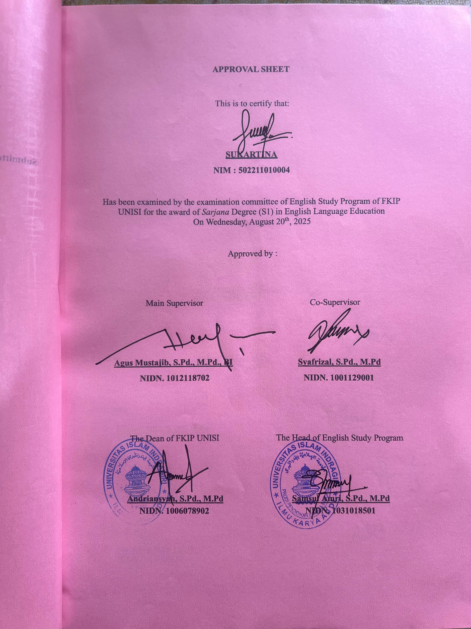
.

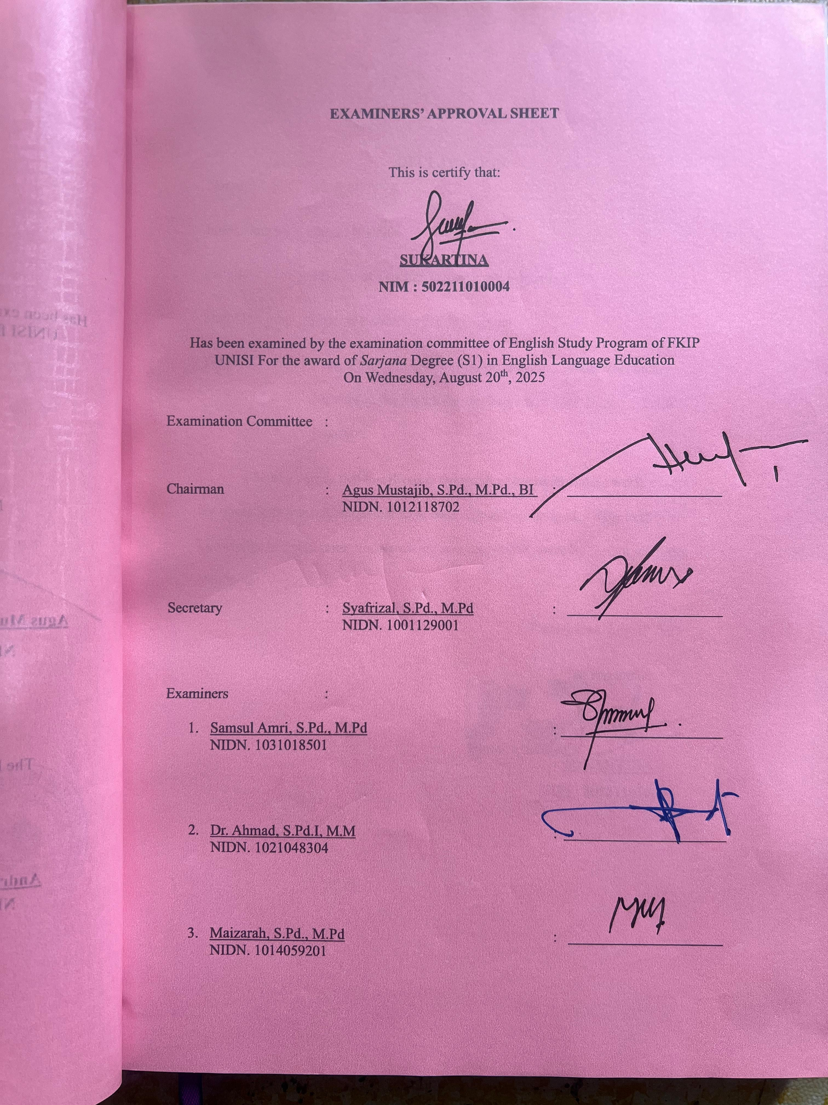

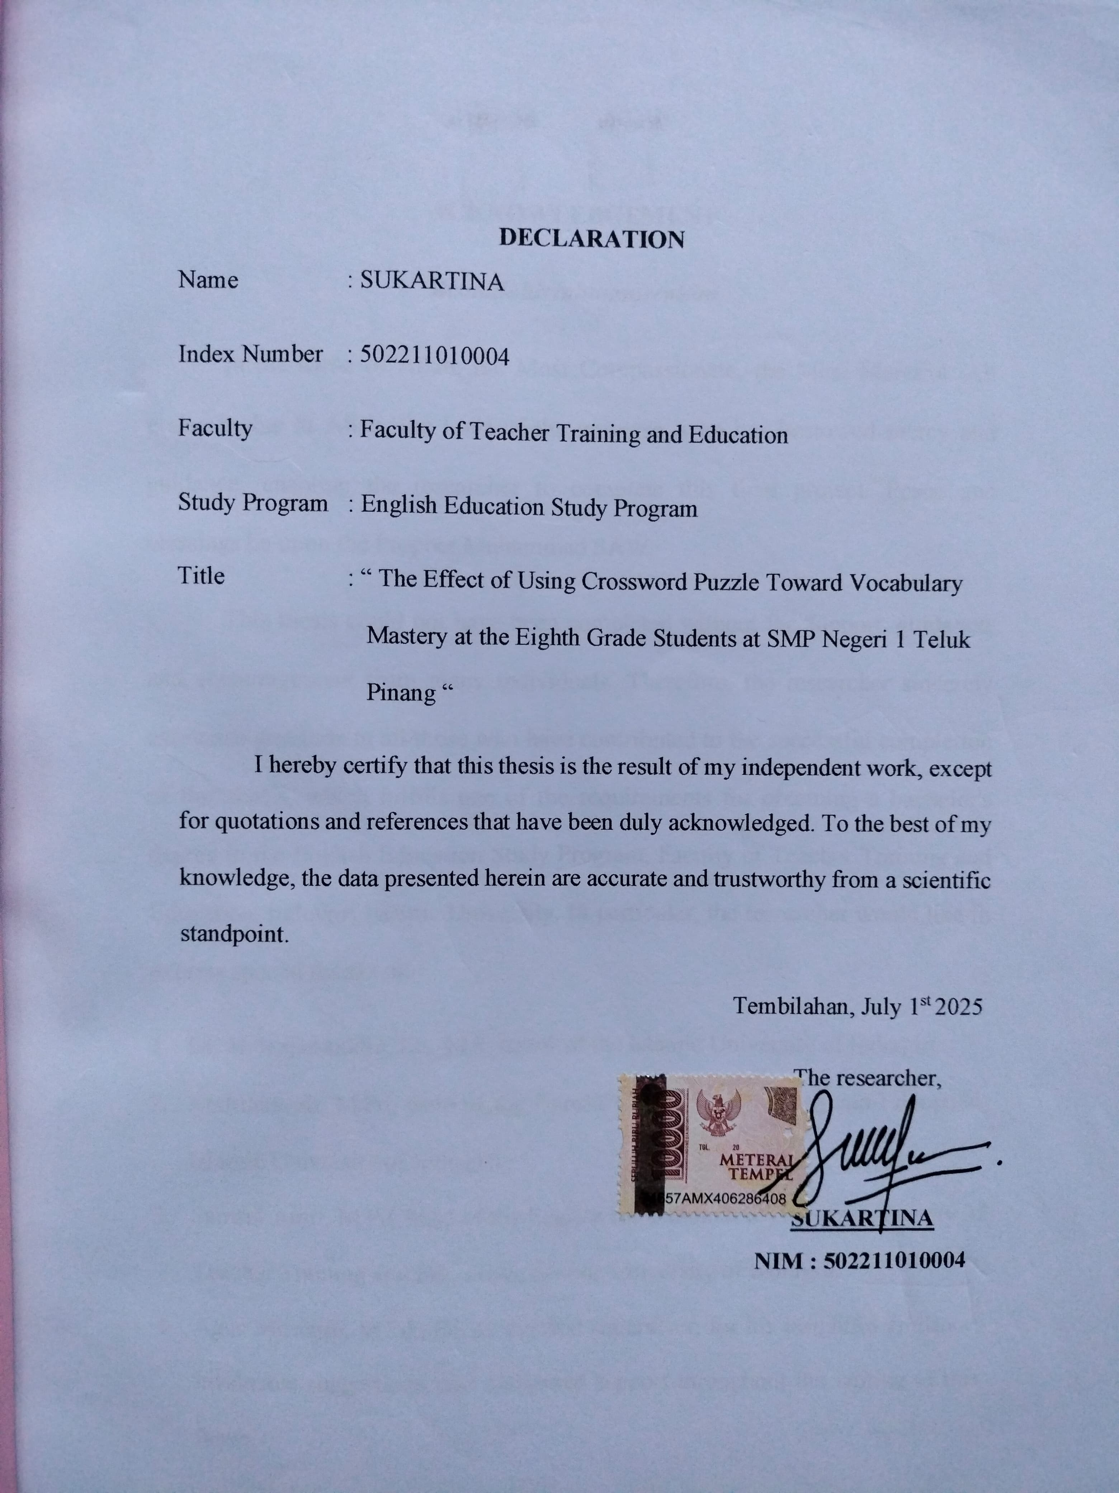

ACKNOWLEDGEMENT
Bismillahirrahmanirrahim
In the name of Allah, the Most Compassionate, the Most Merciful. All praise is due to Allah, the Lord of the universe, who has bestowed mercy and guidance, enabling the researcher to complete this final project. Peace and blessings be upon the Prophet Muhammad SAW.
This thesis could not have been completed without the support, guidance, and encouragement from many individuals. Therefore, the researcher sincerely expresses gratitude to all those who have contributed to the successful completion of this thesis, which fulfills one of the requirements for obtaining a bachelor's degree in the English Education Study Program, Faculty of Teacher Training and Education, Indragiri Islamic University. In particular, the researcher would like to express special thanks to:
- Dr. H. Najamuddin, Lc., MA, rector of the Islamic University of Indragiri.
- Andriansyah, M.Pd, dean of the Faculty of Teacher Training and Education, Islamic University of Indragiri.
- Samsul Amri, M.Pd, head of the English Education Study Program, Faculty of Teacher Training and Education, Islamic University of Indragiri.
- Agus Mustajib, M.Pd., BI, as the first supervisor, for his insightful guidance, invaluable suggestions, and consistent support throughout the writing of this thesis.
- Syafrizal, M.Pd, as the second supervisor, for his constructive feedback, encouragement, and thoughtful advice during the research process.
- Edi Ardian, M.Pd, Samsul Amri, M.Pd, and Felci Tria Sauhana, as the thesis examiners, for their valuable input and critical evaluation.
- All lecturers and administrative staff of the English Education Study Program and the Faculty of Teacher Training and Education, Indragiri Islamic University, for their academic and administrative assistance.
- Dewi Purwani, S.P., Principal of SMP Negeri 1 Teluk Pinang, for granting permission and providing support during the data collection process.
- All eighth-grade students of SMP Negeri 1 Teluk Pinang, for their participation and cooperation during this research.
- Ustadz Syahrul Aidil Maazat, Ustadz Yuslizar, Fernandes Fransiska, Tomi Ramadani, and Husnul Khatimah, for their assistance and support regarding the scholarships received during the course of study.
- The researcher's beloved parents, Mr. M. Nasir and Mrs. Samsidar, siblings Novi Sari Girian Putra Mandahu, Sibawaihi Kosasi, Afrinal Gunawan, Tri Novangke Fatimah, Sonia Putri, M. Al-Hafiz, M. Fikri, brother-in-law Faisyal, and the entire extended family. Thank you for your endless prayers, encouragement, and unwavering support throughout this journey.
- Dearest friends, Maulia Fadila and Fatimah Azzahra, for their companionship, motivation, and support during the thesis writing and academic life.
- All fellow students of the 2021 English Education Study Program, especially Engsdypro A '21, for their friendship and solidarity.
Finally, the researcher is fully aware that this thesis is not without shortcomings. Therefore, constructive criticism and suggestions are highly appreciated for the improvement of future research. May this thesis be beneficial for the researcher in particular, and for others in general.
Tembilahan, July 1st 2025
The researcher,

SUKARTINA
NIM : 502211010004

ABSTRAK
SUKARTINA. 502211010004. 2025. Skripsi. Pengaruh Penggunaan Crossword Puzzle terhadap Penguasaan Kosakata pada Siswa Kelas VIII SMP Negeri 1 Teluk Pinang. Program Studi Bahasa Inggris. Fakultas Keguruan dan Ilmu Pendidikan. Universitas Islam Indragiri.
Penelitian kuasi-eksperimental ini bertujuan untuk mengevaluasi efektivitas penggunaan teka-teki silang dalam meningkatkan penguasaan kosakata pada siswa kelas VIII di SMP Negeri 1 Teluk Pinang. Penelitian ini melibatkan dua kelompok: kelas eksperimen (Kelas VIII.1) dan kelas kontrol (Kelas VIII.2), masing-masing berjumlah 25 siswa yang dipilih melalui total sampling. Fokus utama penelitian ini adalah untuk mengetahui apakah terdapat perbedaan penguasaan kosakata yang signifikan antara siswa yang mendapatkan pembelajaran menggunakan teka-teki silang dan siswa yang diajarkan tanpa menggunakan teka-teki silang. Pre-test dan post-test diberikan kepada kedua kelompok untuk mengumpulkan data sebelum dan sesudah perlakuan. Kelas eksperimen mendapatkan pembelajaran kosakata berbasis teka-teki silang, sedangkan kelas kontrol menerima pembelajaran kosakata dengan metode menebak kata berdasarkan gambar. Data yang terkumpul dianalisis menggunakan IBM SPSS Statistics (versi 27) dengan menerapkan statistik deskriptif, uji normalitas, uji homogenitas, dan uji-t sampel independen. Hasil analisis menunjukkan adanya peningkatan pada kelas eksperimen, di mana rata-rata skor meningkat dari 37.40 (pre-test) menjadi 61.80 (post-test). Sebaliknya, kelas kontrol menunjukkan peningkatan dari 41.00 menjadi 56.60. Uji-t sampel independen menghasilkan nilai signifikansi (Sig. 2-tailed) sebesar 0.251, yang lebih besar dari ambang 0.05, menunjukkan bahwa perbedaan tersebut tidak signifikan secara statistik. Dengan demikian, temuan penelitian ini menunjukkan bahwa metode teka-teki silang dapat digunakan sebagai strategi alternatif untuk meningkatkan penguasaan kosakata siswa, meskipun efektivitasnya setara dengan metode menebak kata berdasarkan gambar.
Kata kunci: Teka-teki silang, Penguasaan kosakata

ABSTRACT
SUKARTINA. 502211010004. 2025. A Thesis. The Effect of Using Crossword Puzzle Toward Vocabulary Mastery at Eighth Grade Students at SMP Negeri 1 Teluk Pinang. English Study Program. Faculty of Teacher Training and Education. Islamic University of Indragiri.
This quasi-experimental research aimed to evaluate the effectiveness of incorporating crossword puzzles to enhance vocabulary mastery among eighth-grade students at SMP Negeri 1 Teluk Pinang. The study involved two groups: the experimental class (Class VIII.1) and the control class (Class VIII.2), each comprising 25 students selected through total sampling. The primary focus of this research was to identify whether a notable difference in vocabulary mastery emerged between students who received instruction through crossword puzzles and those taught without using crossword puzzles. Pre-tests and post-tests were administered to both groups to collect data before and after the intervention. The experimental class was exposed to crossword puzzle-based vocabulary instruction, while the control class received vocabulary instruction with word guess by picture. The collected data were analyzed using IBM SPSS Statistics (version 27), applying descriptive statistics, normality test, homogeneity test, and independent samples t-test. The analysis revealed a notable improvement in the experimental class, where the average score rose from 37.40 (pre-test) to 61.80 (post-test). In contrast, the control class showed an increase from 41.00 to 56.60. The independent samples t-test produced a significance value (Sig. 2-tailed) of 0.251, which is greater than the 0.05 threshold, indicating no statistically significant difference. Thus, the findings suggest that the crossword puzzle method can serve as an alternative strategy for enhancing students’ vocabulary mastery, although its effectiveness is comparable to the word guess by picture method.

Keywords: Crossword Puzzle, Vocabulary Mastery

LIST OF CONTENTS

ACKNOWLEDGEMENT i
ABSTRAK iv
ABSTRACT v
LIST OF CONTENTS vi
LIST OF TABLES viii
LIST OF APPENDICES x
CHAPTER I: INTRODUCTION 1
- Background of the Problem 1
- Identification of the Problem 4
- Limitation of the Problem 4
- Research Question 4
- Objective of the Research 4
- Significances of the Research 5
- Definition of the Key Terms 5
CHAPTER II: REVIEW OF RELATED LITERATURE 7
- Review of Related Theories 7
- Concept of Educational game 7
- Definition of Educational Game 7
- Characteristics of Educational Game 9
- Benefits of Educational Game 10
- Concept of Crossword Puzzle 11
- Definition of Crossword Puzzle 11
- Kinds of Crossword Puzzle 13
- Procedure of Crossword Puzzle 14
- Concept of Vocabulary Mastery 15
- Definition of Vocabulary 15
- Types of Vocabulary 17
- Importance of Vocabulary 18
- Indicator of Vocabulary 19
- Review of Related Findings 23
- Conceptual Framework 27
- Hypothesis 28
CHAPTER III: RESEARCH METHODOLOGY 29
- Research Design 29
- Time and Location 30
- Population and Sample 30
- Research Procedure 31
- Research Instrument 32
- Data Collection Techniques 34
- Data Analysis Techniques 35
CHAPTER IV:
DATA PRESENTATION AND RESEARCH FINDING 39
- Data Presentation 39
- Research Finding 56
CHAPTER V: CONCLUSION AND SUGGESTION 58
- Conclusion 58
- Suggestion 59
REFERENCES 61
APPENDICES 64

LIST OF TABLES
Table | Page
Table III.1 Research Timeline 30
Table III.2 Population of the Research 31
Tabel III.3 Non-equivalent control group design 32
Table III.4 The Map of Questions 33
Table III.5 Assessment 34
Table III.6 The Category of Student Score 35
Table IV.1 The description of the Pre-Test scores of the Experiment Class 40
Table IV.2 The Classification of Students’ Pre-Test Scores in
the Experimental Class 41
Table IV.3 Students Score Pre-Test in Control Class 42
Table IV.4 The Classification of Students’ Pre-Test Scores in the
Control Class 43
Table IV.5 Students Score Post-test in Experiment Class 43
Table IV.6 The Classification of Students’ Post-Test Scores in the
Experimental Class 44
Table IV.7 Students Score Post-test in Control Class 45
Table IV.8 The Classification of Students’ Post-Test Scores in the
Control Class 46
Table IV.9 Descriptive Statistics of Pre-test and Post-test Results in
Experimental Class and Control Class 47
Table IV.10 Tests of Normality 49
Table IV.11 Test of Homogeneity of Variance 50
Table IV.XII Group Statistics 50
Table IV.XIII Independent Samples Test 52
Table IV.XIV Independent Samples Effect Sizes 53

LIST OF APPENDICES
Appendix | Page
- Modul Ajar 60
- Question Sheets 84
- Answer Keys 88
- Students’ Scores 89
- Attendance Lists 92
- SPSS Outputs 94
- Documentation 99
- Approval Sheet of Validation Test 103
- Application for Submission of Thesis Proposal Title 104
- Proposal Exam Improvement Sheet 105
- Oral Comprehension 106
- Decree of Supervisor Appointment 107
- Research Letter from the Campus 109
- Research Letter from the School 110
- Students Answer Sheets 111
- Researcher Biography 119

